Water Resources Simulation Model and WR2012 Resources

24 August 2018

# TUTORIAL 1

## Overview

This tutorial enables users to create a simplified rainfall/runoff model with the WRSM 2000/ Pitman Model. The software consists of three basic components being the ***WRSM2000.EXE***, ***WRSM2000DB.dll*** and ***WREng.dll*** files as shown in **Figure 1‑1**.

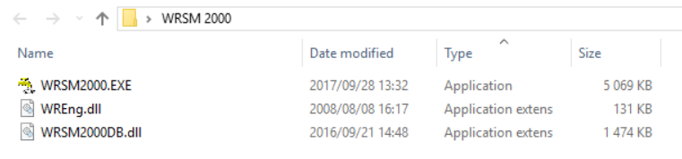

Figure 1‑1: Software components to start with basic hydrology

The software can be used by selecting the ***WRSM2000.EXE*** fileand the Graphical User Interface (GUI) as shown in **Figure 1‑2** will appear. The GUI consists of a “**menu bar**”, which is above various “**task icons**”.

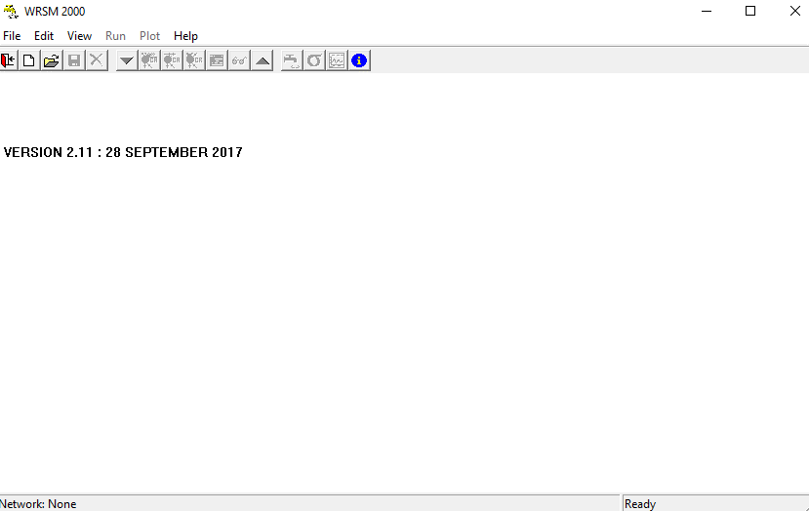

Task Icons

Minimise Window

Close Window

Minimise Window

menu bar

Figure 1‑2: GUI for WRSM 2000

## Modules

There are five modules forming the network, listed below:

* Runoff (Parent, Child Afforestation and Child Alien Vegetation)
* Irrigation (WQT method)
* Channels
* Reservoir
* Mine

A network diagram can be created with Microsoft (MS) Visio, MS PowerPoint or any other program that can be used to draw simplified schematics.

## Setting up Model and Running Simulation

Before setting up a model it is important to create a network diagram as shown in **Figure 1‑3**. The network diagram will assist in creating a representative simplified layout of the catchment.

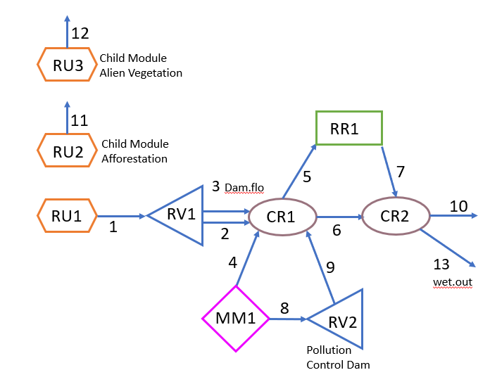

Figure 1‑3: Model Layout

### Step 1: Set-up WRSM_Pitman folder

Create **WRSM_Pitman** folder on your C-Drive (**C:\** directory), as shown in **Figure 1‑4**. Copy and Paste the WRSM 2000 program into the newly created **WRSM_Pitman** folder (**Figure 1‑5**).

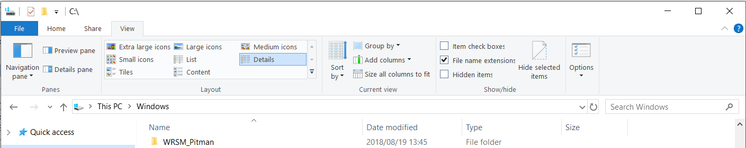

Figure 1‑4: Setting up Pitman file on c:\ drive

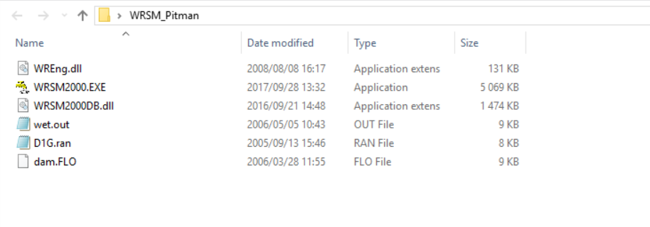

Figure 1‑5: Pasting Program Files into WRSM_Pitman folder

### Step 2: Create Network File

Create network file by selecting the **WRSM2000.EXE** file , this will open the application with the WRSM2000 GUI. Select from the drop down menus ***File>New Network****.* Give the network name “**SV**”, set the ***Data*** and ***Results Folder*** to **C:\WRSM_Pitman**”, set the **simulation** **start year** to **1920** and the **simulation end year** to **2003**. Finish off by selecting “OK” and then “Cancel”. See **Figure 1‑6** and follow steps to .

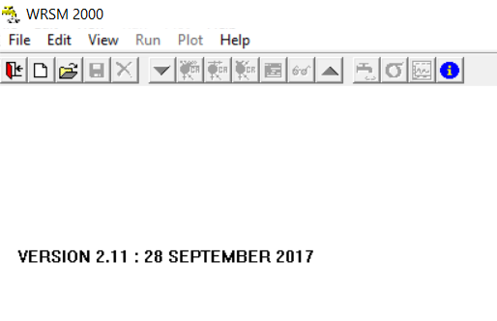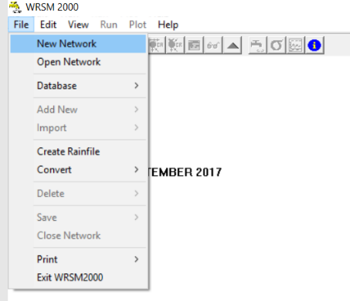

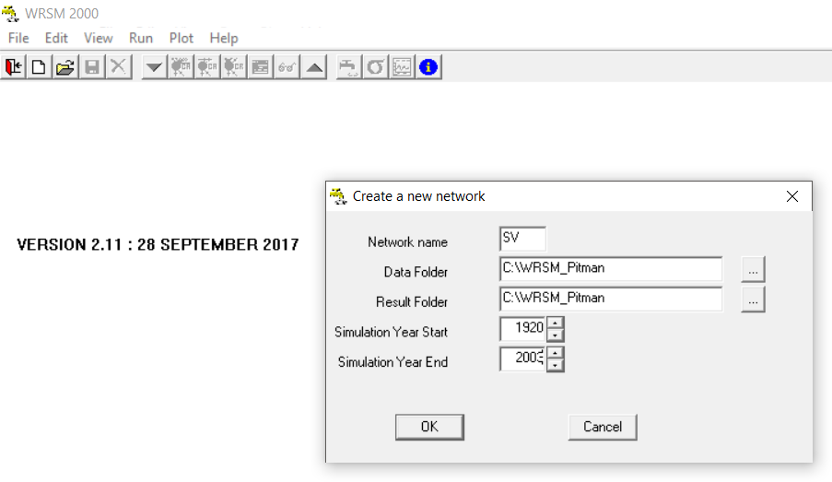

Figure 1‑6: Creating a new network

### Step 3: Create Runoff Module

Create the runoff module by selecting the File drop down menu and the Add New menu and then Runoff Module (***File>Add New>Runoff Module***). A “**Create new Runoff Module(s)**” window will pop-up, select Module number **1** and press “**OK**”.

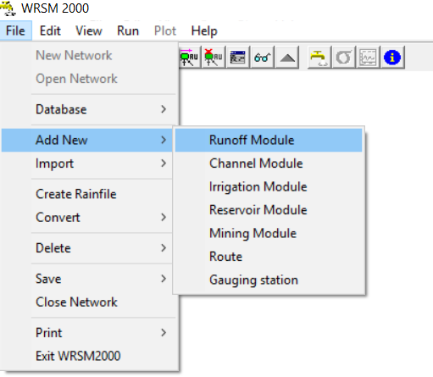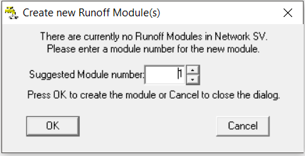

Figure 1‑7: Add New Runoff Module

**General Tab**

Insert Module name **RU1**, Catchment area of **1000** km2 and choose **Sami Groundwater Model**. Do **not** tick Parent module box.

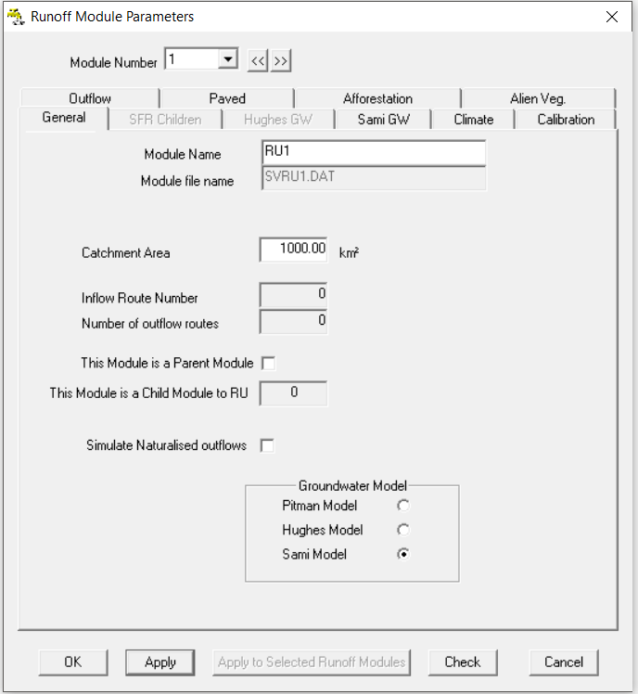

Figure 1‑8: Runoff Modules

Select “**Apply**” after every change that has been made. The model will advise you that it needs a Rainfile to set up under Climate data. **Ignore warning** and select “**OK**”.

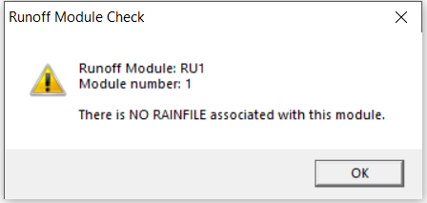

Figure 1‑9: Runoff Module Check (select “OK”)

**Climate Tab**

Select the **Climate Tab** for the **Runoff Module**, the same Rainfile will be used for the Mining, Reservoir, and the second channel module. Set the Rainfile to “**D1G.ran**” with a mean annual precipitation (MAP) of **700** mm, shown in **Figure 1‑10**. For all the runoff modules select the Symons Pan Factors from **Table 1‑1**.Use the sliding bar to move from October to September. **Note that the APan factors are calculated by the Model**.

Table 1‑1: Symons Pan Factors

|  |  |  |  |  |  |  |  |  |  |  |  |  |
| --- | --- | --- | --- | --- | --- | --- | --- | --- | --- | --- | --- | --- |
| **Month** | **Oct** | **Nov** | **Dec** | **Jan** | **Feb** | **Mar** | **Apr** | **May** | **Jun** | **Jul** | **Aug** | **Sep** |
| Evaporation (mm) | 158 | 178 | 204 | 199 | 150 | 130 | 88 | 64 | 47 | 55 | 81 | 122 |
| SPan Factors | 0.8 | 1.0 | 1.0 | 1.0 | 1.0 | 1.0 | 1.0 | 1.0 | 1.0 | 0.8 | 0.8 | 0.8 |

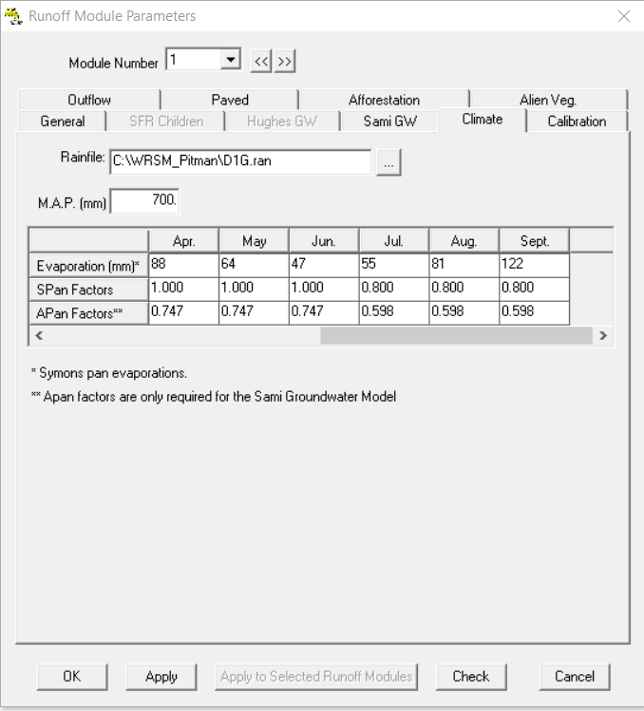

Figure 1‑10: Climate Tab for RU1

**Sami Groundwater (GW) Tab**

Continue by selecting the **Sami GW Tab** from the top Runoff Module ribbon. The same data will be used for all the runoff modules. The child runoff modules will have the same properties as their parent module. The majority of the data is default data. The white insert boxes indicate that this information should be changed, the blue boxes indicate that the information can be changed but it is not necessary and the red boxes indicate information which should only be changed by advanced users (**See pg. 46 of WRSM2000UserGuide for details**). The following information should be inserted into the Sami GW Tab (See **Figure 1‑11** for details):

* Aguifer thickness = 20 m
* Storativity = 0.005
* Initial Aquifer Storage = 45 mm
* Static Water Level = 60 mm
* Maximum Discharge Rate = 2 mm
* Power = -0.05
* Maximum Hydrological gradient = 0.001
* Groundwater evaporation area = 7 km2
* Months to average recharge = 2
* Unsaturated Storage Capacity = 20 mm
* Initial Unsaturated Storage = 10 mm
* Percolation Power (PPOW) = 0.2
* Transmissivity = 10 m2/day
* Borehole distance to river = 1000 m
* K2 = 0.1
* K3 = -3
* Interflow lag = 0

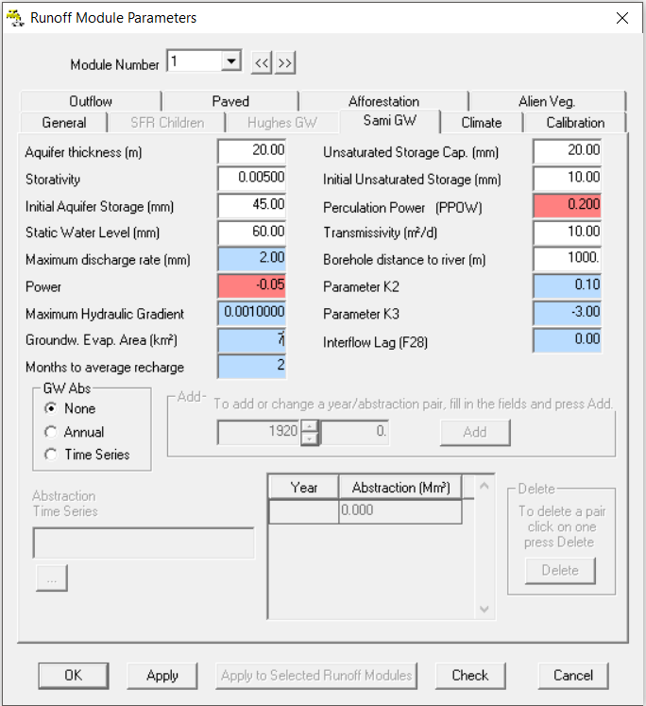

Figure 1‑11: Sami Groundwater tab

Select “**Apply**” to save changes after completing a **Tab**.

**Calibration Tab**

Go to the **Calibration Tab** and insert the information given in **Again,** note the colours of the different input fields.

Table 1‑2 and **Figure 1‑12** (See **pg. 36** of **WRSM2000UserGuide** for details). Again, note the colours of the different input fields.

Table 1‑2: Calibration parameters

| **Parameter** | **POW** | **SL** | **ST** | **FT** | **GW** | **ZMIN** | **ZMAX** | **PI** | **TL** | **R** | **HGGW** | **HGSL** | **GPOW** |
| --- | --- | --- | --- | --- | --- | --- | --- | --- | --- | --- | --- | --- | --- |
| **Value** | 3.0 | 0 | 150 | 5 | 0 | 20 | 700 | 1.5 | 0.25 | 0.5 | 2 | 5 | 3 |

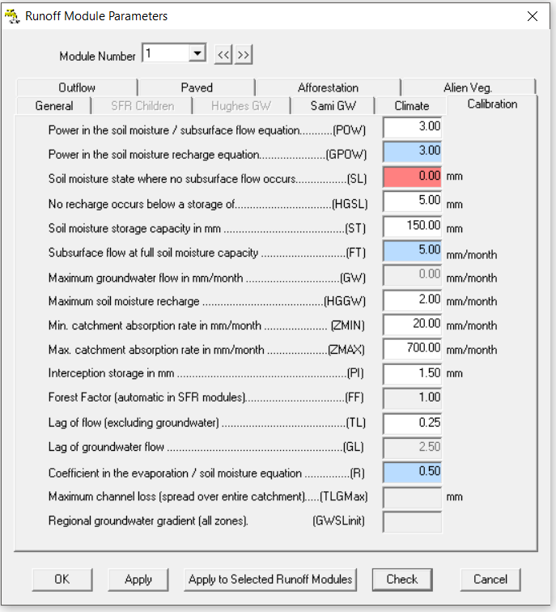

Figure 1‑12: Calibration Tab

**Paved Tab** assume that there are no paved areas i.e. there is no impervious area

**Outflow Tab** no information has to be added, this will be done later in the Tutorial.

**SFR Children Tab** no information has to be added.

**Afforestation Tab** no information has to be added.

**Alien Vegetation Tab** no information has to be added.

All the information has been entered for the first Runoff Module, select “**OK**”. Continue by adding a second Runoff Module under ***File>Add New>Runoff Module***.

**Afforestation Child Module**

**General Tab**

Insert module name **RU2**, catchment area of **5.5** km2 for the maximum afforestation areaand choose **Sami Groundwater Model** (**Figure 1‑13**). Do **not** tick Parent module box. Select the “**Apply**” button after completing all the information on the **General Tab**.

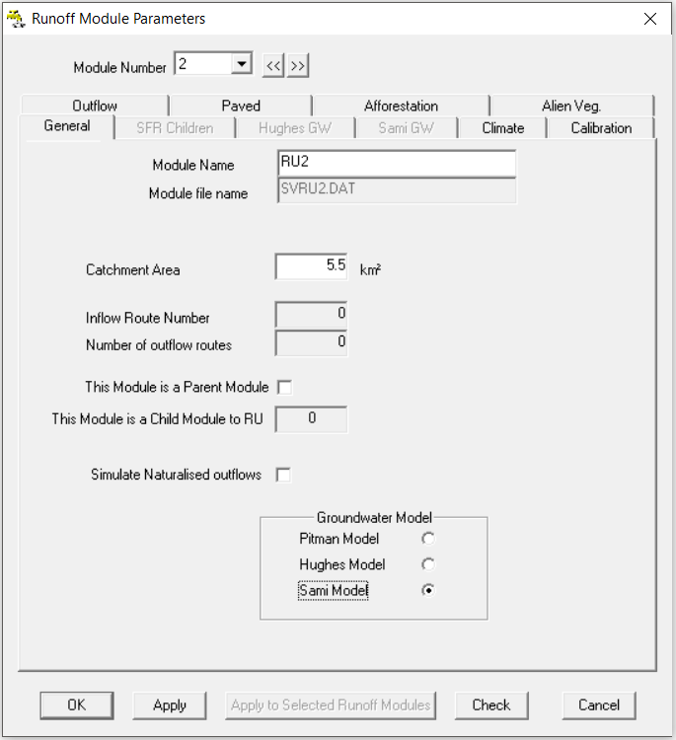

Figure 1‑13: RU2 Afforestation Child Module

**Climate Tab**

Use the module number  navigation keys << and >> to switch between runoff modules and to copy paste climate information, as shown in **Figure 1‑14**. This is done by copying (Ctrl+C) all the information from **RU1 Climate Tab** and pasting (Ctrl+V) to **RU2 Climate Tab**.

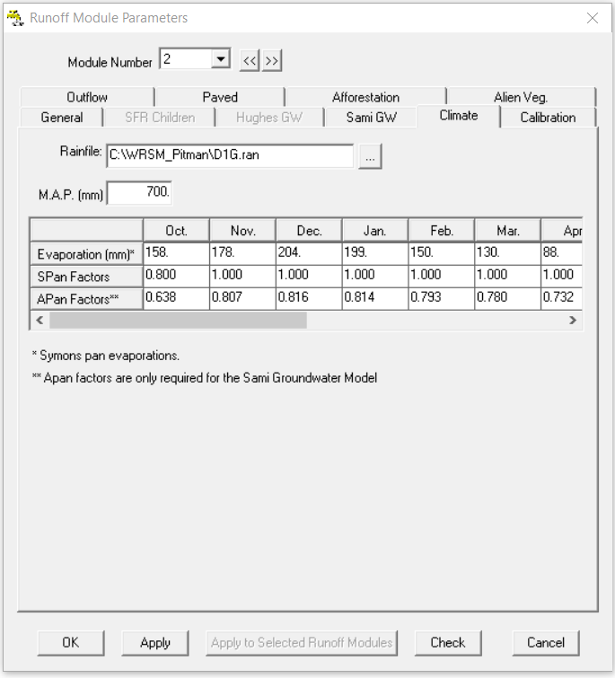

Figure 1‑14: RU2 Afforestation Child Module Climate Tab

**Calibration Tab** is automatically copied from Parent when model is run.

**Sami Tab** is automatically be copied from Parent when model is run.

**Afforestation Tab** insert the information given in **Table 1‑3** and shown in **Figure 1‑15**, select “**Apply**”.

Table 1‑3: Afforestation areas

|  |  |  |  |
| --- | --- | --- | --- |
| **Year** | 1920 | 1960 | 2003 |
| **Area (km2)** | 1.1 | 2.2 | 5.5 |

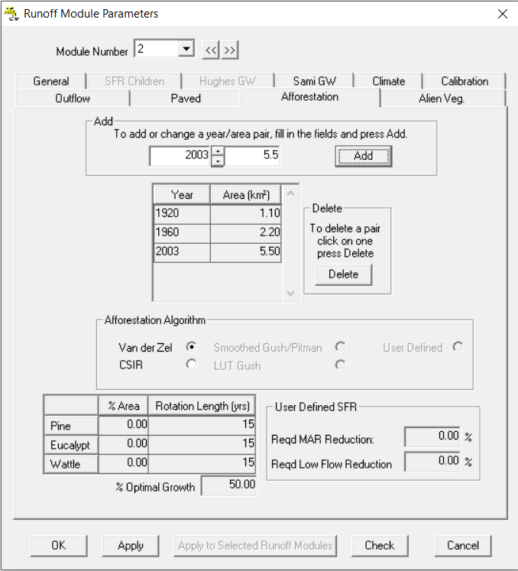

Figure 1‑15: Afforestation Tab

**Alien Vegetation Tab** no information has to be added.

**Paved Tab** no information has to be added, as this runoff module is only for afforestation.

**Outflow tab** no information has to be added, this will be done later in the Tutorial.

All the information has been entered for the first Runoff Module, select “**OK**”. Continue by adding a third Runoff Module under ***File>Add New>Runoff Module***.

**Alien Vegetation Child Module**

**General Tab**

Insert module name **RU3**, catchment area of **3.0** km2 for the maximum afforestation areaand choose **Sami Groundwater Model**. Do **not** tick Parent module box. Select the “**Apply**” button after completing all the information on the **General Tab**.

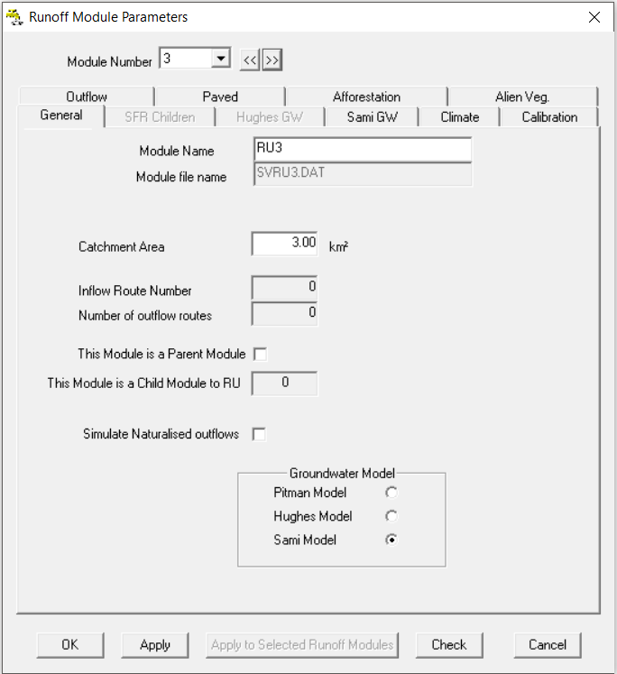

Figure 1‑16: RU3 Alien Vegetation Child Module

**Climate Tab**

Use the module number  navigation keys << and >> to switch between runoff modules and to copy paste climate information, as shown in **Figure 1‑14**. This is done by copying (Ctrl+C) all the information from **RU2 Climate Tab** and pasting (Ctrl+V) to **RU3 Climate Tab**. Select “**Apply**” after completing the **General Tab**.

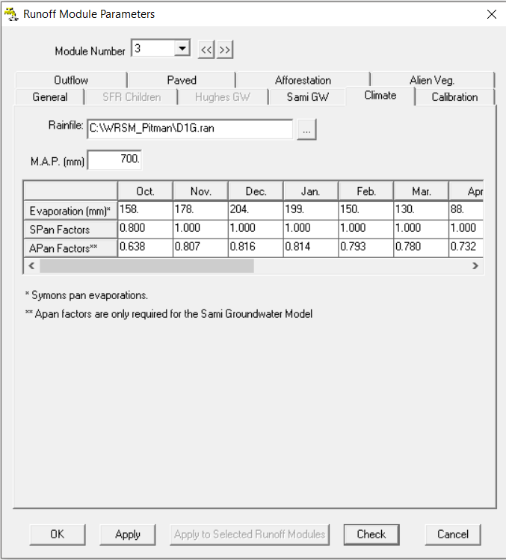

Figure 1‑17: RU2 Afforestation Child Module Climate Tab

**Calibration Tab** will be copied from Parent when model is run.

**Sami Tab** will be copied from Parent when model is run.

**Afforestation Tab** no information has to be added.

**Alien Vegetation Tab** insert the information given in **Table 1‑4** and shown in **Figure 1‑18**.

If the areas are small the model will set the area to zero. 40% of the area is covered by Tall trees being 20 years old, 40% medium trees 15 years old and 10% tall shrubs 10 years old. The optimal growth is 50% and the riparian vegetation makes up 80% of the total. Select “**Apply**” after completing the **Alien Vegetation Tab**.

Table 1‑4: Alien Vegetation Areas

|  |  |  |  |
| --- | --- | --- | --- |
| **Year** | 1920 | 1960 | 2003 |
| **Area (km2)** | 0.1 | 0.5 | 3.0 |

Note on “**Optimal Growth**” parameters: The CSIR method consists of two principals which are, optimal and sub- optimal growth. An optimal area is defined as an area with deep fertile soils, high rainfall and sub- tropical climate. Whereas shallow soils, lower rainfall and cooler temperature are defined as sub- optimal. A value of **50%** for **Optimal Growth**  is seen as a middle value between the two values.

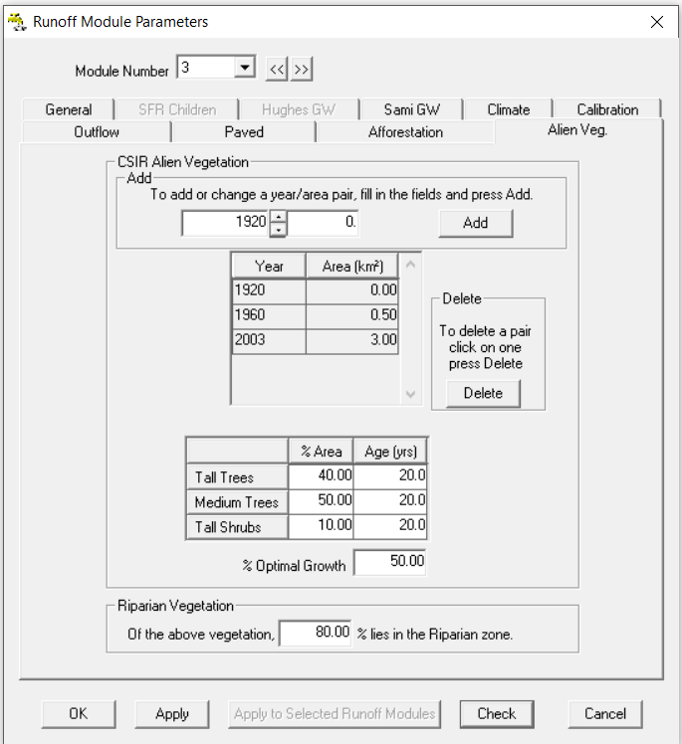

Figure 1‑18: Alien Veg Tab

**Paved Tab** no information has to be added, as this runoff module is only for afforestation.

**Outflow tab** no information has to be added, this will be done later in the Tutorial.

Select “**OK**” to complete the Runoff Module, and select “**Cancel**” on the following prompt window.

### Step 4: Saving the Network

Save the network by selecting ***File>Save>Network*** on the drop-down menu (**Figure 1‑19**) or select the save button on the icon ribbon ().

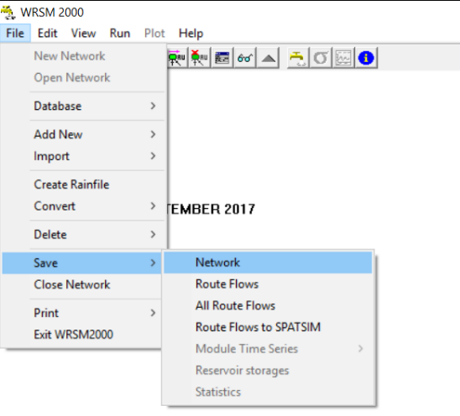

Figure 1‑19: Saving Network File

The Runoff Modules can be edited under “**Edit**”drop-downmenu, if parameters need to be re-entered or adjusted. Saving the network should be repeated throughout the tutorial to prevent losing data.

### Step 5: Creating the major Reservoir Module

Add a reservoir module by selecting ***File>Add New>Reservoir Module*** (**Figure 1‑20**) or by selecting the **up** or **down** **buttons** on the icon ribbon () until you reach the reservoir icons  and select the second button from the left to add the reservoir module .

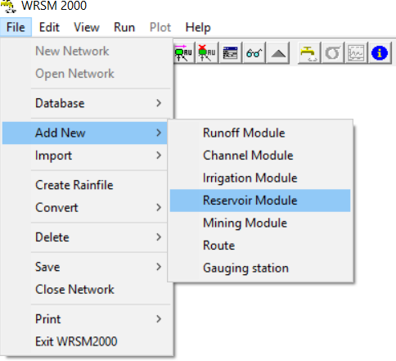

Figure 1‑20: Adding Reservoir Module

Similar to the Runoff Module add the Reservoir Module, by selecting the **Module Number** as **1**, as shown in **Figure 1‑21**. On the **General Tab** insert the **Module Name** as “**RV1**” andselect “**Apply**”, to save the changes.

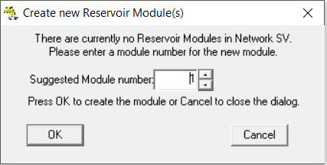

Figure 1‑21: Select reservoir module number

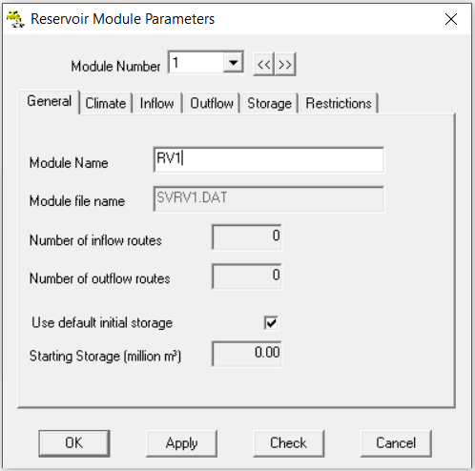

Figure 1‑22: Reservoir Module Parameters (General Tab)

Open the **Climate Tab** and browse for the Rainfile, which is the same as for the Runoff Module “**D1G.ran**”.Copy and paste the evaporation and pan factors into the **Climate Tab** from the Runoff modules, by selecting “**OK**” on the open window, this will close the window and “**Cancel**” on the **Create Reservoir Module(s)**. Go to the ***Edit>Runoff Module*** or Alt+R, use the Module Number buttons to select a module . Go to the Climate Tab and select the top left (blank) corner of the table, which will then select the entire evaporation table (the table will be shaded black). Copy the data with Ctrl+C and select “**OK**”, this closes the window and return to the Reservoir Module ***Edit>Reservoir Module*** or shortcut key Alt+D (Alternatively use the up and down arrows on navigate to the  and select the fifth icon from the right).

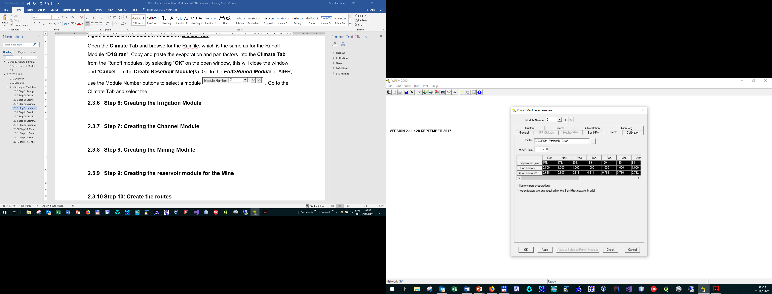

Figure 1‑23:

After opening the Reservoir Module Parameters window, use the Module Number << and >> and navigate to the first Reservoir Module. Open the **Climate Tab** and select the top left corner of the evaporation table and press Ctrl+V, to paste the data into the window.

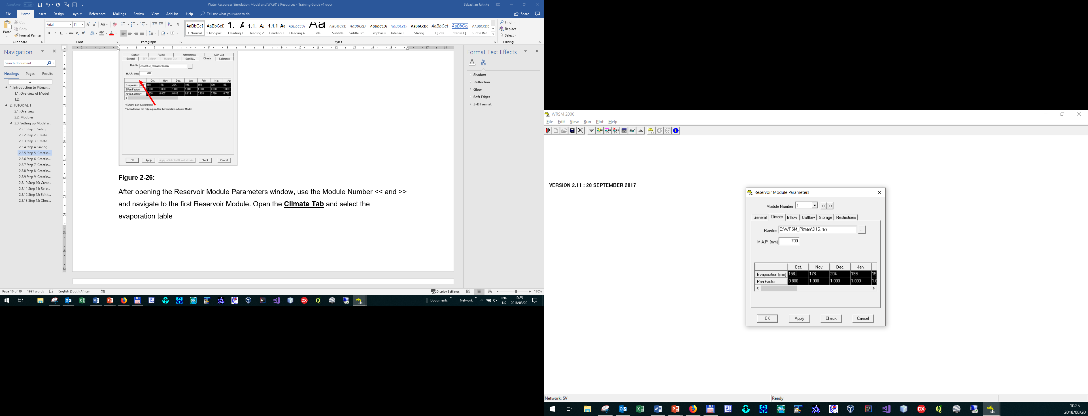

Figure 1‑24: Reservoir Module Climate Tab

Continue to the **Storage Tab** and fill in the storage curves according to **Table 1‑5** and **Figure 1‑25**. The capacity area relationship has a B-constant (Power for the Volume/Area curve) of **0.8**. See completed **Storage Tab** in **Figure 1‑26**. Select “**Apply**” and “**OK**” to complete the Reservoir Module. **Note** that the storage capacity curve extends up to 2003 with in specific “steps”, these have to be correctly entered into the model.

Table 1‑5: Major Dam characteristics

|  |  |  |  |
| --- | --- | --- | --- |
| **Characteristics** | **Year** | **Area (km2)** | **Volume (Mm3)** |
| FSL Initial survey and Year | 1958 | 33.04 | 235.49 |
| FSL Capacity 1st re-survey and year | 1987 | 39.04 | 252.61 |

Figure 1‑25: Storage capacity (Mm3) over time

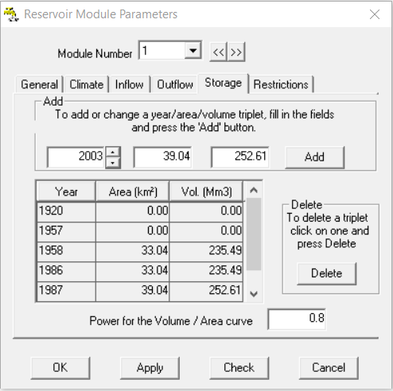

Figure 1‑26: Completed Storage Tab

### Step 6: Creating the Irrigation Module

Create the Irrigation Module by selecting ***File>Irrigation Module*** or use the up and down arrows to move to the irrigation module icons . Use the Suggested module number **1** and select “**OK**”. Give the Module Name “**RR1**” and select **WQT model (Type 2)** from the radio buttons (**Figure 1‑27**).

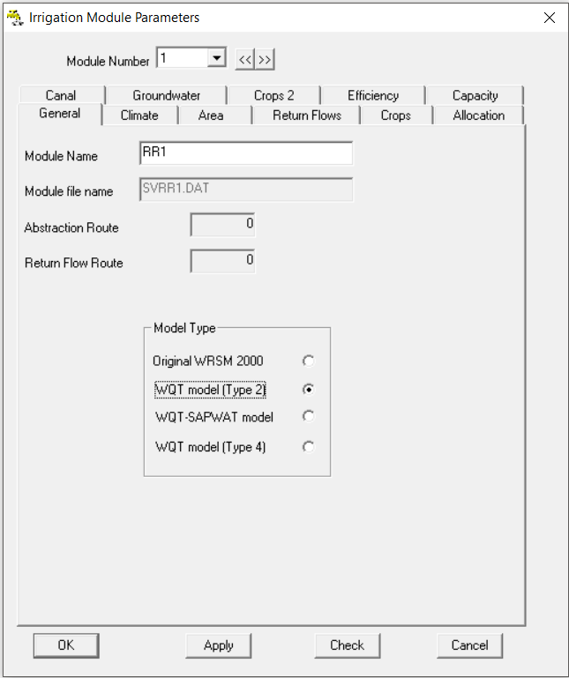

Figure 1‑27: Irrigation Module General Tab

**Climate Tab**

Populate the **Climate Tab** withthe Rainfile “**D1G.ran**” and populate the evaporation table with the values in . The rainfall (efficiency) factors are constant throughout the hydrological year with 75%, this is shown in **Figure 1‑28**.

Table 1‑6: A-pan Evaporation (mm)

|  |  |  |  |  |  |  |  |  |  |  |  |  |
| --- | --- | --- | --- | --- | --- | --- | --- | --- | --- | --- | --- | --- |
| **Month** | **Oct** | **Nov** | **Dec** | **Jan** | **Feb** | **Mar** | **Apr** | **May** | **Jun** | **Jul** | **Aug** | **Sep** |
| **A-pan Evaporation (mm)** | 213 | 215 | 236 | 220 | 179 | 162 | 116 | 93 | 74 | 87 | 127 | 179 |
| **A-pan Factor** | 0.45 | 0.78 | 0.66 | 0.75 | 0.68 | 0.78 | 0.42 | 0.45 | 0.32 | 0.50 | 0.82 | 0.83 |

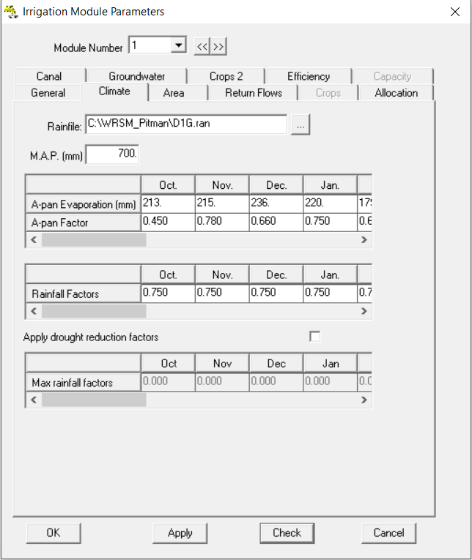

Figure 1‑28: Completed Irrigation Module Climate Tab

**Area Tab**

Fill in the irrigation area over time in the **Irrigation Tab** with the information given in **Table 1‑7**, as shown in **Figure 1‑29**.

Table 1‑7: Irrigation area changes over time

|  |  |  |  |
| --- | --- | --- | --- |
| **Year** | 1920 | 1990 | 2003 |
| **Irrigation Area (km2)** | 3.1 | 10.2 | 10.8 |

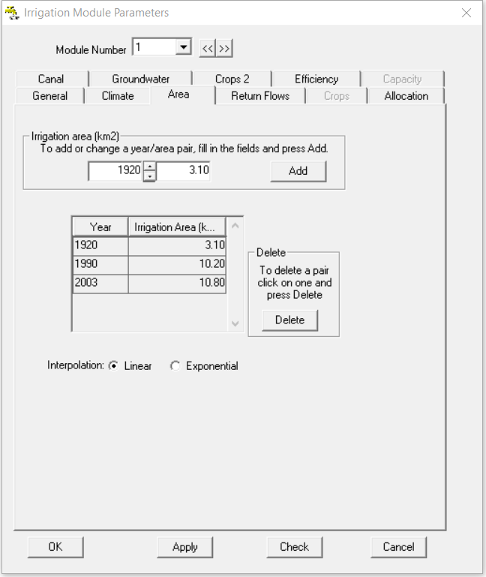

Figure 1‑29: Completed Irrigation Module Area Tab

**Return Flows**

Set the **return flow factor** to **0.01** and the **return flow growth** to **1** in **1920** and **2** in **2003** (**Figure 1‑30**).

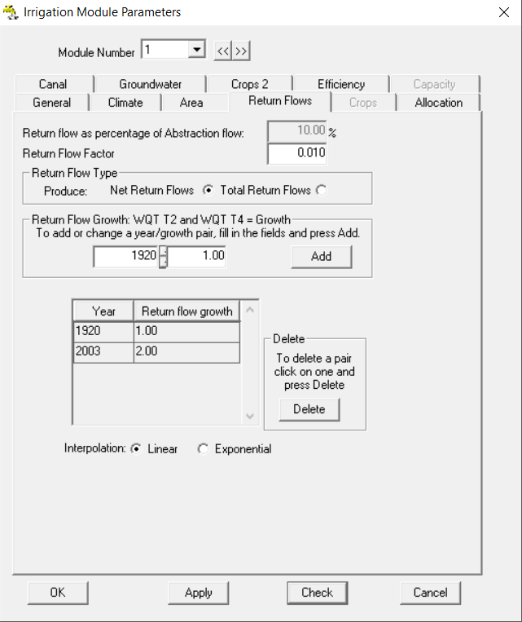

Figure 1‑30: Completed Return Flows Tab

**Irrigation Tab**

Set the irrigation allocation to **1** for **1920** up to **2003**, with the maximum annual irrigation allocation to **9999**, this means that there is no limit on allocation or abstraction (**Figure 1‑31**). Select “**Apply**” to save the values.

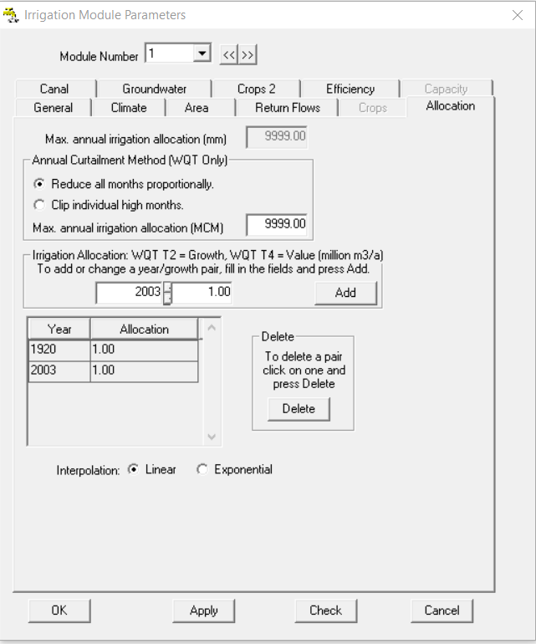

Figure 1‑31: Completed Irrigation Module Allocation Tab

Canal Tab insert the **proportion of seepage** as **0.002** and the **proportion of seepage which is returned to the river** as **0.001**, as shown in **Figure 1‑32**.

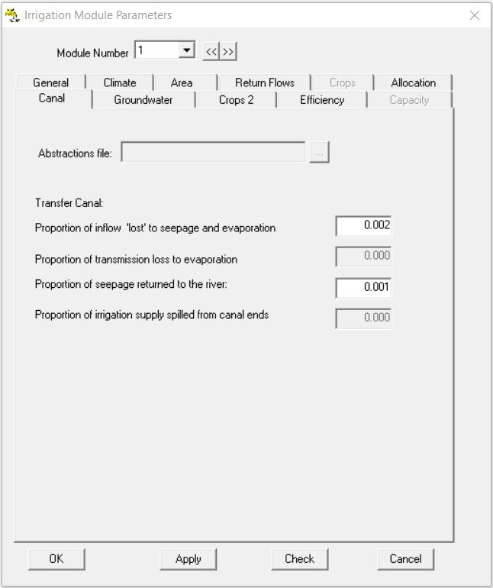

Figure 1‑32: Completed Canal Tab

For the **Groundwater Tab** select the Runoff Module “**RU1**”, set the **Upper Zone** to **400** mm and the **Lower Zone** to **600** mm, set the **Initial** and **Target Soil Moisture Storage** to **250** mm, and the **Upper soil maximum storage zone** to **0.75** and the **lower zone** to **0.15** (**Figure 1‑32**).

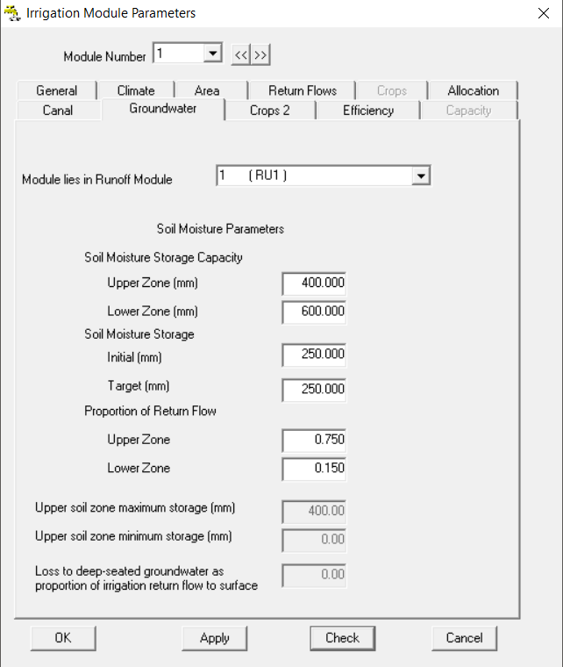

Figure 1‑33: Completed Groundwater Tab

**Crops 2 Tab**

Fill in the **Crops 2 Tab** with the information given in **Table 1‑8**, and set the effective rainfall limit 1 to 1 (out of a possible 100) and rainfall limit 2 to 0. Complete the tab by selecting “**Apply**” (**Figure 1‑34**).

Table 1‑8: Crop demand factors

|  |  |  |  |  |  |  |  |  |  |  |  |  |  |
| --- | --- | --- | --- | --- | --- | --- | --- | --- | --- | --- | --- | --- | --- |
| **Crop Type** | **Percentage** | **Oct** | **Nov** | **Dec** | **Jan** | **Feb** | **Mar** | **Apr** | **May** | **Jun** | **Jul** | **Aug** | **Sep** |
| **Crop 1** | 50 | 0.84 | 0.40 | 0.53 | 0.52 | 0.53 | 0.32 | 0.31 | 0.00 | 0.00 | 0.00 | 0.59 | 0.61 |
| **Crop 1** | 50 | 0.00 | 0.00 | 0.00 | 0.00 | 0.55 | 0.45 | 0.35 | 0.25 | 0.60 | 0.60 | 0.00 | 0.00 |

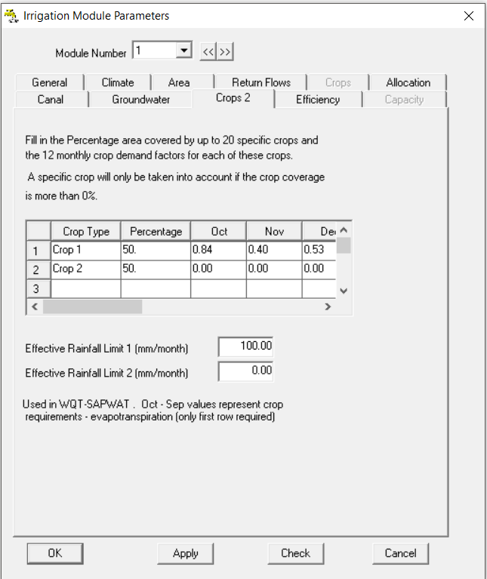

Figure 1‑34: Completed Crops 2 Tab

**Efficiency Tab**

Set the irrigation efficiency to 0.85 and keep the growth factors constant at 1 for 1920 to 2003, as shown in **Figure 1‑35**.

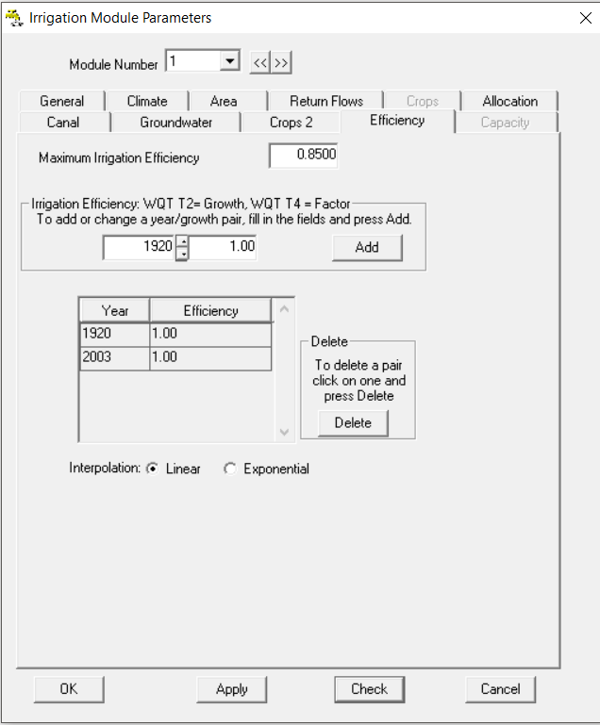

Figure 1‑35: Completed Efficiency Tab

Make sure that the “**Apply**” button was selected after every Tab was completed, this will save any changes made to the model. Continue by **saving** the **Network** (***File>Save>Network***).

### Step 7: Creating the Channel Module

Select ***File>Add New>Channel Module*** or use the up and down arrows on icon tab to add the new Channel Module to the Network .Select 1 for the first Module Number and Select “**OK**” to continue. Set the **Module Name** to “**CR1**”**,** select “**Apply**” to save the changes and finally “**OK**” (**Figure 1‑36** (1)). This will open up the second channel number and select “**OK**”. Set the **Module Name** to “**CR2**” and select the “**Comprehensive Wetlands**” option (**Figure 1‑36** (2)).

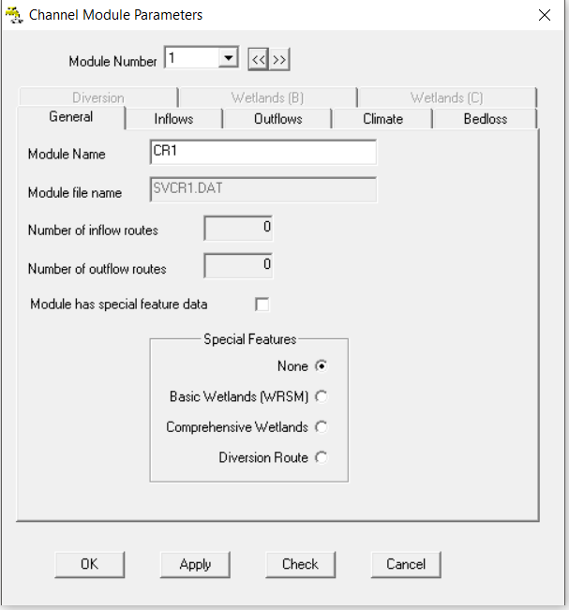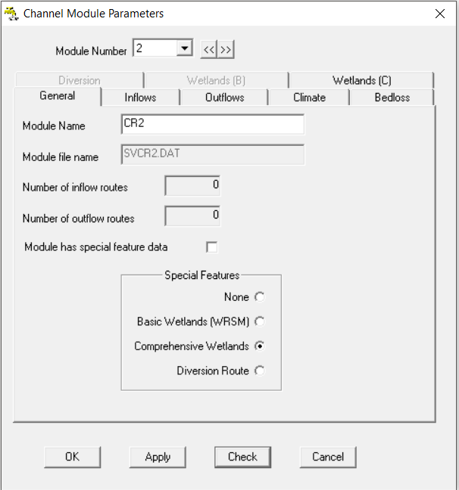

Figure 1‑36: Completed Channel Module General Tab

Use the same **Climate Tab** information for the **Channel Reach Modules 1** and **2** as was used for the **Runoff Modules**, copy and paste the information. Fill in the **Bedloss Tab** by setting the loss to 0.05 million m3/month (**Figure 1‑37**).

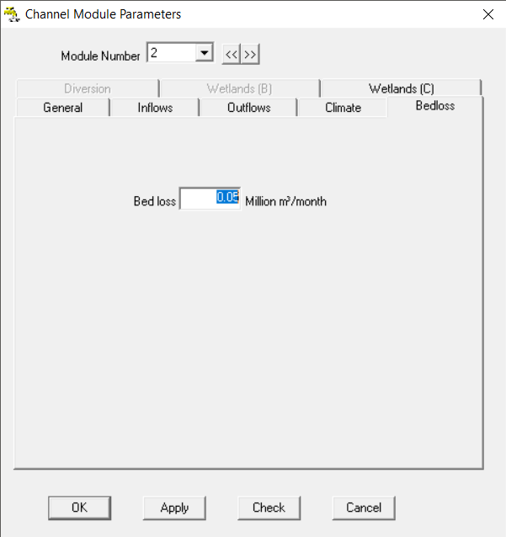

Figure 1‑37: Completed Bedloss Tab

Fill in the **Wetland (C) Tab** according to the information given below (**Figure 1‑38**):

Area of wetland at bankfill level = **0.05** km2

Volume of wetland at bankfill level = **1** million m3

Power of area-volume relationship = **0.6**

Bankfill capacity of river channel = **1.5** million m3/month

Proportion of fill in excess of bankfill into wetland = **0.1**

Proportion of wetland volume (river bankfill) into channel = **0.2**

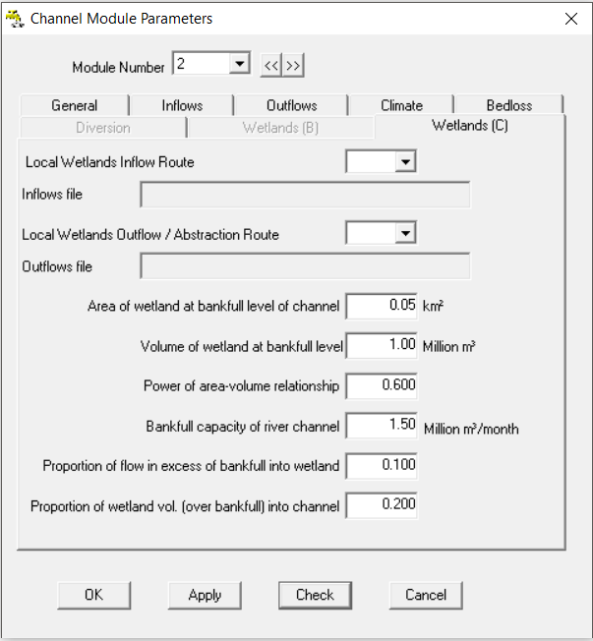

Figure 1‑38: Completed Wetlands (C) Tab

Select “**Apply**” to save the settings and “**OK**” to finish editing the Module.

### Step 8: Creating the Mining Module

Select ***File>Add New>Mining Module***. Select 1 for the first Module Number and Select “**OK**” to continue. Set the **Module Name** to “**Mine1**”, and the Runoff Module to **RU1** select “**Apply**” to save the changes. Use the same Climate information as for the Runoff Module, by copying and pasting the information into the Climate Tab. Note that a warning regarding the outflow route will pop up, select “**Cancel**” on the Climate Tab to exit the Module window.

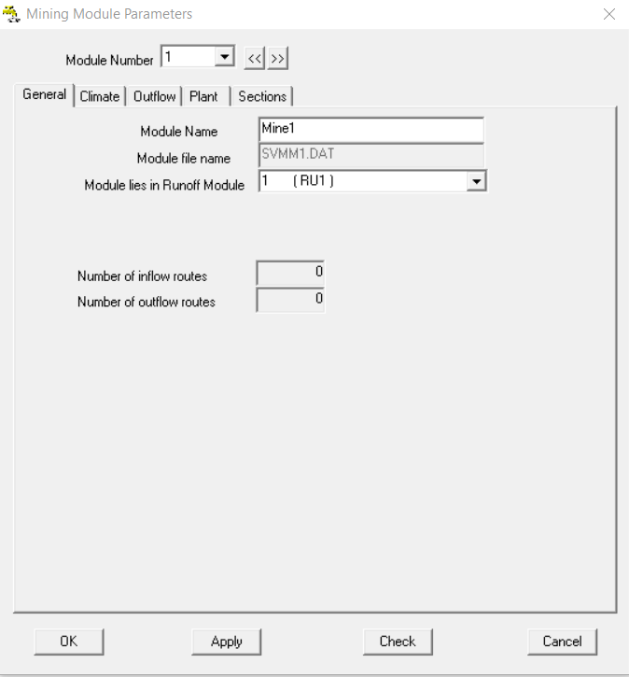

Figure 1‑39: Completed Mining Module General Tab

**Plant Tab** set the plant area to **0.5** km2, the Runoff Factor to 0.7 and keep the growth factor constant at **1** for the simulation period from **1920** to **2003**.

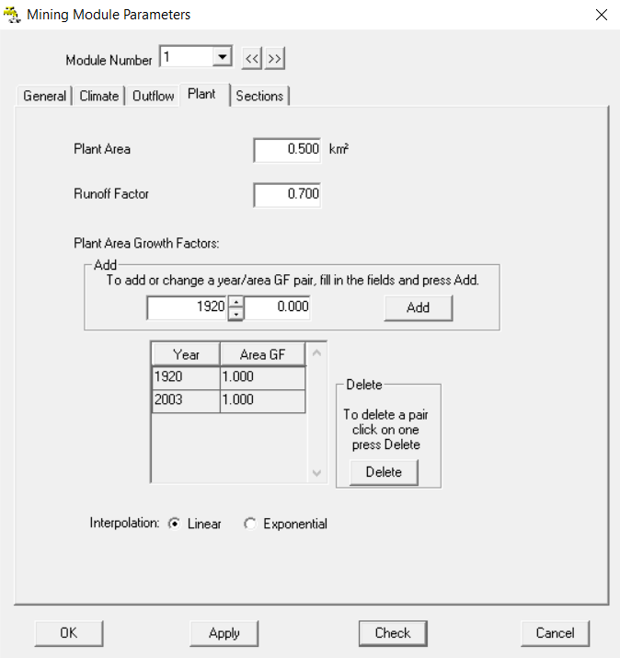

Figure 1‑40: Completed Plant Tab

**Sections Tab**

Add an **Opencast Sections**

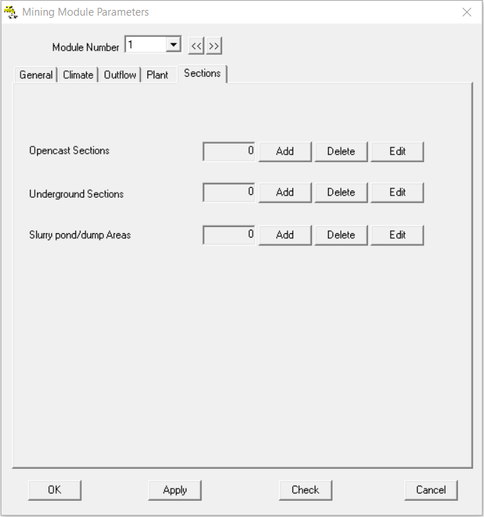

Figure 1‑41: Sections Tab

Insert the following information into the Tabs (follow steps 1 to 7 in **Figure 1‑42**):

**General Tab**

Section Name = Open1

Area of coal reserves = 0.3 km2

Commissioning and Decommissioning date = 1/1970 and 2/2010 respectively

Pollution control dam area = 0.01 km2

Pollution control dam volume = 0.01 million m3

Pollution control dam initial volume = 0.01 million m3

**Distributed Area Tab**

Distributed area that contributes to runoff = 0.05 km2

Runoff factor for distributed area = 0.3

Monthly recharge = 0.1 with constant growth factor 1 1920 to 2003

**Workings Tab**

Working pit area = 0.02 km2 with constant growth factor 1 1920 to 2003

**Pit evaporation Tab**

Pit evaporation area = 0.02 km2 with constant growth factor 1 1920 to 2003

**Rehabilitation Tab**

Assume the rehabilitation area =0.05 km2

Runoff factor = 1

Initial inspoils seepage = 0

Monthly recharge factors = 1 (constant growth factor 1 1920 to 2003)

**Inspoils Seepage Tab**

Inspoils Storage where seepage occurs = 0.05 million m3

Maximum seepage rate = 0

Exponent for seepage equations = 0

Growth factors = 1 (constant growth factor 1 1920 to 2003)

**Inspoils Decant Tab**

Inspoils Storage where decant occurs = 0.05 million m3

Growth factors = 1 (constant growth factor 1 1920 to 2003)

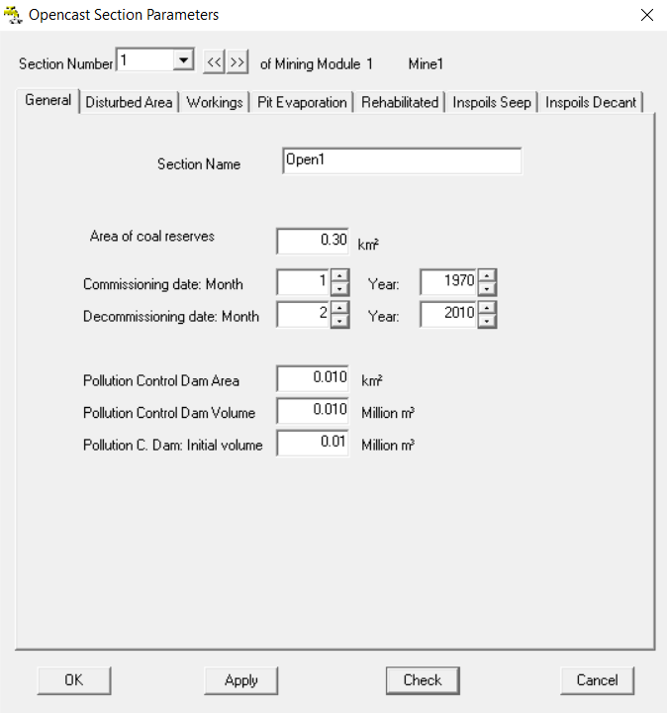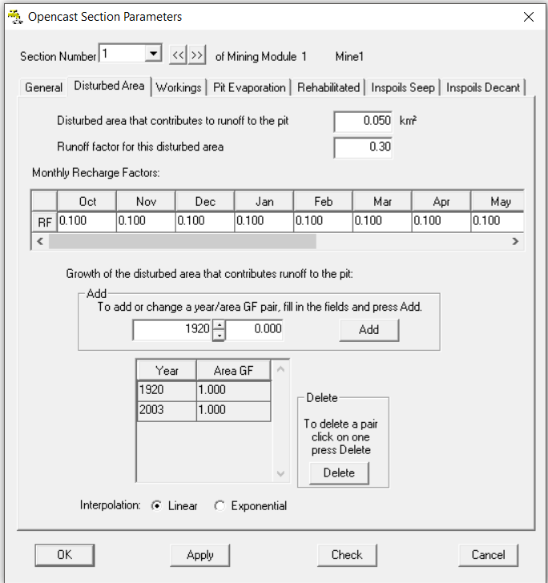

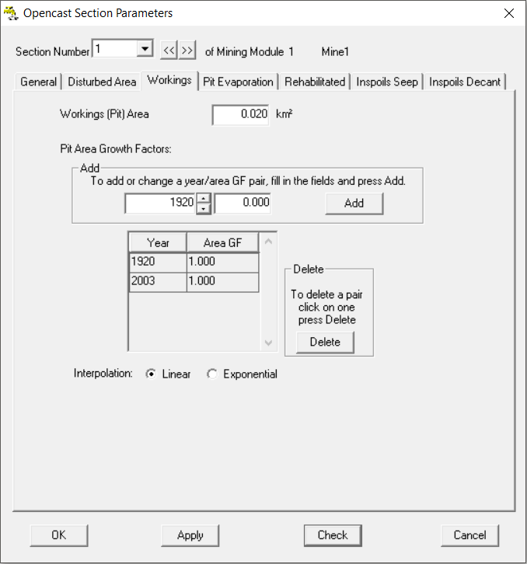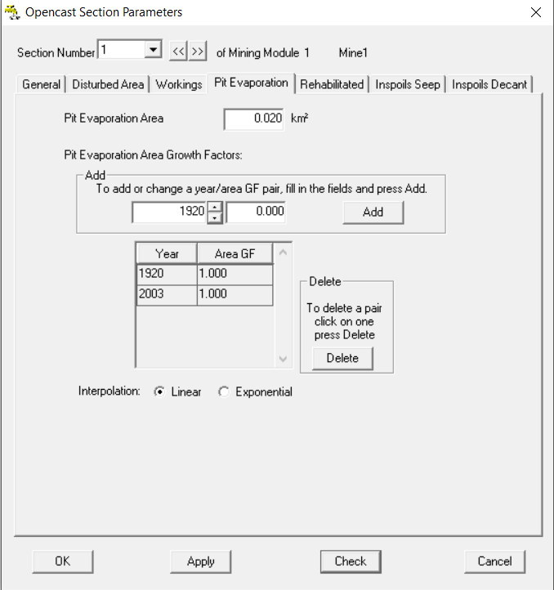

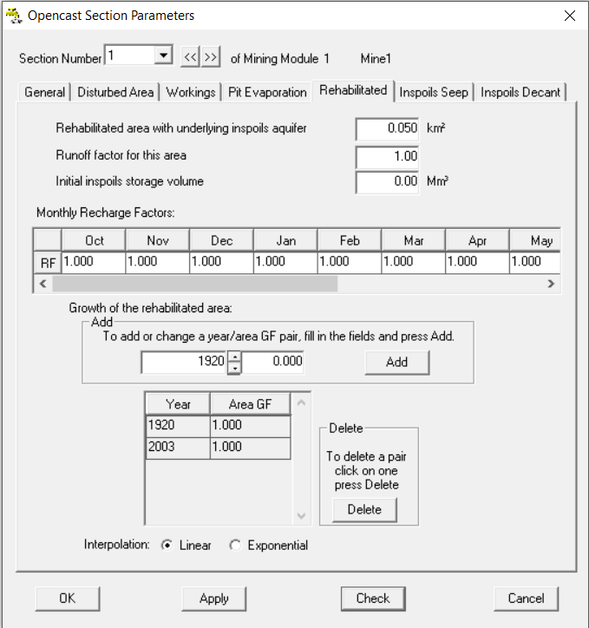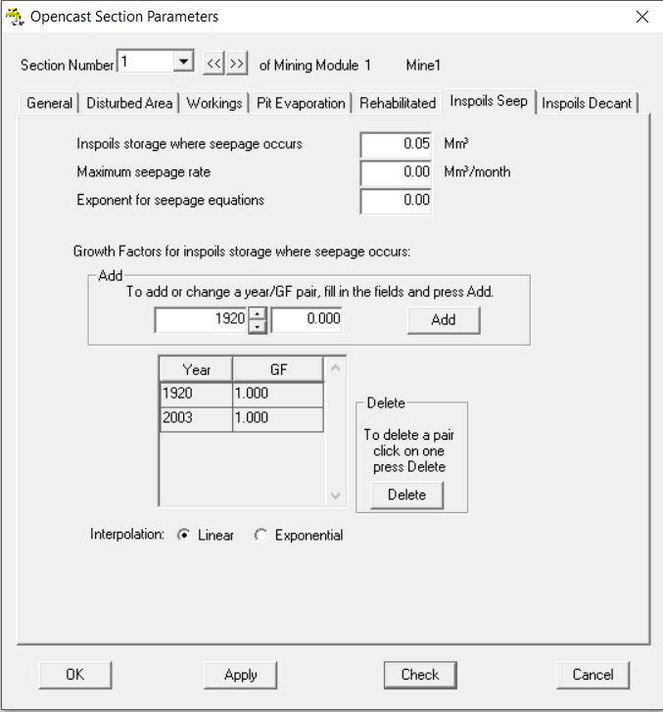

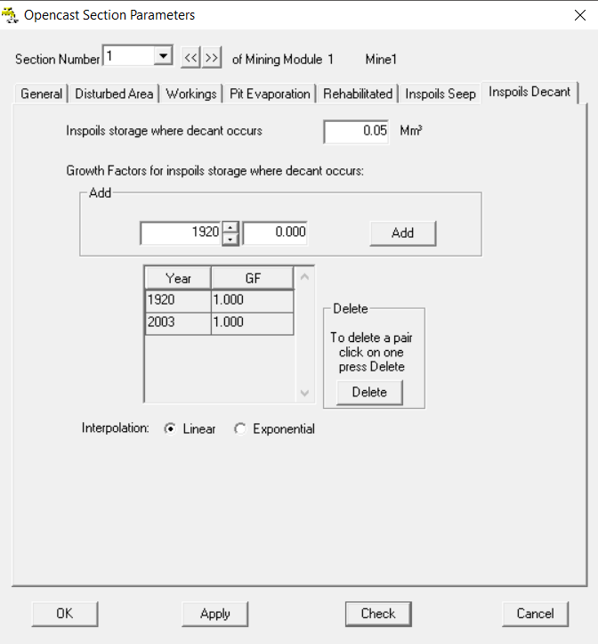

Figure 1‑42: Steps to complete the Opencast Mine

Select “**OK**” to close the Opencast Sections Window. The parameter window will give an Input Error if “**OK**” is selected, because no outflow routes are select, therefore select the **cross** on the top right corner of the **Mining Module Parameter window**, to close the parameter window.

### Step 9: Creating the reservoir module for the Mine

Add a second **Reservoir Module** with ***File>Add New> Reservoir Module***, give the reservoir module name with “**RV2**”. Copy and paste the **Climate Tab** from **RV1**. On the **Storage Tab** set the storage area to 0.2 km2 and 0.1 Mm3 for the time in which the mine was active from 1970 to 2010, apply the same principle as with **RV1** (**Figure 1‑43**). Select “**Apply**” and “**OK**” to close the Reservoir edit window, and “**Cancel**” to continue with creating the routes. **Save** the **Network**.

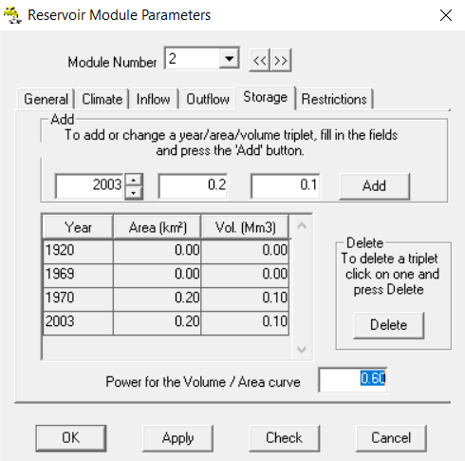

Figure 1‑43: Completed Pollution control Reservoir Storage Tab

### Step 10: Create the Routes

Create routes by selecting ***Files>Add New>Route***. Use the system diagram in **Figure 1‑3** to complete routes in the direction of flow from upstream to downstream (direction of arrows). Where there are no downstream modules shown make use of the Zero Sink Module or where specified give a **\*.FLO** file, or where needed the **\*.out** for a wetland (to select the *.out file select **All Files** on the file explorer and “**Open**”, as shown in **Figure 1‑44**). After all the routes are added select “**Cancel**”.

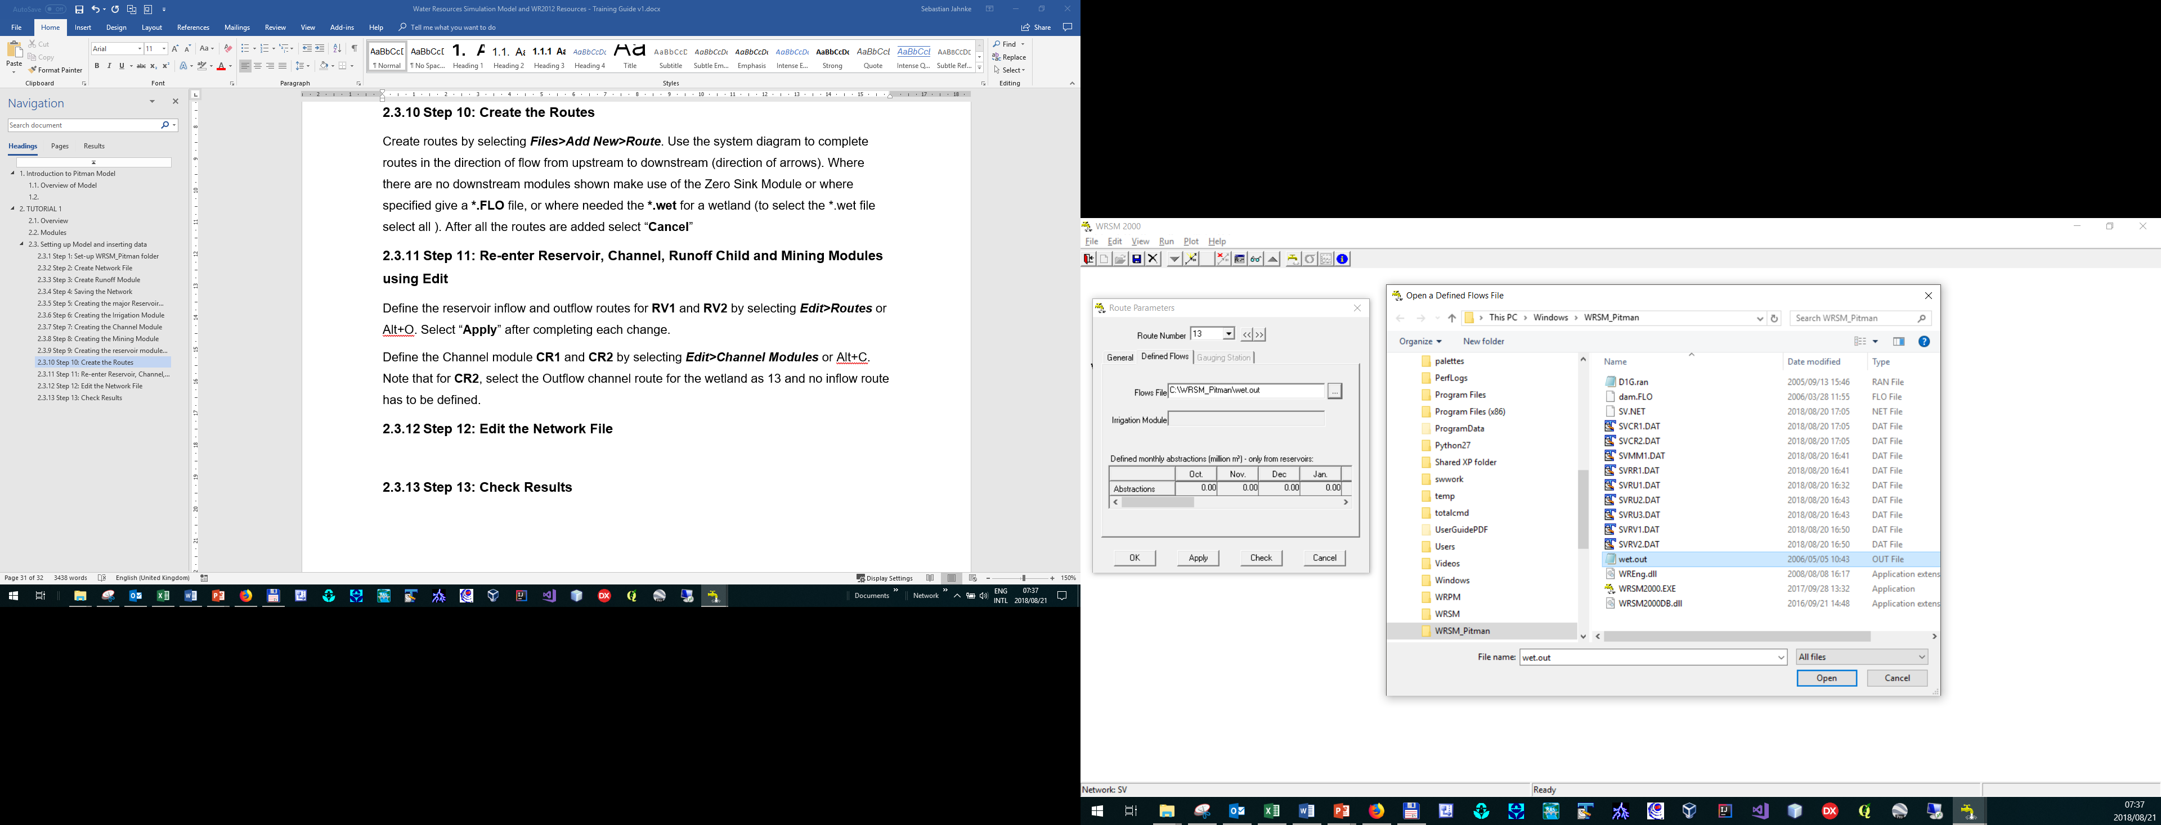

Figure 1‑44: Selecting Wetland outflow folder

### Step 11: Re-enter Reservoir, Channel, Runoff Child and Mining Modules using Edit

Define the reservoir inflow and outflow routes for **RV1** and **RV2** byselecting ***Edit>Routes*** or Alt+O. Think carefully which route should be selected as major outflow route. Select “**Apply**” after completing each change.

Define the Channel module **CR1** and **CR2** by selecting ***Edit>Channel Modules*** or Alt+C. Note that for **CR2**, select the Outflow channel route for the wetland as 13 and no inflow route. Save the Network before continuing.

Edit the Runoff Module **RU1** to select it as **Parent Module** under the **General Tab** and selecting the two (afforestation and alien veg.) child modules **RU2** and **RU3** (**Figure 1‑45**).

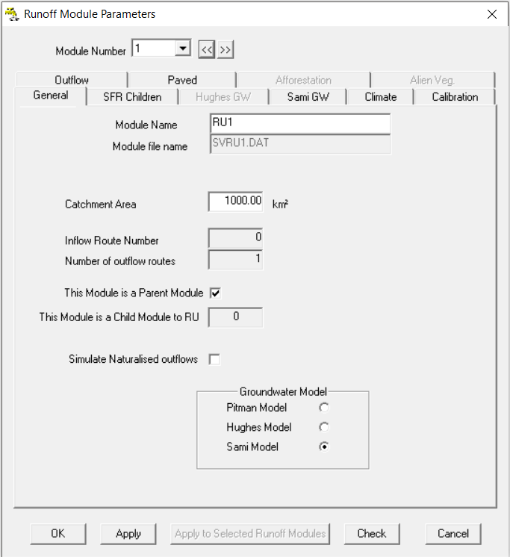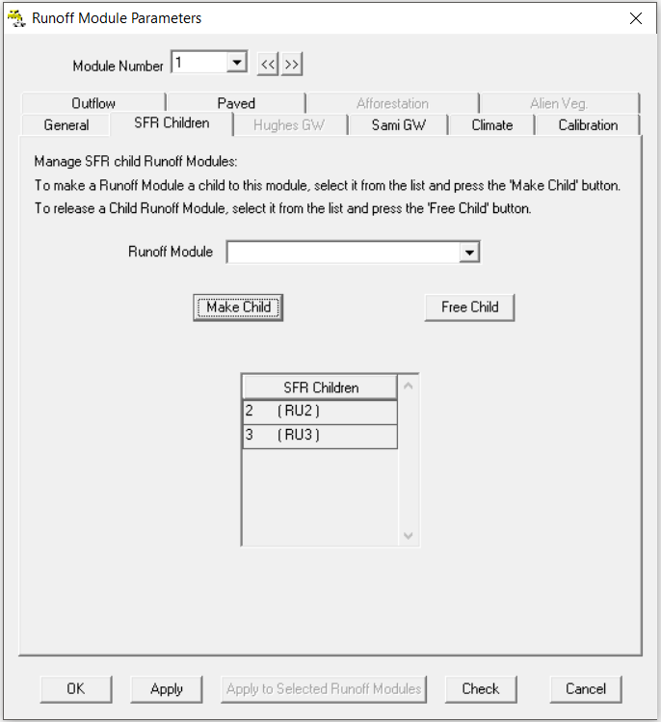

Figure 1‑45: Creating Parent and Child Modules

Change **RU2 Afforestation Tab** to use the **Smoothed Gush/Pitman** Afforestation Algorithm. Assume that the following splits in areas and rotation lengths are used (**Figure 1‑46**):

* Pine 60% and 15 years
* Pine 30% and 15 years
* Pine 10% and 15 years

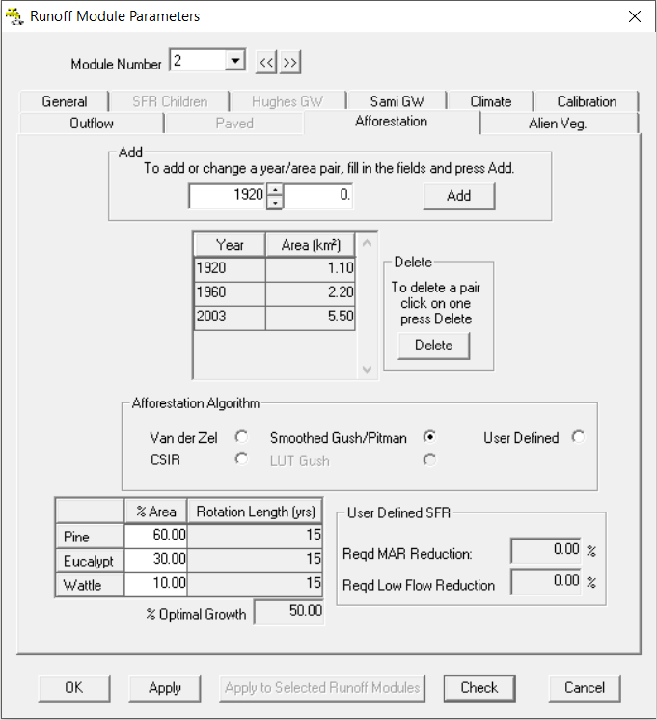

Figure 1‑46: Editing RU2 Afforestation Child module

Choose the **Outflow Tab** for all of the three Runoff Modules and set the runoff module outflow to **100%.**

Select “**Apply**” and “**OK**” to complete the process.

Edit the Mining Modules and select the outflow route pollution route to the Central Pollution Control dam as **Route 8** and the outflow route to river as **Route 4**, asshown in the network diagram.

### Step 12: Edit the Network File

Edit the way in which the model calculates the network by selecting on ***Edit>Network*** or Alt+N. Select the module which needs to be moved up and down and use the arrows on the right hand side of the window in **Figure 1‑47** to change the sequence of the modules. This opens the sequencing window of the calculations of the various modules. Runoff Modules are always first in the calculation sequence. The Reservoir Modules receive flow from the Runoff Modules. The mining and pollution control module discharge back to **CR1**. The irrigation block determines first what the irrigation requirements are form the crop type, rainfall evapotranspiration and finally tries to draw water from whichever source it can, therefore it must come after the mining module. Keep in mind that the sequence needs to be determined with great care to ensure that the modules are calculated in the correct way.

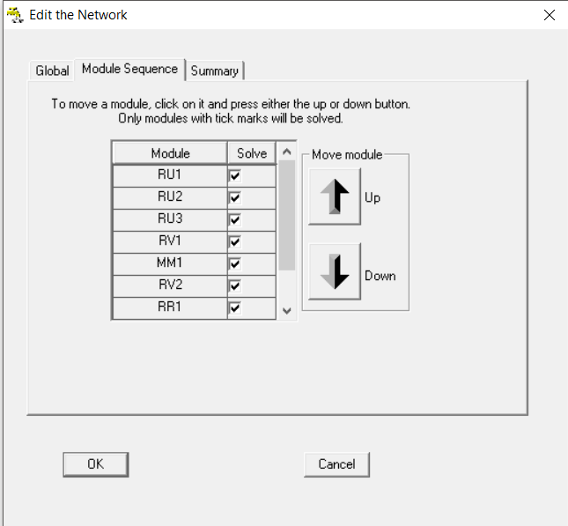

Figure 1‑47: Select the correct network sequence

Save the Network before running the simulation.

### Step 13: Check Results

Before running the simulation select ***Run>Module Check*** *and* ***Connectivity Check*** to ensure that all the modules are correctly configures and connected. To run the simulation select ***Run>Simulation***, a Simulation Run Report window will open after the run was completed successful, giving a warning of possible simulation errors, ignore these and select “**OK**” to finish.

To view the outcome of the simulation select ***View>Statistics*** and select the << and >> to move to the next channel. Select “**Calculate**” to view the **simulated MAR** and other parameters**.** Complete the diagram below, with the simulated runoff obtained.

