Monthly Multi-Site Stochastic
Streamflow Model

STOMSA USER GUIDE

Report to the
Water Research Commission

by

P. van Rooyan, R. McKenzie

WRC Report No. 909/1/04
ISBN No. 1-77005-178-3 APRIL 2004

Monthly Multi-Site Stochastic Streamflow Model

STOMSA USER GUIDE

TABLE OF CONTENTS

Page

TABLE OF CONTENTS ………..……………………………………………………………… (ii)
1. background 1-1
1.1. general 1-1
1.2. purpose and structure of document 1-1
1.3. Historical development of model 1-2
2. fundamentals of Stochastic streamflow generation 2-1
2.1. general 2-1
2.2. stochastic streamflow generation process 2-1
2.3. Marginal distribution 2-2
2.4. serial correlation 2-3
2.5. Cross-correlation 2-3
2.6. Monthly disaggregation 2-4
2.7. verification and validation 2-5
2.7.1. Distribution of normalised annual flows 2-6
2.7.2. Correlation of normalised residual annual flows 2-7
2.7.3. Monthly and annual means 2-7
2.7.4. Monthly and annual standard deviations 2-7
2.7.5. Minimum run-sums 2-7
2.7.6. Maximum deficits and deficit durations 2-8
2.7.7. Longest depletion durations 2-8
2.7.8. Yield-capacity relationship 2-9
2.7.9. Cross-correlation test 2-9
3. STOMSA basiC structure 3-1
3.1. general 3-1
3.2. Operating system 3-1
3.3. Graphical user interface 3-1
3.4. dynamic link libraries 3-1
3.5. Linkages with other models 3-3
4. model data requirements 4-1
5. model features 5-1
5.1. installation 5-1
5.2. overview of controls 5-1
5.3. project administration 5-2
5.4. parameter estimation 5-4
5.4.1. Marginal distribution 5-4
5.4.2. Serial correlation 5-6
5.4.3. Cross-correlation 5-7
5.5. streamflow generation 5-9
5.6. verification and validation testing 5-10
5.7. mode of operation 5-14
6. Example 6-1
7. references 7-1

APPENDICES
Appendix A: Example of model input
Appendix B: Example of model output

background

general
Stochastic hydrology is a process that is applied to determine the reliability of supply of water resource systems and is a standard technique used by the Department of Water Affairs and Forestry of South Africa since the early nineteen eighties. The need for stochastic hydrology originates from the requirement to estimate the assurance of supply, at say a recurrence interval of a failure of 1:200 years, when the available recorded streamflow data rarely exceeds 40 years and that, through rainfall-runoff simulation, a maximum period length of only 80 years can be derived. Stochastic hydrology provides the capability to synthetically increase the available data in order to evaluate the behaviour of water resource systems using alternative, but statistically plausible, streamflow conditions. This gives the opportunity to assess the probability of occurrence of critical periods that can be as long as nine years, which is difficult given the relative short historical time series.
The initial stochastic model (prior to the existence of STOMSA) was coded in the FORTRAN programming language, which although mathematical sound, lacks in flexibility and is without an intuitive user friendly graphical interface that is available in Windows based software developed in modern programming environments such as Delphi.
To fulfil this shortcoming this Monthly Multi-Site Stochastic Streamflow Model was developed as a user-friendly application to generate, validate and verify stochastic streamflow sequences. The model, referred to as STOMSA (STOchastic Model of South Africa), functions within the Windows operating system environment while using existing routines coded in Fortran to perform the parameter estimation, flow generation as well as the verification and validation tests associated with the process of stochastic streamflow generation.

purpose and structure of document
This document serves as a user guide to the Monthly Multi-Site Stochastic Streamflow Model, or STOMSA, Version 0.3 (March 2001). It describes the fundamental principles applied in the stochastic streamflow generation process as well as the related model features, including a detailed guide of the various software menus and options available to the user.

The user guide is divided into a number of sections, providing:
- An overview of the fundamentals of stochastic streamflow generation (Section 2);
- Information on the development of the model (Section 3);
- Details on model data requirements (Section 4);
- A step-wise description and guide to the use of the model features (Section 5);
- An example of a model input data set and related output information (Section 6).

Historical development of model
The development of the stochastic streamflow model was commissioned in the early 1980s by the Department of Water Affairs and Forestry as part of the Vaal River System Analysis Study (VRSAS). The objective was to provide a generic streamflow generator that is technically sound and versatile in nature so that it can be incorporated with the models used to analyse water resources systems in South Africa. As a result, a suite of software routines were developed to estimate the parameters required for stochastic streamflow generation as well as a stand-alone flow generator that is used for verifying and validating generated flow sequences.

Since the first version of the stochastic streamflow model was developed, a number of refinements were introduced to incorporate, amongst others, the following:
- “warm up” procedures to ensure that generated flows are independent of the seed values obtained from random number generators;
- Extension of the serial correlation modelling feature (see Section 2.4) to allow for larger dimensions of the Auto Regressive Moving Average Model. Currently up to nine possible time-series algorithms are available;
- Improved modelling of streamflow sequences that incorporate zero annual flows;
- Incorporation of basic yield-capacity relationship characteristics to improve criteria for the selection of appropriate time-series algorithms.

Finally, it should be noted that the stochastic streamflow generation techniques contained in STOMSA is effectively based on an annual time step with a monthly disaggregation features (see Section 2.6 for details). Although the model is appropriate for a wide variety of hydrological conditions experienced in South Africa, carefull consideration should be given in cases where the critical period of the water resource system is less than a year (this is generally experienced as a result of reservoir storage being small relative to inflow). In such cases it may be found that a stochastic model based on monthly flows rather than annual flows is required. Such a monthly model has been developed subsequent to the design and implementation of this model and details can be found in the report by Pegram, 2001.

fundamentals of Stochastic streamflow generation

general
This section provides a description of the basic procedures incorporated with STOMSA for the generation of stochastic streamflows. Note however that a detailed account of the underlying mathematical and statistical principles and approaches is not included since extensive information in this regard can be obtained from existing study reports and papers that have been published and presented around the world (DWAF, 1986).

stochastic streamflow generation process
The foundation for the generation of acceptable stochastic streamflow is sound historical naturalised streamflow data that is derived through rigorous hydrological assessments.
The first step in the process of stochastic streamflow generation is to capture the various statistical properties inherent to the natural historical streamflow sequence of each incremental sub-catchment under investigation. This is achieved by selecting the appropriate statistical distribution models and parameter sets that best describe:
- The characteristics of the marginal distribution of the annual flows. The aim is to find a distribution that can be used most successfully to transform the annual flows to a normal distribution (see Section 2.3);
- The time-series distribution that best represents the serial correlation exhibited by the normalised annual flows. The result is used to determine the normalised residual annual flows (see Section 2.4);
- The cross-correlation between the normalised residual annual flows from multiple catchments (see Section 2.5).

Based on the selected statistical distribution models and parameter sets, annual stochastic flow values are generated for a particular sub-catchment by following basically the same steps as outlined for parameter estimation above, but undertaken in reverse order. It starts with random number generation, followed by the introduction of cross-correlation and then serial correlation characteristics, after which the marginal distribution model is applied. Monthly stochastic flows, in turn, are generated based on the annual stochastic flows, disaggregating into 12 corresponding monthly values (see Section 2.6).

Marginal distribution
The marginal distribution for a historical streamflow sequence refers to the relationship between the total annual flows when ranked according to magnitude. A typical example is shown in Figure B-1 of Appendix B, which depicts annual flows (in units of volume) plotted against probability of exceedance (as a percentage). The marginal distribution can also be presented on a transformed graph, with the probability of exceedance plotted in terms of standard deviations from the mean, as shown in Figure B-2.

The above figures also show an additional four curves, each of which represents the results of an alternative marginal distribution model. These are the 3-parameter Log-normal (LN3), 2-parameter Log-normal (LN2), 4-parameter Bounded (SB4) and 3-parameter Bounded (SB3) distributions respectively.

The Log-normal distribution is defined as follows:
y = γ + δ ln (x - ξ); and

The Bounded distribution is defined as follows:
y = γ + δ ln (x - ξ) / (λ + x - ξ);

Where:
- x is an annual streamflow variate;
- y is the transformed variate;
- ξ < x < λ; and
- γ (Gamma), δ (Delta), ξ (Xi) and λ (Lambda) are parameters.

The aim is to find a marginal distribution that can be used most successfully to transform the annual historical streamflows to a normal distribution. The selection is made based on various statistical criteria as described by the so-called Hill Algorithm which is based on the Johnson Transform Suite (Hill et. al. 1976). More information in this regard can be found in the publication Stochastic Modelling of Streamflow (DWAF, 1986).

serial correlation
Using the normalised annual historical streamflows for the sequence under consideration (see Section 2.3), a determination needs to be made of the time-series model and associated parameter set that best represent the serial correlation exhibited by the data. The serial correlation characteristics of a particular sequence is illustrated by means of a graphical representation called a correlogram, a typical example of which is shown in Figure B-3 of Appendix B.

The sequence of normalised annual historical streamflows is analysed by means of the Auto Regressive Moving Average Model, based on nine possible ARMA(φ,θ) time-series model types. The most appropriate model type is selected based on a selection criteria and can be ARMA (0,0), ARMA (0,1), ARMA (0,2), ARMA (1,0), ARMA (1,1), ARMA (1,2), ARMA (2,0), ARMA (2,1) or ARMA (2,2).

The ARMA(φ,θ) time series model is defined as follows:
xt - φ1 xt - 1 - φ2 xt - 2 = at - θ1 at - 1 - θ2 at - 2;

Where:
- x1, x2, … xn is a stationary sequence of centred (zero mean) normal variates;
- at is a sequence of independent random variables with a normal distribution having zero mean and constant variance (white noise);
- φ1 and φ2 (Phi 1 and 2) are auto-regressive model parameters; and
- θ1 and θ2 (Theta 1 and 2) are moving average model parameters.

Once an appropriate time-series model has been selected, the model is applied to the normalised annual historical streamflow data for the purpose of “removing” its serial correlation characteristics. This results in a corresponding set of normalised residual annual historical streamflows.

Cross-correlation
When generating stochastic streamflow data for more than one sub-catchment simultaneously, the inherent inter-dependence between flows that occur in the catchments must be preserved. This is required to generate sequences that exhibit the same correlating properties between adjacent catchment, which is particularly important for yield analysis of water resource systems with inter-basin transfers.

The cross-correlation that occurs between flows from multiple catchments is determined based on the normalised residual annual historical streamflows (see Section 2.4), using a technique called Singular Value Decomposition. The result of the process is a set of matrices that are used to re-generate the cross-correlation dependencies among all the runoff sequences considered for a water resource system. These matrix parameters together with the results of the marginal distribution and serial correlation analyses are written to a stochastic parameter file generally referred to as the PARAM.DAT file. The parameter file is used together with sophisticated computational routines in the process of generating stochastic streamflows. More information in this regard can be found in the publication Stochastic Modelling of Streamflow (DWAF, 1986).

Monthly disaggregation
Over the course of the development of the stochastic model (during the early nineteen eighties), various approaches were considered for the generation of monthly flow values. Finally, the approach that was adopted is based on a technique by which each annual stochastic flow is disaggregated into 12 corresponding monthly values. This method was found to result in realistic monthly flow values without the necessity of developing a complex monthly stochastic flow generator. A description of the process of disaggregating annual flows into monthly flows is provided below.

The disaggregation of the generated annual flow totals to monthly flow values are undertaken based on a user defined set of so-called key gauges. If a total of say 40 sub-catchments are to be included in the streamflow generation process, 10 of these might be considered the most important and will therefore be selected as the key gauges. Using the generated annual flows for each key gauge, the historical streamflow time series is analysed to identify the year for which the total flow is closest to the generated annual flow value. If there are 10 key gauges, then 10 such years will be identified. Some of the years may be the same, for example the year 1956 may be selected for four of the 10 gauges, although it is not unusual for all of the 10 years to differ. After having identified the 10 key years, a simple least squares fit-analysis is undertaken to select the single year for which the difference between the historical and the generated annual flow values is the smallest for the group of 10 key gauges.

Using the single key historical year identified in this manner, the monthly distribution for that year is used to distribute the generated annual flows of all catchments. In other words, if 1956 is selected, the distribution for 1956 in catchment A is used to disaggregate the annual flows in catchment A, while the distribution for 1956 in catchment B is used to disaggregate the annual flows in catchment B and so on.

verification and validation
The primary objective when undertaking stochastic streamflow generation is to provide realistic alternative sequences of flow data that can be used to determine the assurance of supply from a water resource system. What is important to note is that rigorous assessments of the validity of the stochastic streamflow sequences have to be undertaken to ensure the yield results are reliable realistic and plausible.

Two different classes of tests are used when checking stochastically generated streamflow data:
- Verification tests involve the re-sampling of various statistics from the generated sequences to ensure that the model can reproduce the statistics from the historical sequence within reasonable boundaries. Comparison of the mean and standard deviation are examples of verification tests;
- Validation tests involve testing certain features of the generated sequences that were not directly employed as part of the generation process. All tests in this category relate to the role of reservoir storage and include the maximum deficit, duration of maximum deficit, duration of longest depletion and yield-capacity relationship tests. Note that such tests are always undertaken assuming zero evaporation losses from the reservoir water surface.

Any one of the above tests is undertaken by generating a number of stochastic streamflow sequences and calculating, for each sequence, the value of the characteristic under consideration (e.g. mean, maximum deficit, etc.). The result is a range of values that are represented as a distribution by means of a so-called box-and-whisker plot, an example of which is shown in Figure 2-1. The box-and-whisker plot is evaluated by comparison with the corresponding value from the historical data and generally the results are deemed acceptable if the historical value lies between the 25 and 75 percentiles.

Figure 2-1: Typical definition of a box-and-whisker plot

In cases where the historical value lies outside the normally accepted limits, it is the responsibility of the analyst to decide whether or not there is a problem with either the historical naturalised data or a shortcoming in the stochastic model. It should be remembered that no stochastic model is perfect, particularly one in which stochastic sequences are generated simultaneously for multiple catchments. Errors or anomalies should be evaluated individually to ensure that they are not large enough to have a significant influence on the overall results of an analysis. The time and effort required to address a possible problem should also be compared to the expected benefit. This model is considered to be one of the most robust available and has been thoroughly tested over a number of years. It is, however, not necessarily applicable to every water resources system and modifications may be required in certain cases.

Distribution of normalised annual flows
The first step in generating stochastic flow sequences for a particular catchment is to select a marginal distribution for the purpose of normalising the annual historical streamflows (see Section 2.3). Each distribution has its strengths and weaknesses with the result that careful checking needs to be undertaken to ensure that realistic and meaningful results are produced. For this purpose the annual streamflows are normalised using the marginal distribution that has been selected and the results plotted on a graph as shown in Figure B-4 of Appendix B. Note that in this case a standardised graph is used, which means that both the normalised annual streamflows and the probability of exceedance are plotted in terms of standard deviations from the mean. In general the result is considered acceptable if the trend of the plotted values approximates a straight line.

Correlation of normalised residual annual flows
As discussed in Section 2.4, a time-series model is selected for the purpose of removing the serial correlation characteristics of the normalised annual streamflows, resulting in a corresponding set of residual annual flows. In order to evaluate the selected time-series model, the serial correlation of the normalised residual annual streamflows is illustrated using a correlogram as shown in Figure B-5 of Appendix B. This correlogram can then be compared with that of the normalised annual streamflows before application of the time-series model (an example of which is shown in Figure B-3).

Monthly and annual means
The first and most basic verification test carried out on stochastically generated streamflow sequences involves comparing the monthly and annual means of each generated sequence with that of the historical sequence. The distribution of monthly and annual means for stochastic sequences is depicted in the form of box-and-whisker plots. An example is shown in Figure B-6 of Appendix B.

Monthly and annual standard deviations
The second verification test involves the assessment of the monthly and annual standard deviations (SDs) of the stochastic and historical streamflow sequences. Annual SDs are of particular importance in water resource analyses where yield calculations are involved. The yield from a reservoir will generally be significantly greater for a low annual SD compared to that obtained when the SD is high. An example of a plot of monthly and annual standard deviations is shown in Figure B-7 of Appendix B.

Minimum run-sums
The minimum run-sum is defined for a given streamflow sequence as the lowest flow to occur during the complete sequence for a specified number of consecutive months. Minimum run-sums are usually plotted for a variety of time period, such as 12 months, 24 months, 36 months and so on. This is a validation test since the run-sum characteristics of the historical streamflow sequence are not used in any way to generate the stochastic flows. An example of a plot of minimum run-sums, for a variety of time periods, is shown in Figure B-8 of Appendix B.

Maximum deficits and deficit durations
The maximum deficit and deficit duration are validation tests undertaken for a particular generated streamflow sequence by imposing various target water requirements on an imaginary reservoir, starting full. The maximum deficit is calculated as the minimum reservoir storage (in units of volume) required to provide an uninterrupted supply of requirements of 40 %, 50 %, 60 %, 70 % and 80 % of the mean annual runoff (MAR) for the sequence in question.

The maximum deficit duration represent the drought event causing the maximum deficit and is calculated as the period (in months) over which the reservoir level drops from full supply to the maximum deficit and then recovers again. Note that the deficit duration can never exceed the total length of the sequence analysed.

An example of a plot of maximum deficits is shown in Figure B-9 and maximum deficit durations in Figure B-10 of Appendix B.

Longest depletion durations
This validation test is undertaken in the same way as that for the maximum deficit duration discussed in Section 2.7.6. In this case the duration of the longest depletion is determined for a particular streamflow sequence (in months) caused by the supply of requirements of 40 %, 50 %, 60 %, 70 % and 80 % of the MAR for the sequence in question. Note that generally the same drought event causes both the maximum deficit and longest depletion, but that this is not true in all cases. An example of a plot of longest depletion durations is shown in Figure B-11 of Appendix B.

Yield-capacity relationship
The yield-capacity relationship validation test is undertaken by estimating, for a particular streamflow sequence, the minimum reservoir storage (in units of volume) required to provide an uninterrupted supply for a range of target water requirements. Requirements of 20 %, 40 %, 60 %, 80 % and 100 % of the MAR of the historical streamflow sequence are analysed. An example of a yield-reliability relationship plot is shown in Figure B-12 of Appendix B.

In this regard it is important to note that the analysis undertaken for the yield-capacity relationship test is similar to that for the maximum deficit (see Section 2.7.6), but differs in that water requirements are expressed in terms of the MAR of the historical streamflow sequence, whereas in the case of the maximum deficit, the MAR of the stochastic sequence being analysed is used.

Cross-correlation test
Finally, an additional test can be undertaken for the purpose of evaluating the cross-correlation that occurs between monthly and annual flows from selected pairs of catchment flow time series. Similar to the other tests, the cross correlation is calculated for each of the generated sequences and the distribution of these values is compared with the cross-correlations calculated for the pair of historical sequences.

Correlation tests can be undertaken as described above for various pairs of sub-catchments, depending on the physical relational characteristics of the catchments under consideration and the particular requirements of the analyst. An example of a graph of monthly (boxes associates with x-axis values 1 to 12) and annual (x-axis value 13) cross-correlations is shown in Figure B-13 of Appendix B.

STOMSA basiC structure

general
STOMSA was developed as a user-friendly application to perform the parameter estimation, flow generation, verification and validation tests that form part of the process of stochastic streamflow generation. It functions within the Windows operational environment and uses existing DOS-based routines coded in Fortran. More information in this regard is provided in the following sections.

Operating system
STOMSA is fully compatible with the Microsoft Windows operating system environment and can be installed to any one of the following versions: Windows XP Home, Windows XP Pro, Windows 2000 and Windows 98.

Graphical user interface
The graphical user interface (GUI) for STOMSA was coded in Delphi and provides the user with a means of managing the operation of the model, including data input and result output, with standard Windows-type control features, such as menus, buttons, tree views, file navigation dialogs, charts and so on. The GUI consists mainly of two components: the main model control window, providing access to the model controls, and a window for the display of graphical results. A detailed account of these features is provided in Section 5.

dynamic link libraries
The basic approach in developing STOMSA was to utilise the functionality of existing routines coded in Fortran. The Fortran routines were broken up into discreet units, each performing a specific logical function and represents a basic step within the standard stochastic streamflow generation process. Each routine is accessed by means of the GUI (see Section 3.3) as a Fortran Dynamic Link Library (DLL) and provides the user with the facility of inputting information to the model or receiving model results. A summary of the DLLs utilised by STOMSA is provided in Table 3-1.

Table 3-1: Summary of Dynamic Link Libraries (DLLs)
DLL name | Purpose | Variables⁽¹⁾
ANLMK6 | Fit marginal distributions. | N, ISTART, NZF, ICURV, YIN, X, W, GA, DE, XL, XXX and CR.
AJV | Converts a standard normal variate (SNV) into a Johnson variate (AJV). | ITYPE, IFAULT, S1, G1, D1, X1 and X2. Result is AJV.
XNORM | Converts a uniform variate into a normal variate. | P.
SNV | Converts a Johnson variate to a standard normal variate using a transformation. | ITYPE, IFAULT, A, G, D, X and XX.
MDSTATS | Calculates statistics for a selected model. | NY, NNP, M1, M2, Y, X, W, XA1, XSD1, XS31, XS41, WA1, WSD1, WS31, WS411, CL11, CL21, XX11, QCH11, XX21 and QCH21.
SERCOR | Fits ARMA time-series models to simulate the serial correlation characteristics of an annual streamflow sequence. | NNPD, NYD, NFRD, NLAG, ITP, W, YIN, G, D, XL, XXI, NCORR, NPORT, NCONF, NEXCD, PCORR, PPORT, PFRD, PLAG, PCONF, PEXCD, NN, IT, IER, FFF, FF, FFI, TTH, AIC, DIST, CRIT, QI, CRNX, CRJX, CRSX and CRP.
CROSS | Derive the matrixes required to simulate the cross-correlation among the streamflow sequences. | NG, N, ISTRT, FI1, FI2, TH1, TH2, YD, SO, Eg0, Eh1, Eh0, B, B0, B1, A, C, BB, D
FLOWCOR | Calculate the cross-correlation parameters of the generated flows for comparison with the historical values. | NRR, NYRS, ISTRY, NSYRI, XH1, XH2, FLOWD1, FLOWD2, RSHO, RMEANO, PO
FLOWGEN | Generate stochastic flow sequences for output to files or to use in the validation and verification tests. | NSYRD, IFLAGD, NKEYGD, NFGD, NGPD, NGSTORD, ITYPED, NZFD, NYRSD, ISTRYD, IKEYGD, XSDel, PHID, THETAD, PZEROD, GAMMAD, DELTAD, XLAMD, XID, ZMEAND, ZSTDEVD, BD, AA1D, AA2D, ZZ1D, ZZ2D, B0D, B1D, AD, CD, FLOW1, FLOW2, FLOW3, FLOW4, FLOW5, FLOW6, FLOW7, FLOW8, FLOW9, FLOW10
FLOWSTAT | Derive the statistics of the generated flows for comparison with the historical streamflow sequences. | NRSEQ, LWD, NYRS, LPD, RILHD, RILSD, RJLHD, RJLSD, XH, FLOWD, APAD, GPAD, HGPAD, TSAMD, TSTMD, TSKMD, TSASD, TSTSD, TSKSD, TSCVD, TSTVD, TSKVD, GJAD, PGD, HSAD, PSD, X1D, PMAD, X2D, PMSD, HSKD, HJAKD, RELD, AMIND, WMIND, QRHD, QRSD, RSHD, RSSD, MNGPAD, MDXJD
LF90WIOD | DLL used by the others. | Not applicable

Linkages with other models
Statistical model parameters used for the process of stochastic streamflow generation are summarised in several parameter matrices and saved by STOMSA to a stochastic parameter file generally referred to as PARAM.DAT (see Section 2.5). The information incorporated with the parameter file serves as a direct input to both the Water Resources Yield Model (WRYM) and the Water Resources Planning Model (WRPM) and is used when analyses are undertaken that require stochastically generated streamflow sequences. Such sequences are generated internally at run-time by the WRYM and WRPM, following the same procedure as outlined for STOMSA in Section 2.2.

model data requirements
The process of stochastic streamflow generation involves the estimation of statistical model parameters based on sequences of historically observed natural streamflow data (see Section 2.2). These sequences can be obtained either by simulation through rainfall-runoff modelling, or by naturalising actual recorded flows. The latter is achieved by taking into account all factors affecting flow in the sub-catchment under consideration and adding the impact of those factors back onto the recorded flows. The result is a set of flows that would have occurred historically had there been no developments inside the catchment area.

Natural historical streamflow data are input to STOMSA in the form of monthly time-series data files, one for each of the sub-catchments considered in the analysis. In this regard it is important to note that:
- All files must adhere to the so-called HRU standard flow file format, with data in hydrological years (normally starting in October for South African conditions) and units of million m³;
- All files must be named with the *.INC file-extension, a convention that is followed to signify that incremental runoff is represented. For example if the Bloemhof Dam, Katse Dam and Vaal Dam sub-catchments are being analysed, the corresponding data files might be called BLOEM.INC, KAT.INC and VAAL.INC;
- The record period need not be the same for the various data files used in a given analysis;
- Files need not be located in a single directory. The individual location of each file is specified by the user via a standard file navigation dialog (see Section 5.3).

model features

installation
STOMSA is installed simply by copying the model executable, STOMSA.EXE, and the associated Fortran DLLs (see Section 3.4) into a user-selected directory by means of a standard file management utility like Microsoft Windows Explorer. The model is initialised by double-clicking on the model executable. In some cases it might be desirable to create a STOMSA shortcut on the Windows desktop to provide quick access to the model executable. Such shortcuts can also be created using Explorer.

overview of controls
The basic layout of the main model control window, shown in Figure 5-1, was designed to mirror the sequential steps of a standard stochastic streamflow generation analysis process. As each step in the analysis is completed the model controls for the next step become enabled, guiding users to undertake only those actions appropriate in terms of the overall progress that has been made. A summary of the main model controls is provided below:
- A file-menu and buttons for the administration of stochastic streamflow generation projects (see Section 5.3);
- Buttons to control stochastic parameter estimation (see Section 5.4);
- A button to initialise the generation of stochastic streamflow sequences (Section 5.5);
- A button to activate the graphical display window for outputting plotted results of validation and verification tests (see Section 5.6);
- A main information window that displays detailed data and results for each analysis step, as well as facilitates user input;
- A progress display label providing a summary of the progress achieved with each analysis step.

Figure 5-1: Layout of main model control window

project administration
Each stochastic streamflow generation analysis undertaken with STOMSA is managed as an individual project. A project is defined at the start of an analysis by selecting a number of time-series data files of monthly natural historical streamflows, one for each of the incremental sub-catchments to be included (see Section 4).

At any point the user has the option of saving interim results to a stochastic project file (*.SP), enabling the user to exit the model and continue with the analysis at a later point in time. Various file-menu options and buttons are used to administrate projects, providing options to create a new project, save and close the active project, open an existing project from file and also to merge the active project with an existing one. These are shown in Figure 5-2. Note that the name and file location of the active project file is displayed on the bottom left-hand corner of the main model window.
Figure 5-2: Project administration

The selection of incremental sub-catchment data files for a particular project is undertaken by clicking the [Select Data Files]-button, resulting in four columns being displayed on the main information window, as shown in Figure 5-3.

The first column contains a file navigation utility for selecting a directory, while the second displays data files located in the directory that has been selected (note that only files with the *.INC file-extension will be shown). The third and fourth columns display information on the selection that has been made. A data file is added to the selection by clicking the file name in the second column and then the [Add >>>>>>]-button. Consequently the name of the file will be displayed in the fourth column and its directory location in the third. Data files can also be removed from the selection by clicking the name of the unwanted file in the fourth column and then the [<<<<<< Remove]-button. Finally, note that all *.INC files located within a selected directory can be added simultaneously to the selection by clicking the [Select All]-button and then [Add >>>>>>]. As soon as the process of file selection is completed, the label [OK] appears to the left of the [Select Data Files]-button, signifying that the user can proceed with parameter estimation.
Figure 5-3: Selection of data files

parameter estimation
Once a project has been defined by selecting streamflow data files for the incremental sub-catchments to be included (see Section 5.3), various steps are undertaken to estimate the statistical distribution models and parameter sets that are used for stochastic streamflow generation. These are discussed in Sections 5.4.1 to 5.4.3.

Marginal distribution
The estimation of the appropriate marginal distribution for the historical streamflow sequence of a particular sub-catchment involves finding a model that can be used most successfully to transform the annual total flows to a normal distribution (see Section 2.3). The analysis is undertaken in STOMSA by clicking the [Fit Marginal Curves]-button, resulting in three forms being displayed on the main information window, as shown in Figure 5-4.
Figure 5-4: Selection of marginal distribution

A summary table with runoff characteristics and analysis results for each sub-catchments is provided on the left-hand side. This includes the start year, end year, length of record period, number of zeros, as well as the preferred marginal distribution as selected by the model. The distribution is identified as either 1, 2, 3 or 4, signifying 3-parameter Log-normal (LN3), 2-parameter Log-normal (LN2), 4-parameter Bounded (SB4) and 3-parameter Bounded (SB3) respectively.

By clicking on a particular sub-catchment in the summary table, associated analysis results are detailed for all four of the alternative distribution models on the right-hand side. This includes values for the marginal distribution parameters γ (Gamma), δ (Delta), ξ (Xi) and λ (Lambda), as well as the calculated selection criterion value used by the model to identify the preferred marginal distribution (which is highlighted in red).

Finally, general information on the definition of the marginal distributions and related parameters is shown on the bottom right-hand side, similar to that provided in Section 2.3.

As soon as the process of selecting marginal distributions is completed, the label [OK] appears to the left of the [Fit Marginal Curves]-button signifying that the user can proceed with serial correlation.

Serial correlation
Once the appropriate marginal distribution has been selected for each of the sub-catchments under consideration (see Section 5.4.1), the annual historical streamflows are normalised and a determination made of the time-series distribution that best represents the serial correlation exhibited by the resulting data set. This is achieved by clicking the [Fit Time Series]-button, resulting in three forms being displayed on the main information window, as shown in Figure 5-5.

Figure 5-5: Selection of time-series distribution

A list of sub-catchments is provided on the left-hand side. By clicking on a particular sub-catchment, analysis results are detailed on the right-hand side for all of the alternative time-series distributions available (ARMA(φ,θ)). This includes values for distribution parameters φ1 (Phi 1), φ2 (Phi 2), θ1 (Theta 1) and θ2 (Theta 2), as well as various calculated selection criterion values used by the model to identify the preferred marginal distribution (which is highlighted in red).
Finally, general information on the definition of the time-series distributions and related parameters is shown on the bottom right-hand side. More information in this regard is provided in Section 2.4.

As soon as the process of selecting time-series distributions is completed, the label [OK] appears to the left of the [Fit Time Series]-button signifying that the user can proceed with cross-correlation.

Cross-correlation
The next step in parameter estimation is to determine the cross-correlation between flows from multiple sub-catchments, based on the normalised residual annual historical streamflows (see Section 2.5). Before cross-correlation can be undertaken however, the model requires the definition of a set of so-called key gauges. Key gauges are used for monthly disaggregation, a procedure that forms part of the streamflow generation process (see Section 2.6).

Key gauges are defined by clicking the [Identify Key Gauges]-button, resulting in a list of sub-catchments shown on the main information window, as shown in Figure 5-6. The user selects or deselects a sub-catchment as a key gauge by clicking on the tick-box to its left. Simultaneous selection or deselection of all sub-catchments is allowed for by clicking the [Select All Gauges] and [Deselect All Gauges]-buttons respectively.

Once the key gauges have been selected, the cross-correlation analysis can be undertaken by clicking the [Create PARAM File]-button, resulting in the creation of the stochastic parameter file (PARAM.DAT), which is displayed on the main information window (see Figure 5-7). The parameter file contains results of the cross-correlation as well as the marginal distribution and serial correlation analyses. At this point, the label [OK] appears to the left of the [Create PARAM File]-button signifying that the user can proceed with streamflow generation.

As mentioned in Section 3.5, information incorporated with the stochastic parameter file serves as a direct input to both the WRYM and WRPM and is used when analyses are undertaken that require stochastically generated streamflow sequences. For this purpose, the user is provided with the option of saving the file to a selected directory by clicking the [Save PARAM File]-button.

Figure 5-6: Selection of key gauges

Figure 5-7: Creation of stochastic parameter file (PARAM.DAT)

streamflow generation
Based on the results of the parameter estimation analysis and selection of key gauges as summarised in the stochastic parameter file (see Sections 5.4.1 to 5.4.3) stochastic streamflow sequences can be generated for any of the analysed sub-catchments. This is achieved by clicking the [Generate Stochastic Flows]-button, resulting in a table shown on the main information window providing a list of sub-catchments (see Figure 5-8). Note that generated sequences are required for validation and verification testing, as discussed in Section 5.6.

Figure 5-8: Generation of stochastic streamflows

The user selects or deselects sub-catchments for streamflow generation by clicking on the appropriate sub-catchment name. Simultaneous selection or deselection of all sub-catchments is allowed for by clicking the [Select All Gauges] and [Deselect All Gauges]-buttons respectively. Selected sub-catchments are highlighted in blue. Once the final selection has been made, the streamflow generation process is initialised by clicking the [Generate Stochastic Flows for Selected Gauges]-button. For each of the selected sub-catchments 100 sequences are generated and the length of the sequences is specified by the user.

Generated streamflow sequences can be saved to file for selected sub-catchments by clicking the [Save Selected Stochastic Files]-button. Note that the selection of sub-catchments is undertaken in the same way as for streamflow generation, described above.

verification and validation testing
Once stochastic streamflow sequences have been generated (see Section 5.5) various statistical characteristic values are calculated for each sequence (e.g. mean, maximum deficit, etc.) by clicking the [Calculate Statistics]-button, as shown in Figure 5-9. The values are used as the basis of undertaking verification and validation tests for the purpose of checking that the generated flows are realistic and plausible. A detailed description in this regard is provided in Section 2.7.

Figure 5-9: Calculating statistics for verification and validation tests

Verification and validation test plots are viewed by clicking the [Display Graphs]-button, which opens the graphical display window as shown in Figure 5-10. The sub-catchment of interest can be selected using the [Select Gauge]-drop-down menu and the appropriate plot displayed by selecting from the list provided in the [Graph Type]-box. This includes one of the following:
- Marginal distribution of normalised, standardised annual streamflows (see Section 2.7.1);
- Correlogram of normalised residual annual streamflows (see Section 2.7.2);
- Monthly and annual means (see Section 2.7.3);
- Monthly and annual standard deviations (see Section 2.7.4);
- Minimum run-sums (see Section 2.7.5);
- Maximum deficits (see Section 2.7.6);
- Maximum deficit durations (see Section 2.7.6);
- Longest depletion durations (see Section 2.7.7);
- Yield-capacity relationship (see Section 2.7.8).

Figure 5-10: Layout of graphical display window

Facilities are also provided to send a particular plot to the printer or to save it to file, through the [Print Current Window] and [Download Current Graph]-buttons respectively.

An additional test can be undertaken for the purpose of evaluating the correlation that occurs between the annual flows from specific pairs of sub-catchments (see Section 2.7.9). The test is initiated by returning to the main model control window (close the graphical display window) and clicking the [Correlate Gauges]-button, which results in a sub-catchment correlation grid being displayed on the main information window, as shown in Figure 5-11.

Figure 5-11: Sub-catchment correlation grid

The correlation grid consists of rows and columns, both of which show the complete set of sub-catchments available for the analysis. The function of the grid is to specify pairs of sub-catchments for which the annual correlation test is required and a selection is made by clicking on the grid in the appropriate box. Once a particular pair has been selected, the corresponding box is highlighted in black (in Figure 5-11 for example, 10 boxes are highlighted in this way, signifying the selection of all possible combinations of available sub-catchments).
Once the final selection has been made, the correlation process is initiated by clicking the [Correlate Selected Gauges]-button. Boxes for selected sub-catchments will now be highlighted in blue and the label [OK] appears to the left of the [Correlate Gauges]-button.

Monthly and annual cross-correlation plots are viewed by clicking the [Display Graphs]-button to open the graphical display window and then selecting [Annual Correlations] from the list provided in the [Graph Type]-box. Each plot represents the correlation between a particular sub-catchment pair, specified by selecting simultaneously from both the [Select Gauge]-drop-down menu and the [Correlating Gauge]-box. An example is shown in Figure 5-12, in which case the Bloemhof Dam (BLOEM9.INC) and Katse Dam (KAT9.INC) sub-catchment pair was selected.

Figure 5-12: Plot of monthly (x-axis values 1 to 12) and annual (x-axis value 13) cross-correlations for a selected catchment pair

mode of operation
The vast majority of STOMSA users will employ the model simply as a tool to undertake the basic analyses required to facilitate the process of generating stochastic streamflows used in the analysis of water resources systems. As discussed in Section 2.2, stochastic streamflow generation requires that a number of appropriate statistical distribution models and parameter sets be selected to ensure that the resulting flows are realistic and plausible. For this purpose the model follows various standard selection criteria and automatically identifies the preferred combination. Generally users will not become involved with the selection process and will accept the model results without question or alteration.

In such cases the model provides the user with the facility of eliminating many of the manual steps discussed in Section 5, by automating the procedure. To initiate the automated analysis, the user must first define a project by selecting a number of time-series streamflow data files (see Section 5.3), as well as a set of key gauges (see Section 5.4.3), after which the [Process Automatically With Defaults]-button becomes enabled, as shown in Figure 5-13. Clicking the button results in the following steps in the analysis to be undertaken automatically:
- Estimation of the marginal distribution (see Section 5.4.1);
- Serial correlation (see Section 5.4.2);
- Cross-correlation (see Section 5.4.3);
- Creation and saving of the stochastic parameter file (see Section 5.4.3);
- Streamflow generation (see Section 5.5);
- Calculating statistics for verification and validation tests (see Section 5.6);
- Annual correlations between sub-catchments. Note that all possible combinations of sub-catchments are analysed (see Section 5.6).

Figure 5-13: Initiating automated stochastic streamflow generation analysis

The model however also provides an advanced mode of operation, enabling the user to apply changes to certain parameters and/or perform sensitivity analyses of alternative distribution model selections, superseding the model’s standard selection. The user may intervene with the selection process at any given stage, enabling, for example, investigation of cases where the results from the standard selection are suspect or an analysis for the advancement in our understanding of the mechanism of the stochastic model. The user is allowed to change the selection of the following:
- The marginal distribution of annual historical streamflows (see Sections 5.4.1);
- The time-series distribution for the serial correlation of normalised annual historical streamflows (see Sections 5.4.2)

As mentioned before, the model’s standard selection will be highlighted in red. The selection is altered by clicking on an alternative distribution, which is then highlighted in blue and used in subsequent calculations. Examples are shown in Figures 5-14 and 5-15. Note that the standard selection will always be identifiable, allowing the user the option of reselecting it at a later stage.
Figure 5-14: User selection of an alternative marginal distribution

Figure 5-15: User selection of an alternative time-series distribution

Example
This section provides an example of a standard stochastic streamflow generation analysis as undertaken with STOMSA, based on five selected incremental sub-catchments. Time-series data files of monthly natural historical streamflows for each of the sub-catchments is provided in Appendix A and a summary of the associated characteristics in Table 6-1.

Table 6-1: Runoff characteristics for selected incremental sub-catchments
Description | Data file name | Start year (hydrological) | End year (hydrological) | Record period length (years) | Mean annual runoff (million m³)
Bloemhof Dam | BLOEM9.INC | 1920 | 1994 | 75 | 154
Delangesdrift | DELA9.INC | 1920 | 1994 | 75 | 249
Katse Dam | KAT9.INC | 1920 | 1995 | 76 | 546
Vaal Dam | VAAL9.INC | 1920 | 1994 | 75 | 519
Welbedacht Dam | WELB9.INC | 1920 | 1987 | 68 | 630

Analysis results for the marginal distribution estimation and serial correlation are summarised in the tables below. Note that for the purpose of this example the standard model selections were accepted without alteration.

Table 6-2: Results of the marginal distribution estimation
Sub-catchment | Selected marginal distribution model | Associated parameter values |  |  |  | Selection criterion value
Sub-catchment | Selected marginal distribution model | γ  (Gamma) | δ  (Delta) | ξ  (Xi) | λ  (Lambda) | Selection criterion value
Bloemhof Dam | SB4 | 1.38E+00 | 6.47E-01 | 7.40E+02 | 2.34E+01 | 4.48E+00
Delangesdrift | SB4 | 8.16E-01 | 6.48E-01 | 8.22E+02 | 1.53E+01 | 5.05E+00
Katse Dam | LN2 | -1.50E+01 | 2.41E+00 | 1.00E+00 | 0.00E+00 | 5.37E+00
Vaal Dam | SB4 | 9.26E-01 | 6.62E-01 | 1.62E+03 | 8.56E+01 | 5.67E+00
Welbedacht Dam | LN2 | -9.39E+00 | 1.51E+00 | 1.00E+00 | 0.00E+00 | 5.84E+00

Table 6-3: Results of the serial correlation parameters
Sub-catchment | Selected time-series distribution model | Associated parameter values |  |  |  | Selection criterion value
Sub-catchment | Selected time-series distribution model | φ1  (Phi 1) | φ2  (Phi 2) | θ1  (Theta 1) | θ2  (Theta 2) | Selection criterion value
Bloemhof Dam | ARMA (2,2) | -0.0154 | 0.5846 | 0.0140 | 0.9737 | 39.0800
Delangesdrift | ARMA (1,0) | 0.2944 | 0.0000 | 0.0000 | 0.0000 | 38.9507
Katse Dam | ARMA (0,1) | 0.0000 | 0.0000 | -0.2415 | 0.0000 | 39.9478
Vaal Dam | ARMA (2,2) | 0.0615 | 0.8254 | -0.0021 | 0.9755 | 40.6329
Welbedacht Dam | ARMA (0,0) | 0.0000 | 0.0000 | 0.0000 | 0.0000 | 37.1694

The stochastic parameter file, called PARAM.DAT, generated for the five incremental sub-catchments is reproduced in Appendix B. The file contains several parameter matrices summarising the results of the marginal distribution, serial correlation and cross-correlation analyses, and is used in the process of generating stochastic streamflows. Note that a list of the selected key gauges for the analysis is shown in the third line of the parameter file. For the purpose of the example, all five sub-catchments were selected as key gauges.

Based on the stochastic parameter file, a set of 100 76-year stochastic streamflow sequences were generated for each sub-catchment and the results were used for undertaking validation and verification tests. The resulting plots (for the Katse Dam sub-catchment only) are presented in Appendix B. These are:
- Marginal distribution of normalised, standardised annual streamflows (Figure B-4);
- Correlogram of normalised residual annual streamflows (Figure B-5);
- Monthly and annual means (Figure B-6);
- Monthly and annual standard deviations (Figure B-7);
- Minimum run-sums (Figure B-8);
- Maximum deficits (Figure B-9);
- Maximum deficit durations (Figure B-10);
- Longest depletion durations (Figure B-11);
- Yield-capacity relationship (Figure B-12);
- Annual correlation, with the Vaal Dam sub-catchment (Figure B-13).

references

DWAF (1986) | Stochastic Modelling of Streamflow. Report No. PC000/00/5186 by BKS (Pty) Ltd for the Department of Water Affairs and Forestry as part of the Vaal River System Analysis study, Pretoria, South Africa.

DWAF (1999) | Verification and Validation of Stochastic Flow Sequences. August 1999. Draft report No. PC 000/00/17896 by BKS (Pty) Ltd for the Department of Water Affairs and Forestry as part of the Vaal River System Analysis Update study, Pretoria, South Africa.  Compiled by VILJOEN, OJ, DE JAGER FGB and VAN ROOYEN, PG.

HILL et. al. (1976) | Fitting Johnson Curves by Moments (Algorithms AS 99). Applied Statistics, Vol. 25, pp 180 – 189.  Compiled by HILL, ID, HILL, R, and HOLDER, RL.

Pegram, (2001) | A monthly Flow Generator/Forecaster for Operational Decision-Making. Report to KOBWA through the Maguda Joint Venture. Compiled by GGS Pegram.

Appendix A
Example of model input
Bloemhof Dam sub-catchment
(BLOEM9.INC)
Monthly natural historical streamflows (million m³)

1920 6.29 2.64 1.33 3.46 9.91 234.34 80.28 1.87 1.46 1.24 1.07 0.95 344.84
1921 0.87 24.68 102.70 41.73 4.05 1.20 0.96 0.79 0.82 0.84 0.99 0.89 180.52
1922 1.11 23.26 11.66 21.72 55.11 17.86 1.35 1.20 1.15 1.15 1.06 0.87 137.50
1923 0.73 1.02 0.69 5.96 3.17 34.24 12.44 1.07 0.93 0.88 0.84 1.20 63.17
1924 4.28 25.97 19.67 15.93 9.97 269.12 97.29 5.36 2.62 1.78 1.33 1.12 454.44
1925 0.98 1.53 1.00 3.43 10.66 7.95 2.30 0.87 0.86 0.87 0.82 0.75 32.02
1926 1.33 1.14 4.46 5.78 4.16 23.80 8.66 1.00 0.88 1.11 1.11 0.87 54.30
1927 1.95 1.09 1.38 43.09 20.10 8.56 3.28 1.20 1.05 0.96 0.91 0.98 84.55
1928 1.46 7.10 3.26 24.40 9.58 9.55 4.16 1.33 1.57 1.56 1.26 11.69 76.92
1929 5.03 19.80 26.66 34.08 12.65 6.45 3.23 1.47 1.17 1.06 0.97 0.84 113.41
1930 0.69 0.67 3.68 32.84 13.92 5.27 41.46 14.40 1.11 1.00 0.91 0.75 116.70
1931 1.46 20.73 7.48 0.69 17.03 8.84 1.87 0.97 0.87 0.82 0.78 0.70 62.24
1932 0.62 0.93 12.36 4.55 0.76 1.18 1.00 0.82 0.74 0.71 0.69 0.62 24.98
1933 0.55 75.73 51.98 367.63 123.81 5.63 2.74 12.90 5.46 1.53 1.38 1.06 650.40
1934 4.25 106.46 44.87 3.88 1.51 28.39 10.73 1.32 1.03 0.93 0.84 0.74 204.95
1935 0.66 2.77 6.47 6.72 11.91 73.03 25.13 3.61 2.59 1.59 1.21 0.99 136.68
1936 0.97 199.21 68.31 39.20 21.16 5.40 1.77 1.05 0.91 0.84 0.78 0.69 340.29
1937 0.62 0.55 15.60 23.93 17.62 4.47 4.94 2.52 1.15 1.09 1.11 0.93 74.53
1938 10.70 4.07 15.71 32.36 50.86 26.54 5.61 1.47 1.29 1.79 1.74 1.30 153.44
1939 1.74 11.63 5.30 3.26 2.08 5.58 3.20 1.44 1.24 1.14 1.00 1.15 38.76
1940 0.95 4.66 15.63 28.95 22.36 5.69 2.26 1.52 0.98 0.87 0.79 0.73 85.39
1941 1.66 0.93 1.33 38.69 17.77 11.61 4.65 1.31 1.06 0.96 0.97 0.88 81.82
1942 5.95 5.30 77.66 32.02 3.35 5.34 48.25 57.70 15.45 2.58 2.23 1.54 257.37
1943 21.03 68.89 72.23 24.13 230.19 82.24 2.26 1.33 4.72 3.21 1.63 2.26 514.12
1944 6.54 11.83 4.13 2.29 2.62 75.78 27.11 1.44 1.17 1.06 0.93 0.79 135.69
1945 0.66 0.57 0.69 22.51 14.75 46.75 16.42 1.64 1.33 1.15 1.00 0.84 108.31
1946 4.32 2.49 1.60 8.26 8.33 11.68 8.16 2.77 1.24 1.05 0.91 0.80 51.61
1947 0.73 1.03 21.49 16.99 4.06 190.77 67.00 2.44 1.42 1.15 1.00 0.84 308.92
1948 0.97 4.95 2.06 12.03 4.63 1.71 1.15 0.79 0.80 0.84 0.80 0.73 31.46
1949 1.57 9.10 40.79 17.85 7.18 36.16 34.41 46.86 15.09 2.07 1.56 1.18 213.82
1950 0.96 0.79 43.03 21.81 4.09 3.73 4.12 2.46 1.65 1.44 1.28 1.02 86.38
1951 7.95 3.26 1.26 2.64 8.57 3.41 0.96 0.88 0.82 1.11 1.09 0.83 32.78
1952 0.87 15.42 29.61 9.00 51.14 20.85 3.06 1.66 1.23 1.07 0.96 0.82 135.69
1953 3.12 5.09 3.88 6.30 15.17 17.50 5.36 1.20 1.11 1.05 0.93 0.82 61.53
1954 0.73 3.08 7.02 70.75 92.03 25.49 6.36 3.28 1.62 1.33 1.11 0.91 213.71
1955 1.80 2.75 8.52 3.17 45.98 38.08 8.46 1.69 1.44 1.12 0.95 0.84 114.80
1956 6.93 3.52 61.71 57.52 15.40 5.39 2.54 1.18 1.66 2.22 2.08 103.24 263.39
1957 54.13 9.09 15.03 94.58 31.22 1.68 2.90 2.68 2.02 1.55 1.29 1.28 217.45
1958 1.12 2.93 11.67 7.65 2.59 1.20 4.83 3.35 2.04 1.51 1.06 0.73 40.68
1959 3.15 1.74 20.65 5.01 7.86 11.94 5.36 3.50 1.90 1.51 1.37 1.23 65.22
1960 1.23 1.79 72.86 29.04 2.50 2.21 30.80 14.65 0.70 3.98 1.97 0.80 162.53
1961 0.32 37.55 12.93 0.00 17.76 14.73 12.12 5.09 1.71 0.91 0.37 0.00 103.49
1962 0.00 12.60 7.42 37.91 14.13 0.18 0.00 1.48 2.78 1.98 1.06 0.00 79.54
1963 0.23 19.70 10.74 2.24 1.06 17.70 3.91 1.33 1.56 0.31 0.00 0.00 58.78
1964 52.09 9.77 6.58 14.56 4.61 0.00 2.46 1.79 1.17 1.14 0.42 0.00 94.59
1965 0.00 0.00 0.00 7.20 58.98 25.61 1.15 0.73 0.98 0.58 0.00 0.00 95.23
1966 1.02 1.52 13.59 158.05 120.07 42.58 56.79 20.62 2.59 1.71 1.32 1.09 420.95
1967 0.93 1.54 1.50 0.78 0.56 14.25 7.02 1.93 1.21 0.96 0.84 0.73 32.25
1968 0.40 1.23 4.63 1.72 0.57 2.66 1.54 18.90 6.98 0.78 0.60 0.48 40.49
1969 7.87 3.97 4.23 7.21 2.77 0.84 0.79 0.82 0.84 0.97 0.94 0.84 32.09
1970 0.61 2.35 15.07 16.51 5.12 1.42 5.34 2.72 1.02 0.78 0.66 0.57 52.17
1971 0.00 0.00 11.58 47.00 13.14 19.92 5.16 0.00 0.00 0.67 1.46 0.84 99.77
1972 0.38 0.78 0.60 1.35 14.61 5.29 2.00 1.20 0.63 0.54 0.55 0.99 28.92
1973 2.44 7.01 21.73 51.34 81.03 11.12 38.63 4.10 2.80 2.23 1.17 4.34 227.94
1974 0.45 31.07 19.34 2.37 160.13 80.16 29.56 8.86 5.59 6.58 5.94 5.57 355.62
1975 0.00 0.00 50.41 150.07 165.82 178.83 32.64 53.93 7.98 7.83 7.65 3.28 658.44
1976 60.02 29.45 0.78 0.00 101.98 22.73 6.58 2.24 6.92 6.17 4.16 7.33 248.36
1977 12.63 7.09 10.39 2.02 78.41 60.14 65.66 14.19 10.50 11.24 8.68 8.24 289.19
1978 18.11 5.15 6.69 8.10 10.19 2.50 2.83 4.21 5.17 6.07 30.65 13.89 113.56
1979 0.00 0.09 4.79 0.00 3.54 19.81 4.36 3.13 3.31 3.61 3.37 6.32 52.33
1980 3.97 11.61 41.77 33.61 24.26 71.27 7.71 3.12 4.31 4.91 3.76 4.89 215.19
1981 3.65 6.47 26.93 19.08 4.10 3.47 31.93 11.26 3.65 3.34 3.80 2.78 120.46
1982 16.92 9.28 1.99 2.44 1.84 0.00 1.33 1.02 4.41 2.77 1.31 0.00 43.31
1983 9.42 22.28 9.05 2.06 0.78 3.83 1.75 0.61 0.61 0.65 0.84 0.71 52.59
1984 5.89 5.68 2.13 14.71 12.05 6.21 2.11 0.97 0.91 0.87 0.82 0.73 53.08
1985 5.67 2.35 9.61 6.05 1.57 2.44 3.22 1.59 0.95 0.91 1.00 0.96 36.32
1986 3.78 22.18 9.17 13.05 0.36 0.00 0.00 0.00 0.00 0.00 2.08 62.88 113.50
1987 32.93 10.01 11.70 8.31 0.00 295.93 17.69 7.20 1.88 3.73 3.70 3.89 396.97
1988 42.06 39.82 9.31 77.80 110.32 35.43 10.88 13.07 5.57 5.12 7.35 2.02 358.75
1989 3.25 11.66 13.17 9.13 9.86 18.22 26.79 9.84 4.15 2.21 5.06 8.02 121.36
1990 0.76 0.00 3.53 42.63 37.72 17.17 3.10 0.00 1.65 3.74 3.77 2.81 116.88
1991 10.94 4.58 2.66 2.62 0.00 0.00 0.15 0.00 0.00 0.00 0.00 4.50 25.45
1992 0.00 86.33 7.47 5.21 12.41 2.05 0.60 0.00 0.48 0.00 0.00 0.00 114.55
1993 3.98 0.00 0.00 32.81 38.73 13.25 2.50 2.47 2.54 3.70 4.57 1.84 106.39
1994 0.60 0.91 0.99 9.55 3.73 15.25 5.87 1.02 0.93 0.84 0.78 0.71 41.18

Delangesdrift sub-catchment
(DELA9.INC)
Monthly natural historical streamflows (million m³)

1920 45.49 35.20 11.23 13.69 11.96 45.01 16.78 4.55 1.93 1.38 0.88 4.22 192.32
1921 2.08 123.68 140.52 40.80 26.85 10.19 3.89 1.99 2.61 1.49 2.73 1.54 358.37
1922 64.87 184.39 102.50 213.19 102.83 22.84 7.24 4.47 3.35 3.54 1.85 1.09 712.16
1923 0.61 5.24 5.43 60.88 38.56 30.93 9.40 4.12 2.13 1.65 1.26 1.81 162.02
1924 6.01 42.29 33.30 22.37 15.63 80.34 73.24 112.44 15.42 8.99 5.52 5.31 420.86
1925 18.94 45.07 6.56 8.88 18.07 12.07 4.97 2.21 3.50 1.73 1.21 13.78 136.99
1926 3.01 6.12 17.48 11.12 47.08 35.79 18.68 3.48 1.96 3.07 4.49 1.31 153.59
1927 15.46 10.03 21.29 35.27 15.04 34.60 9.43 3.88 1.66 1.27 1.40 5.13 154.46
1928 4.13 2.89 7.75 20.53 12.29 51.01 9.26 2.34 3.47 2.38 1.56 22.36 139.97
1929 80.21 111.92 155.74 101.80 29.99 9.13 5.12 2.66 2.04 1.58 1.52 1.05 502.76
1930 1.70 1.90 7.64 33.06 46.99 4.79 6.53 1.27 0.87 1.44 0.63 0.27 107.09
1931 0.33 4.95 2.13 5.27 28.01 29.50 8.68 8.22 3.49 1.58 1.05 0.58 93.79
1932 2.24 2.15 7.91 5.71 13.61 10.36 2.90 0.66 0.58 0.59 0.34 0.26 47.31
1933 1.28 45.69 100.46 130.39 61.44 17.00 7.63 4.22 3.05 4.28 5.95 1.60 382.99
1934 2.57 20.01 66.66 15.70 14.84 19.24 7.76 4.16 2.09 1.55 1.02 0.92 156.52
1935 0.54 1.25 3.69 109.95 23.25 7.66 19.47 29.36 22.51 6.64 2.83 1.67 228.82
1936 1.66 121.84 29.73 132.94 211.01 24.85 7.07 3.34 2.45 2.02 1.51 1.58 540.00
1937 10.97 3.85 120.27 16.55 9.00 7.99 4.16 1.50 1.63 1.56 1.69 0.69 179.86
1938 41.20 7.08 35.98 40.54 308.86 64.99 15.44 8.26 4.85 26.18 10.86 6.37 570.61
1939 7.46 93.32 64.38 31.40 23.66 15.68 8.56 42.33 20.16 10.06 4.74 3.65 325.40
1940 6.51 52.08 66.91 54.39 50.41 22.56 57.17 8.79 4.23 3.73 1.96 1.00 329.74
1941 3.17 0.80 39.33 25.50 20.17 22.89 10.43 3.99 8.86 2.54 2.05 3.30 143.03
1942 23.45 24.35 129.90 53.84 12.07 34.36 42.06 95.38 15.21 105.15 45.65 48.34 629.76
1943 34.53 105.08 78.84 90.72 329.47 60.86 16.75 6.15 15.05 6.01 3.21 21.96 768.63
1944 61.37 25.67 7.22 3.14 9.78 26.42 5.05 2.57 1.84 1.47 1.15 0.71 146.39
1945 0.36 0.57 0.54 14.58 39.90 59.19 13.10 3.51 1.93 1.51 1.07 0.49 136.75
1946 8.73 16.42 12.68 18.16 30.13 10.04 16.71 5.59 5.51 3.31 2.08 0.81 130.17
1947 0.82 7.09 14.15 33.34 10.18 5.75 3.79 1.35 0.85 0.74 0.61 1.16 79.83
1948 2.02 11.69 3.29 10.75 30.43 9.65 2.95 7.74 2.04 1.26 0.82 0.74 83.38
1949 2.35 20.56 58.31 63.99 8.77 28.57 14.05 7.59 2.80 1.67 2.14 1.23 212.03
1950 3.08 1.83 11.07 16.23 24.50 9.07 3.09 2.23 1.07 0.98 0.62 0.97 74.74
1951 16.62 3.78 14.05 23.60 24.97 3.39 9.12 1.37 1.34 5.08 1.73 0.75 105.80
1952 0.42 45.87 15.95 11.89 177.84 58.20 32.95 8.31 3.79 2.57 2.03 1.77 361.59
1953 2.13 5.19 25.12 18.35 23.00 22.01 7.27 0.14 2.62 2.59 1.42 0.92 110.76
1954 4.32 21.81 13.59 12.05 119.67 62.00 10.76 5.52 3.70 2.23 1.69 0.91 258.25
1955 4.29 4.68 19.07 61.27 12.69 21.01 23.42 16.27 5.29 2.97 1.60 2.57 175.13
1956 4.08 49.52 138.54 137.84 21.64 16.77 5.98 2.97 1.87 37.24 12.66 223.36 652.47
1957 297.68 88.54 61.29 183.54 39.33 14.75 26.24 7.26 5.06 3.57 2.29 6.40 735.95
1958 7.55 39.45 51.44 13.68 8.16 4.83 0.12 8.88 5.05 3.17 1.46 1.49 145.28
1959 9.37 131.20 43.24 13.50 11.80 9.32 7.84 8.91 3.12 2.22 2.24 1.26 244.02
1960 8.21 24.91 128.05 46.02 12.32 15.53 45.04 9.91 9.11 4.58 2.40 3.34 309.42
1961 10.42 17.91 41.39 23.94 11.96 6.62 1.41 1.29 0.88 0.92 0.67 0.69 118.10
1962 1.36 13.38 27.68 59.20 16.25 3.87 2.66 1.02 1.32 57.64 7.19 2.36 193.93
1963 3.21 39.66 16.56 54.23 19.86 12.56 5.32 1.93 1.59 1.38 1.58 1.45 159.33
1964 97.30 276.61 50.82 39.48 27.23 4.04 3.66 1.66 1.55 1.60 1.00 1.26 506.21
1965 1.03 10.24 12.38 1.76 12.29 3.27 0.69 0.36 0.35 0.37 0.37 0.55 43.66
1966 1.79 1.79 23.24 39.34 140.38 35.18 27.89 8.49 6.14 6.02 4.56 2.51 297.33
1967 3.95 17.36 26.44 9.25 3.42 5.08 2.64 1.40 1.04 0.94 0.82 1.05 73.39
1968 0.63 4.26 11.39 22.95 6.82 20.83 21.02 11.05 4.70 2.26 1.58 0.77 108.26
1969 23.63 11.75 31.72 13.50 26.28 2.73 0.40 0.75 0.60 0.43 0.86 1.09 113.74
1970 6.05 9.73 0.26 6.89 9.67 3.36 46.72 2.67 0.33 0.35 1.24 2.54 89.81
1971 1.40 22.84 88.58 26.55 10.47 56.25 4.69 0.89 0.76 1.09 1.36 0.77 215.65
1972 0.67 2.11 6.39 2.48 26.71 4.84 21.59 0.42 1.65 0.37 13.27 1.42 81.92
1973 8.53 19.97 21.87 65.07 79.76 20.74 14.48 14.52 9.92 7.09 2.87 3.60 268.42
1974 2.50 41.56 78.79 94.51 409.70 76.13 27.22 11.70 6.51 3.93 3.10 14.32 769.97
1975 22.45 26.82 190.40 117.55 165.54 53.61 33.68 34.76 8.50 5.67 3.31 1.85 664.14
1976 27.31 23.64 25.39 31.72 196.52 25.32 16.75 4.15 2.79 2.25 1.56 2.17 359.57
1977 2.67 8.63 21.89 217.32 61.24 45.36 8.63 4.62 2.83 2.65 1.94 4.13 381.91
1978 13.52 5.33 4.22 3.51 4.33 4.88 1.19 0.48 0.33 0.96 2.28 6.55 47.58
1979 5.34 4.77 14.20 18.88 77.03 34.93 1.10 0.92 1.12 1.02 0.75 0.70 160.76
1980 1.27 2.82 12.54 9.63 31.89 48.91 2.72 2.01 1.48 1.17 1.18 3.66 119.28
1981 1.70 0.75 3.41 9.15 0.76 0.66 0.49 0.36 0.32 0.41 0.40 0.38 18.79
1982 1.82 9.71 1.04 4.07 1.04 0.80 0.97 0.41 0.43 0.50 0.54 1.47 22.80
1983 14.44 56.47 69.24 34.68 13.95 16.84 26.44 2.95 1.84 2.02 1.52 11.58 251.97
1984 12.81 4.70 4.31 2.15 24.30 14.56 1.87 1.07 0.72 0.47 0.35 0.37 67.68
1985 1.30 13.73 16.47 3.91 11.80 3.61 1.71 1.09 0.67 0.79 0.53 0.41 56.02
1986 0.99 4.14 16.94 45.76 6.16 23.77 3.29 1.30 0.84 0.66 1.01 12.30 117.16
1987 106.54 123.92 176.16 111.50 41.05 81.79 9.11 4.04 2.49 5.45 2.37 2.81 667.23
1988 76.98 36.51 58.01 95.04 159.80 85.84 10.89 9.13 11.70 5.08 3.14 1.62 553.74
1989 1.81 53.00 45.78 23.21 17.44 55.27 19.68 18.96 4.01 2.78 1.96 1.14 245.04
1990 0.68 1.42 1.64 37.86 69.08 24.48 6.33 2.67 1.91 1.67 1.06 0.79 149.59
1991 6.06 2.70 7.02 2.90 7.81 3.41 0.89 0.44 0.32 0.28 0.30 0.31 32.44
1992 0.43 1.02 3.46 4.80 10.30 7.76 1.46 1.07 0.66 0.49 0.29 0.36 32.10
1993 59.87 43.98 17.40 60.12 74.45 16.48 10.16 2.63 1.55 1.34 0.90 0.62 289.50
1994 1.41 2.58 0.93 9.21 9.52 3.58 2.93 2.79 1.30 0.65 0.48 0.44 35.82

Katse Dam sub-catchment
(KAT9.INC)
Monthly natural historical streamflows (million m³)

1920 65.58 27.56 29.18 39.14 81.93 106.63 36.59 5.40 1.95 1.05 0.70 18.29 414.00
1921 18.48 70.18 100.66 108.03 59.14 39.77 10.34 4.51 8.74 4.31 9.34 5.54 439.04
1922 48.43 112.97 71.55 72.88 95.64 45.23 26.32 13.41 34.21 19.61 6.25 4.51 551.01
1923 16.32 35.96 35.43 59.30 50.68 129.15 40.87 1.93 1.55 1.61 1.63 51.58 426.01
1924 70.24 130.18 131.46 63.77 67.06 200.72 106.81 25.21 5.75 2.37 1.46 25.23 830.26
1925 40.88 72.99 34.62 56.00 59.37 83.99 24.30 2.04 2.90 2.00 0.90 41.48 421.47
1926 35.80 39.60 54.80 52.90 71.80 32.40 6.80 2.50 1.10 11.20 17.10 5.30 331.30
1927 45.50 24.60 77.70 98.50 65.50 48.30 14.10 4.00 2.90 1.80 4.20 5.60 392.70
1928 18.50 50.60 47.40 60.50 36.40 94.20 15.60 21.20 59.40 30.30 10.00 79.30 523.40
1929 51.90 49.00 64.70 57.20 55.60 131.20 75.10 13.40 4.10 3.60 9.70 37.70 553.20
1930 28.40 12.10 32.60 112.80 67.90 69.40 163.00 23.00 1.50 20.90 5.30 1.10 538.00
1931 14.30 47.80 21.60 22.70 127.60 96.70 14.50 4.40 2.60 2.00 1.20 3.50 358.90
1932 4.40 60.00 40.80 10.80 35.70 41.80 10.40 3.70 2.70 3.60 2.40 1.70 218.00
1933 2.90 150.90 162.80 244.10 123.30 100.20 79.00 74.70 31.60 54.70 42.20 7.10 1073.50
1934 46.20 205.00 112.70 33.90 35.70 67.30 28.20 12.70 5.00 2.40 5.30 3.70 558.10
1935 10.70 14.90 33.30 30.90 59.80 75.50 12.70 48.40 8.50 2.30 1.40 1.40 299.80
1936 54.00 244.80 69.60 176.20 183.70 83.80 12.00 2.00 1.00 1.80 1.20 0.90 831.00
1937 9.50 10.90 22.50 149.80 147.70 21.90 61.20 12.70 40.00 14.30 51.10 14.10 555.70
1938 54.30 17.00 74.80 86.60 213.60 46.20 5.90 24.20 6.40 17.90 17.40 8.80 573.10
1939 52.70 130.40 51.90 54.50 57.50 54.30 88.00 75.40 13.00 3.20 2.20 45.40 628.50
1940 10.50 75.70 96.00 108.90 97.80 29.60 52.70 9.10 1.20 4.10 2.80 8.30 496.70
1941 83.80 15.30 8.90 77.60 99.70 111.10 60.30 11.70 2.70 6.10 27.40 11.30 515.90
1942 65.10 89.30 111.50 109.70 29.30 74.50 78.40 82.30 15.80 150.00 68.00 10.60 884.50
1943 206.50 157.40 145.90 67.50 123.90 48.00 6.10 5.40 69.20 11.90 1.90 59.50 903.20
1944 65.00 44.70 10.40 11.60 68.40 186.20 44.80 12.20 4.60 1.90 1.30 0.90 452.00
1945 4.80 9.50 10.20 81.00 53.70 95.70 19.60 32.70 6.90 2.70 1.60 1.50 319.90
1946 140.70 95.00 24.50 18.90 68.10 62.10 61.10 10.20 4.90 5.20 2.70 26.20 519.60
1947 57.20 62.80 90.50 73.50 52.40 244.20 78.80 9.80 1.60 1.30 1.50 2.00 675.60
1948 30.20 9.60 6.60 64.30 35.80 97.30 70.60 14.60 3.00 2.40 2.50 4.80 341.70
1949 21.50 40.30 53.30 46.70 93.10 165.80 105.20 55.90 8.60 17.00 90.60 15.70 713.70
1950 11.30 11.70 74.20 64.00 74.50 49.10 43.30 12.40 5.60 2.90 7.80 6.30 363.10
1951 158.60 27.40 14.40 63.90 154.30 68.00 23.70 4.80 2.10 23.50 22.30 7.50 570.50
1952 7.60 40.70 39.20 29.90 158.40 30.80 19.00 6.50 2.60 1.50 5.20 3.50 344.90
1953 63.40 27.50 54.00 56.40 60.70 66.70 14.50 10.50 5.50 2.60 1.50 3.60 366.90
1954 4.40 30.20 26.30 165.60 204.70 37.30 33.00 24.30 5.70 3.30 2.20 1.40 538.40
1955 11.10 65.60 81.40 34.70 144.50 74.80 30.70 26.80 5.50 2.30 1.90 4.30 483.60
1956 74.80 120.00 222.70 118.20 48.30 92.20 26.10 4.40 9.20 21.10 29.70 240.60 1007.30
1957 269.60 72.90 45.50 175.50 37.30 24.50 66.60 32.20 6.60 1.90 1.20 15.40 749.20
1958 17.70 71.00 41.90 18.40 44.70 18.50 96.50 191.50 25.70 44.20 9.20 1.90 581.20
1959 103.70 70.90 96.90 49.50 123.40 101.20 46.50 9.80 3.20 4.00 13.30 8.90 631.30
1960 61.60 78.50 90.40 85.70 24.90 78.20 111.30 53.60 31.90 8.80 4.50 7.20 636.60
1961 2.80 105.60 59.60 61.80 177.40 65.40 44.20 8.20 1.50 1.00 2.30 3.50 533.30
1962 6.20 65.10 30.00 176.90 85.50 92.00 99.40 18.80 18.20 11.50 4.50 2.00 610.10
1963 33.30 65.90 42.50 108.80 38.70 142.70 36.70 4.90 26.40 5.80 4.80 6.80 517.30
1964 176.90 37.60 60.20 72.70 14.40 21.40 60.20 10.60 16.50 8.60 16.40 5.60 501.10
1965 10.10 36.10 12.50 166.30 85.60 21.70 7.40 4.20 3.10 2.00 2.80 2.70 354.50
1966 9.50 32.60 44.10 247.30 150.20 97.40 76.70 29.00 6.30 3.20 4.80 2.60 703.70
1967 1.80 91.60 68.70 16.30 5.90 25.50 25.00 83.00 8.80 6.00 4.00 6.00 342.60
1968 12.20 11.30 58.90 6.10 5.20 27.20 55.00 29.20 24.50 5.00 4.00 3.00 241.60
1969 75.60 29.70 39.60 40.00 46.20 3.60 2.10 1.70 1.00 1.00 1.00 17.80 259.30
1970 89.40 41.30 76.60 103.90 54.60 42.90 69.10 20.20 3.70 3.00 1.50 0.70 506.90
1971 1.60 10.70 25.50 106.10 111.80 152.10 20.80 27.90 7.00 2.80 1.60 1.50 469.40
1972 15.00 50.10 3.80 0.70 103.00 31.80 34.90 5.10 2.20 1.00 51.00 28.60 327.20
1973 30.80 31.00 71.50 107.20 115.20 24.00 41.10 15.20 16.90 6.30 11.00 11.50 481.70
1974 3.60 228.30 46.90 117.50 142.40 148.80 19.10 10.30 3.30 5.10 2.00 50.80 778.10
1975 77.40 252.20 113.30 204.20 190.60 113.50 56.90 32.80 48.20 9.20 4.30 18.20 1120.80
1976 225.20 211.40 13.30 63.30 120.70 190.50 20.90 10.00 3.50 2.00 1.40 6.40 868.60
1977 120.10 39.30 14.70 232.20 51.80 46.30 223.90 14.80 4.20 2.70 2.80 64.10 816.90
1978 60.40 26.30 164.30 33.40 26.90 27.60 3.10 8.70 10.30 31.10 157.00 92.30 641.40
1979 128.70 59.00 121.40 30.80 76.50 18.60 4.70 2.40 1.60 0.80 0.70 18.10 463.30
1980 24.00 73.00 52.10 247.90 64.50 96.00 63.80 24.00 35.70 4.40 33.80 33.90 753.10
1981 7.90 65.20 116.40 11.90 10.40 13.60 104.30 18.80 3.70 4.10 2.20 4.00 362.50
1982 53.60 158.70 14.50 5.10 10.40 18.00 5.80 17.10 8.60 2.60 4.60 3.10 302.10
1983 20.20 30.60 46.20 58.10 5.90 12.60 13.70 20.70 2.10 1.70 1.10 20.60 233.50
1984 14.80 44.30 22.20 11.30 102.90 55.00 11.90 1.90 0.80 0.70 0.20 0.10 266.10
1985 21.00 91.00 198.40 20.10 66.40 13.20 37.60 7.20 21.00 2.60 10.00 32.40 520.90
1986 133.20 240.40 22.60 19.70 20.10 23.90 61.70 4.30 1.30 1.00 44.70 271.70 844.60
1987 178.20 124.00 108.00 72.00 71.20 355.60 59.70 22.30 22.70 22.10 8.90 89.60 1134.30
1988 84.70 104.90 153.30 76.50 236.10 54.00 34.40 46.20 99.40 27.60 8.50 3.80 929.40
1989 15.30 139.10 52.30 16.60 54.90 47.90 124.10 36.80 7.90 14.30 26.90 8.30 544.40
1990 7.00 5.40 14.40 104.30 141.10 78.10 7.20 2.30 1.70 1.30 0.30 2.90 366.00
1991 140.20 50.30 24.60 8.70 2.40 5.20 3.10 0.80 0.10 0.10 0.60 7.60 243.70
1992 16.40 129.10 16.20 11.80 47.70 37.00 82.10 9.10 3.20 2.00 3.70 1.90 360.20
1993 142.50 58.00 93.70 117.50 167.40 45.70 81.70 30.20 4.50 2.80 2.20 1.50 747.70
1994 1.50 9.70 3.80 19.40 43.80 20.40 21.30 25.60 4.40 2.60 2.20 1.90 156.60
1995 11.40 27.90 106.50 108.10 115.90 132.10 10.60 10.80 10.90 20.00 17.40 8.70 580.30
Vaal Dam sub-catchment
(VAAL9.INC)
Monthly natural historical streamflows (million m³)

1920 680.82 145.28 3.78 2.62 5.72 549.69 147.51 2.26 1.34 0.96 0.71 0.91 1541.60
1921 4.98 422.04 115.31 8.25 5.98 7.00 2.63 1.32 1.39 1.21 3.61 2.54 576.26
1922 217.37 354.78 83.01 476.46 127.60 0.91 1.39 1.22 1.17 1.95 1.50 0.62 1267.98
1923 1.46 5.88 0.35 46.76 76.35 15.44 29.47 10.42 7.00 5.84 4.72 0.44 204.13
1924 12.77 90.11 21.71 84.08 38.28 598.40 118.76 147.94 26.84 24.84 12.70 10.26 1186.69
1925 19.79 26.87 21.78 0.46 32.79 27.56 18.74 7.97 0.16 7.43 6.00 2.51 172.06
1926 12.87 8.23 35.78 42.01 125.24 193.98 64.40 4.92 5.97 3.29 12.07 3.72 512.48
1927 1.71 48.43 29.86 74.25 29.69 55.11 16.90 8.93 5.48 2.94 2.12 0.45 275.87
1928 28.48 20.29 17.65 47.76 72.38 228.68 24.04 13.98 22.45 17.62 7.06 69.31 569.70
1929 67.91 96.40 331.25 58.05 0.37 0.44 0.38 0.35 0.34 0.30 7.50 5.34 568.63
1930 0.81 16.11 2.10 105.20 93.01 20.54 29.97 7.88 1.37 3.70 6.10 1.77 288.56
1931 0.50 22.88 11.34 4.44 45.78 31.96 11.42 8.31 3.93 5.83 3.67 2.26 152.32
1932 7.88 17.38 15.09 21.74 10.65 57.78 6.43 4.44 1.24 1.23 1.49 1.18 146.53
1933 0.06 190.75 130.99 212.96 318.66 5.90 30.82 3.50 21.09 9.57 50.25 16.41 990.96
1934 23.42 202.02 245.70 50.01 19.73 62.34 39.71 23.06 10.57 9.19 7.53 5.82 699.10
1935 5.27 4.79 0.45 135.22 54.40 3.72 88.49 137.67 46.89 15.99 10.87 0.93 504.69
1936 7.94 492.75 72.18 145.56 330.36 32.88 25.24 7.61 7.88 5.85 4.04 1.07 1133.36
1937 20.40 8.71 223.57 80.15 45.15 17.17 7.62 0.58 9.99 8.93 0.91 15.05 438.23
1938 85.28 22.81 66.63 163.16 335.98 67.44 3.61 7.58 10.57 34.32 21.72 7.90 827.00
1939 19.19 184.32 146.20 46.54 0.56 9.56 7.43 6.82 7.81 9.32 9.47 18.69 465.91
1940 2.88 105.32 211.04 129.65 103.27 25.17 58.52 4.62 0.54 14.22 6.02 6.66 667.91
1941 9.75 12.81 11.82 45.94 29.57 20.93 23.48 6.33 10.59 11.54 13.97 2.94 199.67
1942 57.42 21.28 109.53 0.88 0.67 52.52 35.51 135.24 0.50 304.90 66.22 106.60 891.27
1943 89.00 108.86 219.94 150.25 828.86 59.14 0.43 0.22 4.66 19.87 18.06 81.79 1581.08
1944 153.44 46.04 0.24 4.91 83.34 220.89 14.50 1.70 14.21 15.28 6.07 6.40 567.02
1945 0.00 0.00 4.75 78.79 159.64 138.36 9.79 10.18 4.23 10.70 0.99 0.00 417.43
1946 10.16 50.80 53.32 78.01 37.41 1.45 40.64 9.65 7.12 8.34 5.12 2.62 304.64
1947 13.45 30.20 11.32 73.52 9.51 32.33 55.83 8.18 1.84 4.83 4.63 5.98 251.62
1948 1.28 17.16 22.97 28.56 66.75 27.77 1.73 4.80 0.48 0.49 2.51 0.16 174.66
1949 36.45 142.18 213.30 32.79 15.14 95.20 15.55 16.39 0.59 4.75 16.05 14.75 603.14
1950 16.02 2.90 4.56 83.53 57.02 12.71 11.94 4.95 2.82 3.17 6.49 7.02 213.13
1951 150.06 18.40 41.39 47.08 18.52 16.28 12.01 0.83 6.32 0.57 6.68 0.16 318.30
1952 3.85 143.16 25.37 13.33 172.87 120.94 46.55 7.37 0.63 3.39 2.99 0.00 540.45
1953 3.39 14.70 68.14 39.63 39.18 8.30 6.20 0.65 1.08 2.15 2.62 0.38 186.42
1954 0.65 26.91 63.89 1.40 569.63 215.63 9.92 0.60 0.64 10.47 5.43 8.47 913.64
1955 23.03 27.75 119.95 89.33 2.83 75.73 40.27 4.82 9.73 11.53 7.69 1.27 413.93
1956 11.23 175.21 391.30 156.47 29.22 69.77 17.60 0.84 0.53 82.81 17.42 272.71 1225.11
1957 434.71 95.05 21.08 46.83 20.76 23.89 29.38 3.58 3.81 13.33 17.88 33.54 743.84
1958 13.28 45.05 47.88 124.91 66.13 12.11 0.82 24.09 11.95 17.15 12.76 17.78 393.91
1959 18.97 63.57 66.47 10.54 93.45 61.80 2.00 32.13 5.80 9.97 17.89 7.37 389.96
1960 31.10 24.84 169.80 83.32 34.82 17.55 62.14 8.28 23.07 0.69 20.63 5.85 482.09
1961 18.06 8.63 48.08 11.93 39.59 31.91 1.05 1.95 1.98 4.32 5.23 29.62 202.35
1962 17.89 80.94 78.24 32.21 36.21 0.98 11.12 3.98 1.13 50.35 9.06 15.34 337.45
1963 6.21 28.81 71.14 154.07 42.69 36.16 21.22 8.67 0.64 11.65 9.85 9.68 400.79
1964 95.38 231.42 230.36 113.21 67.57 7.65 1.37 3.85 0.61 5.02 0.40 22.52 779.36
1965 0.18 7.74 7.61 30.88 68.12 1.30 0.18 1.13 2.22 0.51 5.28 2.92 128.07
1966 4.67 12.47 114.51 180.94 596.26 49.43 101.66 8.41 4.42 0.57 3.90 4.99 1082.23
1967 3.00 32.91 119.98 17.68 1.16 3.49 1.58 5.56 0.98 0.48 0.68 1.28 188.78
1968 2.26 4.19 3.96 21.62 6.26 33.91 18.70 14.29 6.40 0.81 0.65 2.03 115.08
1969 77.20 48.24 81.17 37.77 23.64 16.27 0.89 0.74 0.85 3.07 1.66 9.90 301.40
1970 15.01 98.92 1.63 46.20 41.99 3.74 140.90 13.68 1.06 0.96 3.93 4.09 372.11
1971 1.31 124.33 118.73 164.12 10.31 21.87 16.15 8.82 1.80 4.56 10.04 8.80 490.84
1972 13.60 22.51 8.33 0.69 61.27 7.09 1.84 1.24 0.80 0.44 14.80 6.29 138.90
1973 3.73 55.24 205.46 346.90 141.94 1.58 11.84 1.62 0.80 0.70 1.96 7.35 779.12
1974 0.69 123.31 211.08 200.87 711.90 123.59 48.66 12.28 8.55 7.13 9.93 10.32 1468.31
1975 28.92 132.75 182.31 168.90 510.02 3.56 11.39 113.82 10.87 12.65 16.75 15.73 1207.67
1976 130.87 51.37 69.16 68.85 400.42 15.63 14.45 0.71 4.83 6.93 9.46 13.75 786.43
1977 15.51 17.76 91.77 468.76 61.59 77.03 25.28 3.97 6.43 6.85 3.20 4.95 783.10
1978 98.89 18.47 43.73 20.11 2.59 12.83 1.40 0.79 0.53 4.61 28.70 21.95 254.60
1979 23.09 66.70 62.16 69.75 178.80 18.78 0.85 0.62 0.58 7.13 7.43 5.62 441.51
1980 10.94 23.37 80.94 83.06 53.32 163.27 1.78 0.82 0.74 2.42 1.11 15.96 437.73
1981 5.67 27.46 22.55 26.43 0.00 3.08 1.28 7.63 0.53 6.68 13.67 21.45 136.43
1982 38.83 25.96 9.74 17.06 6.82 10.16 0.64 0.52 0.70 4.74 16.55 1.84 133.56
1983 10.20 5.58 139.99 63.09 0.77 15.39 8.13 4.27 2.10 5.07 11.69 7.26 273.54
1984 10.60 16.97 11.93 21.86 3.24 17.26 2.58 2.69 4.21 11.51 18.66 13.62 135.13
1985 25.16 57.07 31.29 60.10 25.18 12.98 8.91 2.80 1.00 6.13 10.33 8.92 249.87
1986 13.26 35.78 31.34 76.76 37.92 9.62 7.30 0.87 3.55 3.41 6.33 98.59 324.73
1987 243.00 144.56 235.26 2.82 5.68 49.16 1.34 2.71 0.96 1.01 16.31 15.74 718.55
1988 271.46 80.97 2.19 64.89 551.39 80.98 1.75 12.42 14.77 4.97 18.94 9.38 1114.11
1989 11.02 16.94 16.33 5.75 17.08 16.00 18.85 34.00 3.66 7.49 9.24 12.69 169.05
1990 12.13 5.62 31.16 100.42 93.25 6.65 2.87 5.41 1.72 2.41 15.16 7.13 283.93
1991 5.78 7.47 9.43 16.41 12.89 9.90 5.79 2.12 1.95 4.86 8.90 6.43 91.93
1992 7.88 63.28 16.44 40.80 11.61 20.53 2.86 1.22 3.15 5.69 11.71 11.66 196.83
1993 92.78 15.78 66.98 42.35 23.19 14.71 2.62 1.72 1.03 1.29 5.78 4.76 272.99
1994 5.13 6.58 6.56 4.55 18.57 24.26 23.67 5.86 1.41 1.41 1.75 1.32 101.07

Welbedacht Dam sub-catchment
(WELB9.INC)
Monthly natural historical streamflows (million m³)

1920 29.90 9.60 1.60 55.00 104.40 88.70 79.50 10.20 2.90 0.60 0.40 1.20 384.00
1921 1.10 56.70 145.10 122.40 14.00 4.30 2.70 0.80 4.60 1.20 0.60 0.40 353.90
1922 10.90 54.60 19.70 64.50 162.30 26.50 19.80 14.40 15.20 11.80 4.60 4.10 408.40
1923 1.60 33.60 14.10 36.00 75.70 214.70 27.10 3.20 1.90 1.10 0.60 16.70 426.30
1924 41.60 279.50 140.90 72.80 96.50 495.90 191.40 91.90 22.40 6.40 3.90 4.40 1447.60
1925 17.80 17.00 10.30 8.90 29.20 82.30 23.10 2.10 1.80 1.30 0.80 3.10 197.70
1926 8.10 52.20 37.60 34.90 35.80 139.00 36.60 2.00 1.10 1.20 2.60 0.80 351.90
1927 29.10 10.20 61.20 171.60 80.90 34.40 17.60 1.90 1.20 0.90 0.60 0.30 409.90
1928 27.80 37.70 58.40 61.20 20.80 88.10 25.10 4.00 11.50 12.60 2.60 64.90 414.70
1929 42.70 32.40 139.10 72.80 35.80 66.50 106.40 14.10 3.00 2.00 1.40 1.30 517.50
1930 10.30 1.90 10.30 75.80 75.60 50.40 199.30 18.90 3.10 5.00 2.20 0.50 453.30
1931 11.40 165.00 17.40 47.10 53.20 53.20 15.40 2.00 1.20 0.80 0.60 1.80 369.10
1932 1.20 14.30 21.30 10.70 15.20 20.70 7.80 0.10 1.20 0.40 0.10 0.00 93.00
1933 0.00 254.10 242.50 854.90 184.40 108.60 83.60 48.20 41.60 14.70 24.30 5.30 1862.20
1934 26.50 187.40 131.50 26.20 20.00 93.10 43.60 31.90 7.40 4.30 2.20 2.50 576.60
1935 5.00 27.00 11.70 66.00 33.70 19.10 40.70 9.80 6.20 0.80 0.40 0.20 220.60
1936 26.40 185.10 81.50 243.00 255.70 76.60 31.00 6.30 2.70 1.40 0.80 0.80 911.30
1937 1.70 8.20 20.50 27.30 143.60 39.20 24.80 15.40 4.00 3.70 4.10 7.20 299.70
1938 23.60 27.50 50.90 115.30 272.30 65.10 5.90 7.10 2.30 2.90 5.90 4.50 583.30
1939 108.80 136.30 22.50 8.30 26.40 41.40 31.40 38.90 3.40 1.70 1.00 37.80 457.90
1940 16.10 93.00 66.70 73.30 233.80 56.50 35.70 11.90 1.30 1.30 0.80 2.20 592.60
1941 49.60 12.70 1.00 78.20 60.70 161.60 33.90 10.80 1.90 1.00 5.20 5.40 422.00
1942 47.40 98.80 216.10 108.30 41.80 32.20 42.00 167.70 29.90 35.00 66.10 113.50 998.80
1943 155.00 503.20 445.00 160.80 137.60 69.70 11.20 4.60 24.60 7.80 2.80 8.60 1530.90
1944 42.90 36.60 14.00 6.90 25.00 110.50 19.90 6.50 3.20 1.40 0.80 0.70 268.40
1945 2.50 4.90 15.10 140.40 83.00 51.30 44.10 14.10 6.00 0.90 0.80 0.70 363.80
1946 64.20 40.30 22.80 36.90 88.90 26.40 35.50 40.20 1.50 0.90 0.80 5.10 363.50
1947 56.60 35.80 126.80 70.50 27.20 316.70 62.20 23.40 5.30 2.60 1.50 0.70 729.30
1948 6.60 6.10 0.60 41.30 49.60 29.00 2.90 2.20 0.70 0.40 0.20 0.40 140.00
1949 2.60 101.50 111.00 73.20 70.60 243.30 364.50 241.20 38.80 15.40 78.40 43.90 1384.40
1950 9.20 5.70 108.00 234.30 75.10 46.70 39.30 13.90 5.20 3.00 1.50 1.70 543.60
1951 209.80 79.80 11.10 32.30 90.50 76.20 11.10 1.70 1.50 6.00 2.60 2.70 525.30
1952 2.10 79.40 67.20 31.40 108.40 33.60 76.00 19.10 2.80 0.60 0.50 0.40 421.50
1953 57.70 57.50 144.50 73.40 68.00 238.90 72.90 16.60 11.90 7.00 0.40 0.40 749.20
1954 0.40 11.80 29.20 259.20 506.50 61.80 23.10 32.90 8.60 6.80 4.50 0.50 945.30
1955 9.90 35.20 189.40 59.70 191.20 169.90 144.80 18.50 7.90 3.20 2.50 1.80 834.00
1956 13.50 97.60 451.90 159.40 168.30 87.30 39.60 5.40 3.50 7.10 9.30 239.60 1282.50
1957 500.50 189.30 147.50 275.20 92.80 32.40 51.40 44.80 11.00 2.70 1.70 3.80 1353.10
1958 2.10 175.10 47.20 42.30 55.40 30.60 18.70 121.30 13.90 12.10 4.50 1.90 525.10
1959 18.90 65.40 133.80 50.20 58.80 62.20 65.50 12.00 3.20 3.00 4.80 3.10 480.90
1960 23.40 34.50 38.80 70.30 29.00 57.80 99.50 31.90 42.30 8.90 5.20 2.40 444.00
1961 1.00 80.50 141.50 25.40 360.10 105.70 17.80 5.90 2.30 1.80 1.30 1.10 744.40
1962 2.10 74.40 17.50 119.00 76.40 94.20 241.00 39.90 5.20 6.90 3.60 1.50 681.70
1963 2.10 89.20 81.60 22.00 16.50 55.80 120.50 4.40 4.30 1.60 1.90 1.00 400.90
1964 105.30 53.50 37.10 40.30 17.10 0.20 17.30 4.60 1.60 0.90 1.00 1.00 279.90
1965 1.00 8.60 5.70 186.00 178.70 5.00 1.10 1.10 1.00 0.60 0.40 0.30 389.50
1966 0.70 18.90 47.20 81.90 338.40 43.10 152.80 44.50 25.50 4.80 2.60 1.60 762.00
1967 6.10 42.70 17.50 7.10 2.20 23.70 31.70 39.10 4.30 2.30 1.30 1.20 179.20
1968 3.10 1.60 39.70 4.30 35.50 74.90 79.70 15.10 6.50 1.50 1.70 0.60 264.20
1969 44.70 17.50 15.70 22.00 28.50 1.10 0.10 0.10 0.20 0.60 0.40 4.90 135.80
1970 33.90 22.90 91.80 91.70 53.40 16.60 46.80 10.70 2.30 1.00 0.80 1.50 373.40
1971 0.90 1.60 14.50 267.30 295.90 240.20 46.50 23.10 3.20 1.30 0.50 2.10 897.10
1972 8.70 20.50 6.60 0.30 97.40 23.80 9.20 0.40 0.30 0.20 13.80 7.80 189.00
1973 4.00 7.50 57.70 325.60 376.20 90.20 31.20 4.70 2.30 1.50 2.10 1.20 904.20
1974 0.60 110.90 64.30 99.70 251.30 283.10 22.10 6.00 2.80 3.40 2.60 3.40 850.20
1975 11.60 107.10 144.10 671.70 780.60 397.10 236.90 43.80 14.10 7.30 4.30 20.20 2438.80
1976 321.50 128.60 23.50 69.40 159.40 326.70 41.80 5.60 3.60 2.30 2.00 33.70 1118.10
1977 83.60 36.40 30.80 310.80 127.00 93.60 473.30 54.10 7.80 5.20 4.00 6.30 1232.90
1978 11.10 4.60 294.70 33.20 43.70 25.00 2.60 2.60 1.40 6.40 57.80 18.50 501.60
1979 58.00 52.50 45.00 19.80 27.00 18.10 3.60 0.40 0.90 1.00 0.90 12.00 239.20
1980 8.60 29.50 53.90 266.60 195.50 140.00 25.80 8.70 8.70 2.60 42.30 16.40 798.60
1981 2.60 50.30 67.20 26.60 27.30 7.90 166.40 26.50 3.60 2.90 1.20 2.00 384.50
1982 40.30 162.90 25.10 3.00 6.10 3.60 3.50 1.90 1.50 5.30 1.70 0.70 255.60
1983 17.30 40.50 61.10 113.00 8.20 17.10 8.50 19.70 1.30 0.70 2.20 4.40 294.00
1984 8.90 45.80 34.10 27.40 58.30 56.20 4.50 0.20 2.60 0.40 0.30 0.50 239.20
1985 9.10 124.70 158.50 33.20 47.20 27.10 9.10 1.80 4.60 0.60 1.90 7.80 425.60
1986 55.20 283.10 25.60 3.90 14.30 16.20 39.60 2.40 0.30 0.40 11.40 161.60 614.00
1987 80.60 81.90 113.40 27.60 392.90 729.10 96.90 28.40 9.70 8.20 4.10 22.90 1595.70

Appendix B
Example of model output
Stochastic parameter file
(PARAM.DAT)
Generated for the Bloemhof Dam (BLOEM9.INC), Delangesdrift (DELA9.INC), Katse Dam (KAT9.INC), Vaal Dam (VAAL9.INC) and Welbedacht Dam (WELB9.INC) sub-catchments

5 PARAMETER FILE

5 1 2 3 4 5

C:\PROGRAM FILES\STOMSA\DATA\BLOEM9
75 20 -0.8093 -1.0151 -0.5893 0.0417
3 1.3800713 0.6468519 740.3373969 23.3654791
0.00000 1.00000 -0.01540 0.58458 0.01401 0.97365 0.00000 0
153.69333 140.24987 39.07996 77.05479

C:\PROGRAM FILES\STOMSA\DATA\DELA9
75 20 -1.6668 -1.5588 0.8650 0.3671
3 0.8157972 0.6479087 822.3126398 15.2900490
0.00000 1.00000 0.29438 0.00000 0.00000 0.00000 0.00000 0
249.49133 204.15379 38.95075 77.05479

C:\PROGRAM FILES\STOMSA\DATA\KAT9
76 20 1.0842 0.3468 -3.0588 -2.8036
1 -14.9586670 2.4051846 1.0000000 0.0000000
0.00000 1.00000 0.00000 0.00000 -0.24147 0.00000 0.00000 0
545.99987 221.33353 39.94778 78.05405

C:\PROGRAM FILES\STOMSA\DATA\VAAL9
75 20 -2.0263 -2.1471 -0.9807 -0.4220
3 0.9264754 0.6620045 1624.3446110 85.5756446
0.00000 1.00000 0.06146 0.82539 -0.00207 0.97547 0.00000 0
518.65107 375.72759 40.63294 77.05479

C:\PROGRAM FILES\STOMSA\DATA\WELB9
68 20 1.7322 1.7322 0.2925 0.2925
1 -9.3851909 1.5074236 1.0000000 0.0000000
0.00000 1.00000 0.00000 0.00000 0.00000 0.00000 0.00000 0
629.80000 448.79020 37.16943 70.06061

B - THE SQUARE-ROOT OF THE LAG-ZERO DISPERSION MATRIX G0
-0.83926134 0.03350997 -0.25737759 0.18163962 -0.08994172
-0.84288044 -0.41149088 -0.03832084 0.01875208 0.17818001
-0.86280450 0.30552881 0.30293549 0.12240855 0.01927422
-0.86410221 -0.36960214 0.11730640 -0.12460989 -0.14516209
-0.87210059 0.42939585 -0.13121408 -0.19056040 0.03910691

B0 - THE SQUARE-ROOT OF THE LAG-ZERO STARTING MATRIX H0
-0.28478322 -0.06600787 0.00000000 0.00000000 0.00000000
0.00000000 0.00000000 0.00000000 0.00000000 0.00000000
0.00000000 0.00000000 0.00000000 0.00000000 0.00000000
-0.13088624 0.14362041 0.00000000 0.00000000 0.00000000
0.00000000 0.00000000 0.00000000 0.00000000 0.00000000

B1 - THE SQUARE-ROOT OF THE LAG-ZERO STARTING MATRIX H1
-0.42571518 0.02545087 -0.06649208 -0.02982328 0.00000000
0.09474527 0.26201434 -0.00214356 -0.09500953 0.00000000
0.02473433 0.19353365 -0.06319619 0.11416856 0.00000000
-0.18548651 0.10122959 0.14308577 0.03514220 0.00000000
0.00000000 0.00000000 0.00000000 0.00000000 0.00000000

A - THE COEFFICIENT MATRIX OF Z(-1) IN CALCULATING Z(0)
-0.10377301 0.61296771 0.60721296 0.36218280 0.00000000
0.00000000 -0.29438000 0.00000000 0.00000000 0.00000000
0.00000000 0.00000000 0.00000000 0.00000000 0.00000000
-0.01476573 0.34610610 0.07815371 0.39264073 0.00000000
0.00000000 0.00000000 0.00000000 0.00000000 0.00000000

C - THE COEFFICIENT MATRIX OF A(-1) IN CALCULATING Z(0)
-0.13318301 0.61296771 0.60721296 0.36218280 0.00000000
0.00000000 0.00000000 0.00000000 0.00000000 0.00000000
0.00000000 0.00000000 0.24147000 0.00000000 0.00000000
-0.01476573 0.34610610 0.07815371 0.45617073 0.00000000
0.00000000 0.00000000 0.00000000 0.00000000 0.00000000

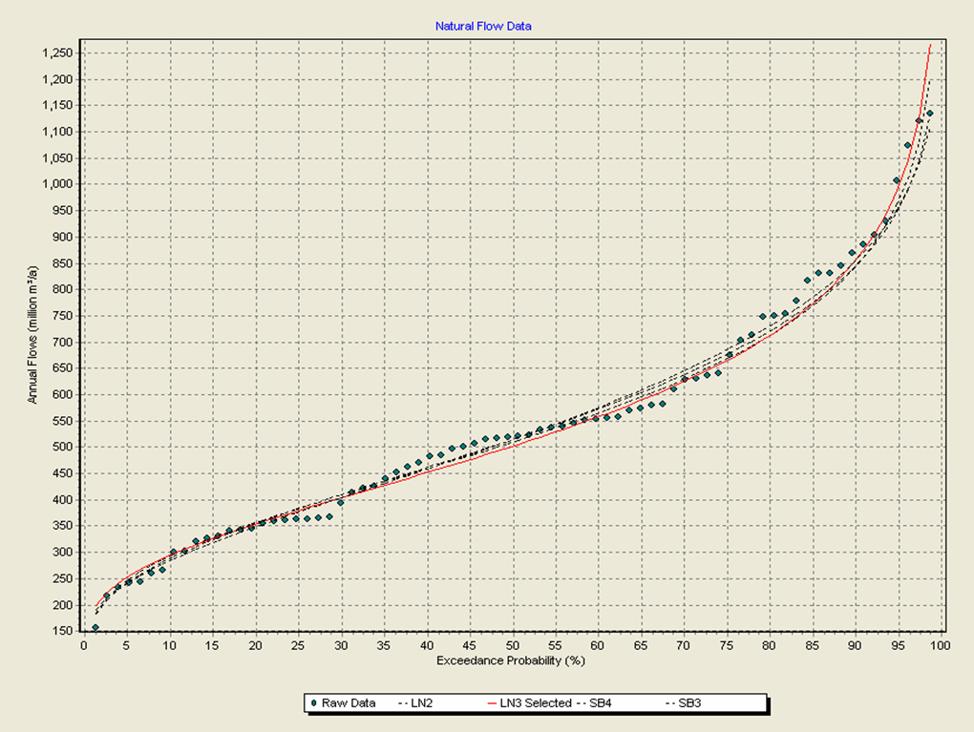
Figure B-1: Marginal distribution of annual streamflows

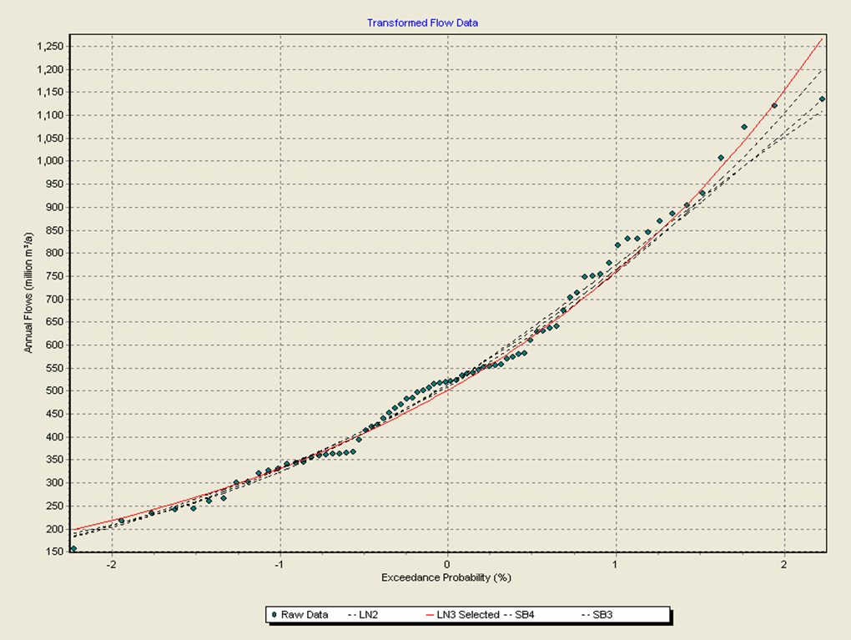
Figure B-2: Marginal distribution of transformed annual streamflows
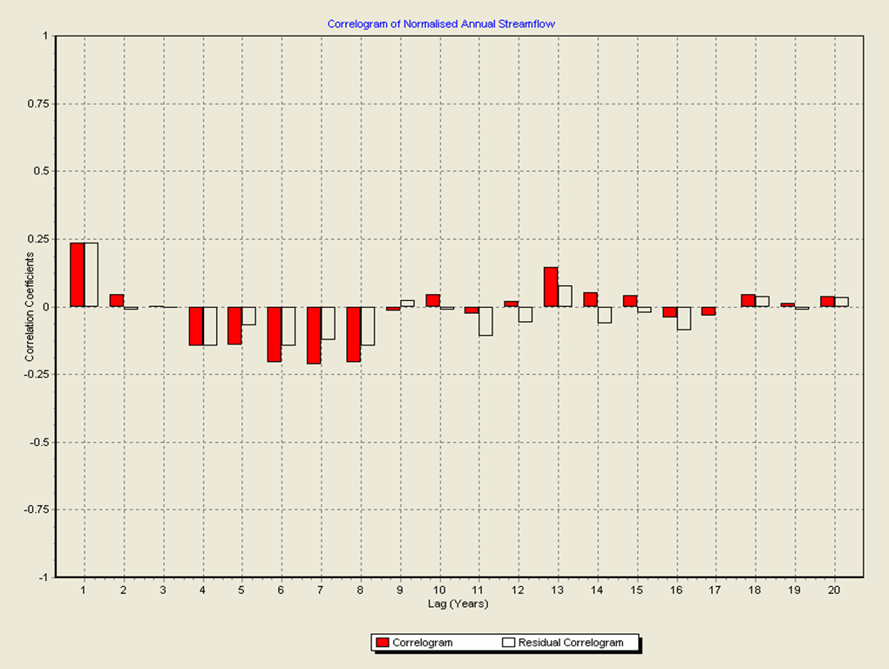
Figure B-3: Correlogram of normalised annual streamflows

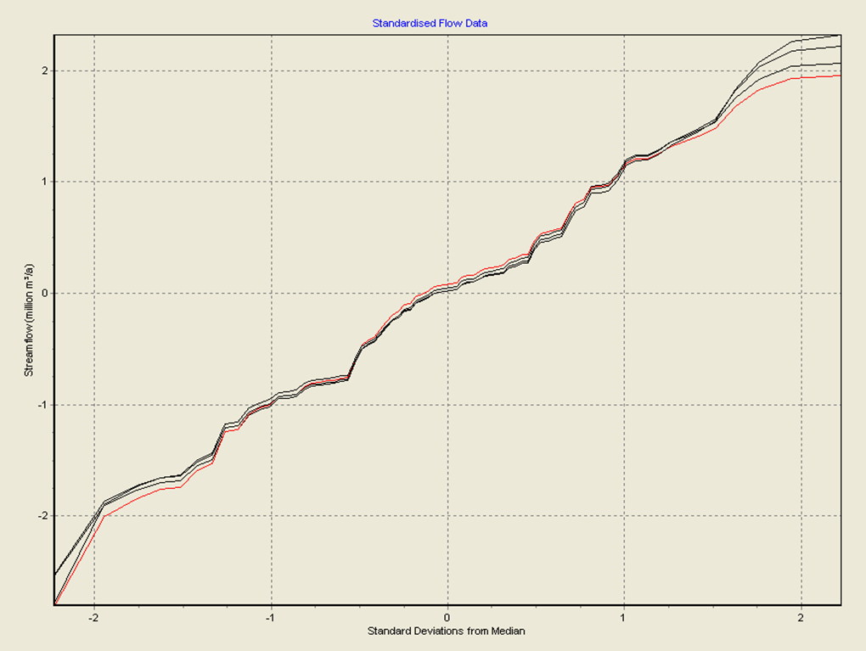
Figure B-4: Marginal distribution of normalised, standardised annual streamflows
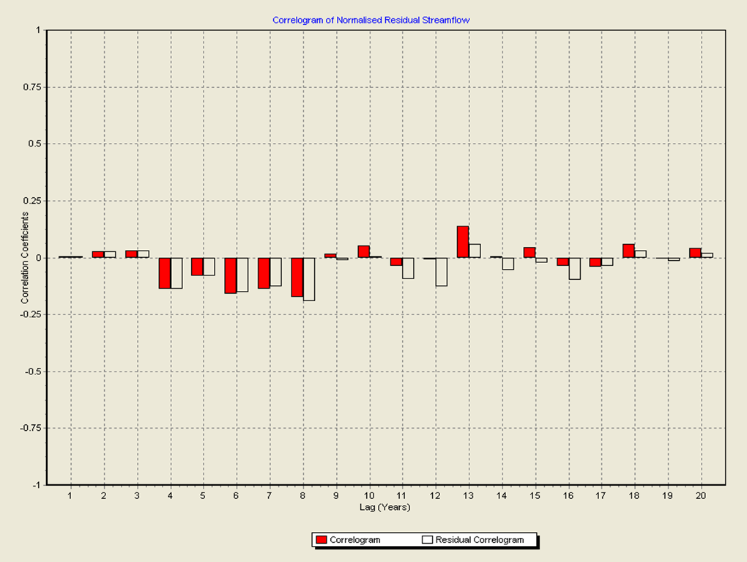
Figure B-5: Correlogram of normalised residual annual streamflows

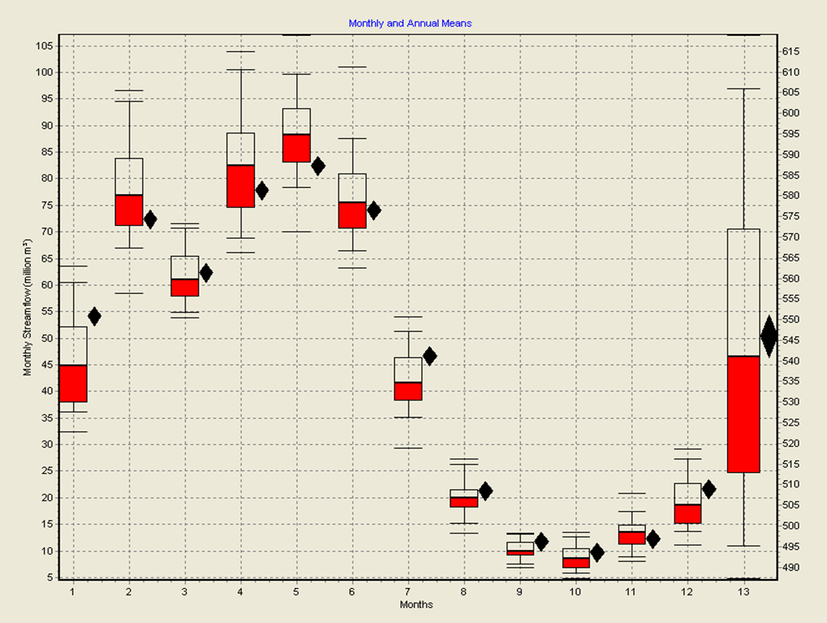
Figure B-6: Plot of monthly and annual means
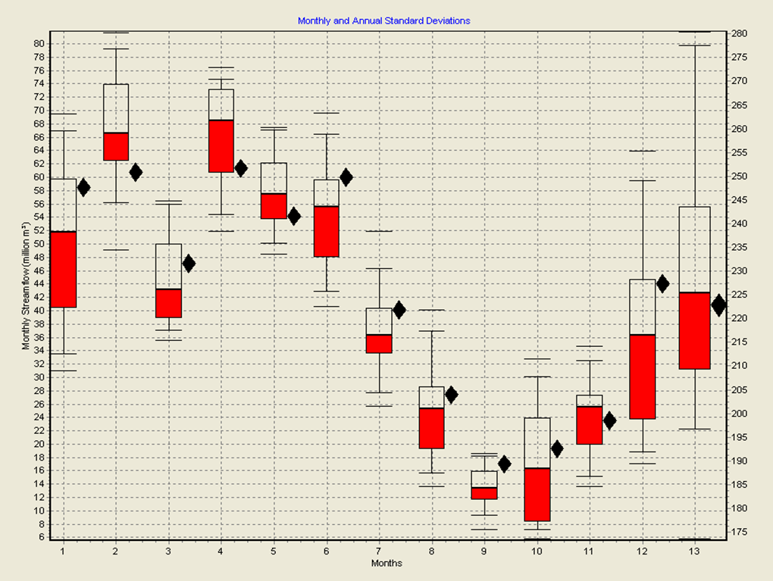
Figure B-7: Plot of monthly and annual standard deviations

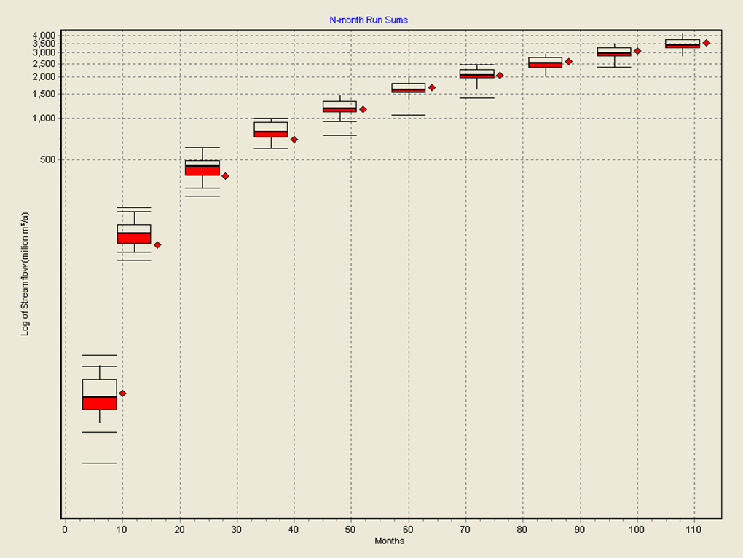
Figure B-8: Plot of minimum run-sums
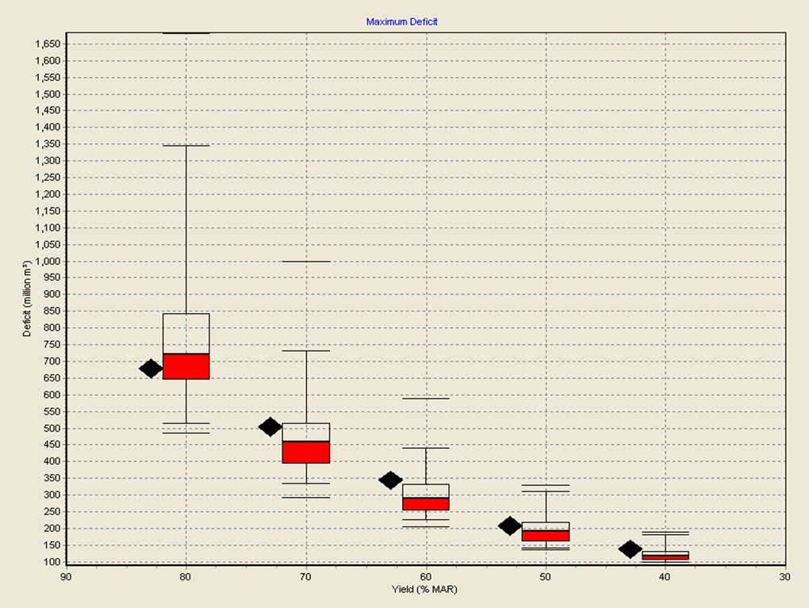
Figure B-9: Plot of maximum deficits

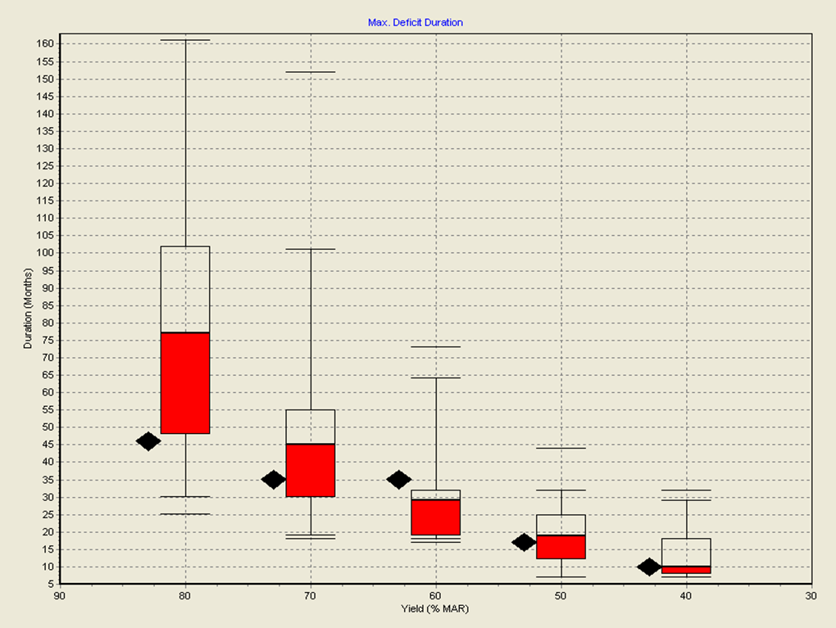
Figure B-10: Plot of maximum deficit durations
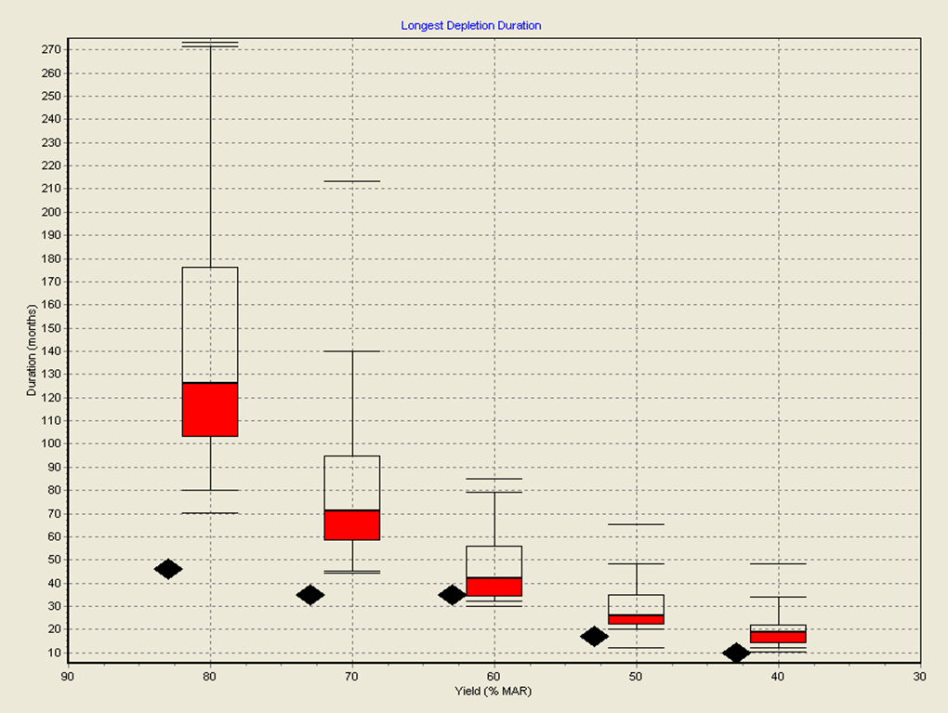
Figure B-11: Plot of longest depletion durations

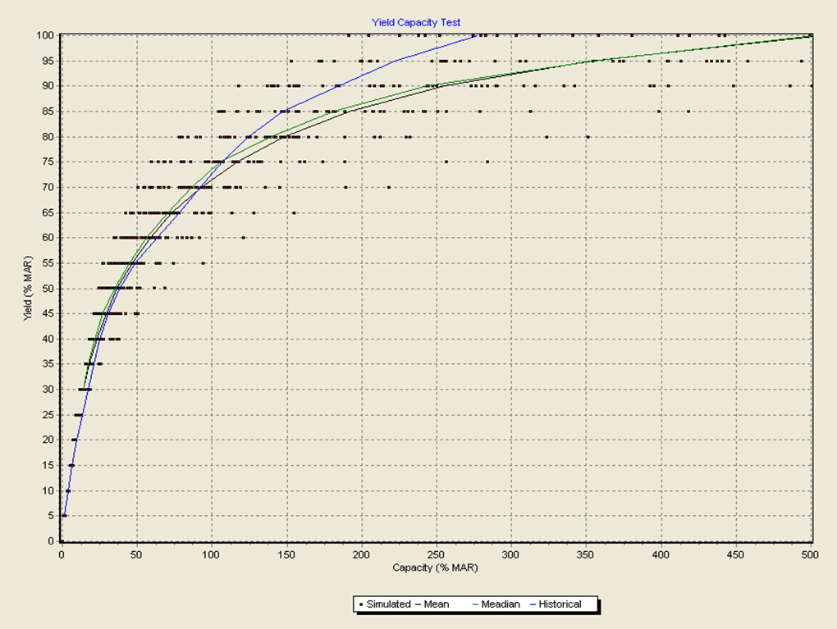
Figure B-12: Plot of yield-capacity relationship
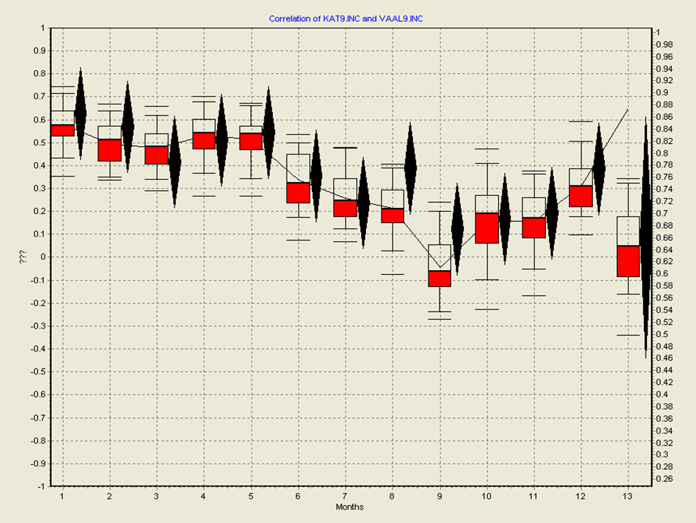
Figure B-13: Plot of annual correlations

