Dams In General
The Dams in General" page is an abstract of a document that was written by Dr Wendy Daniell from the University of Bristol and reviewed by Dr Andy Hughes of Halliburton, Brown and Root for the British Dam Society who has kindly provided permission to contextually change and adopt it for this website.
TYPES OF DAM
A dam is a man made barrier usually built across a river to hold back water and forming a lake, or reservoir, behind it. In South Africa "dam" refers to the barrier and the water behind it, but in may other countries a distinction is made between the two, viz. dam and reservoir respectively referring to the structure and the water body. A dam can be constructed from concrete or natural materials like earth and rock.
These are the main types of dam:
ARCH DAMS
Arch dams are made from concrete. They are curved in the shape of an arch, with the top of the arch pointing back into the water. An arch is a strong shape for resisting the pushing force of the water behind the dam. Arch dams are usually constructed in narrow, steep sided valleys. They need good rock for their foundations, and for the sides of the valleys, to resist the forces on the dam. There are only a few arch dams in the South Africa , including the 186 m high Katse Dam in Lesotho .
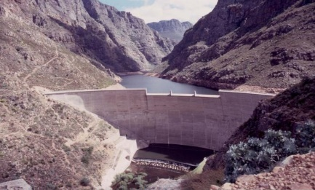
Roode Elsberg Dam, Western Cape Province
BUTTRESS DAMS
Buttress dams are made from concrete or masonry. They have a watertight upstream side supported by triangular shaped walls, called buttresses. The buttresses are spaced at intervals on the downstream side. They resist the force of the reservoir water trying to push the dam over.
The buttress dam was developed from the idea of the gravity dam, except that it uses a lot less material due to the clear spaces between the buttresses. Like gravity dams, they are suited to both narrow and wide valleys, and they must be constructed on sound rock.
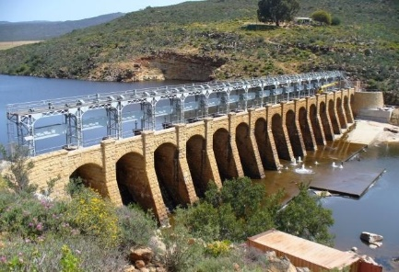
Bulshoek Dam, Western Cape Province
EMBANKMENT DAMS
Embankment dams are made mainly from natural materials. The two main types are earthfill dams and rockfill dams. Earthfill dams are made up mostly from compacted earth, while rockfill dams are made up mainly from dumped and compacted rockfill. The materials are usually excavated or quarried from nearby sites, preferably within the reservoir basin.
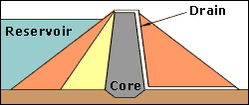
Cross-section of an embankment dam
A cross-section (or slice) through an embankment dam shows that it is shaped like a bank, or hill. Most embankment dams have a central section, called the core, made from an impermeable material to stop water passing through the dam. Clayey soils, concrete or asphaltic concrete can be used for the core.
Rockfill dams are permeable. They can have a core or an impermeable cover on the upstream face. Materials used for the cover include reinforced concrete and asphaltic concrete.
Embankment dams are usually chosen for sites with wide valleys. They can be built on hard rock or softer soils, as they do not exert too much pressure on their foundations.
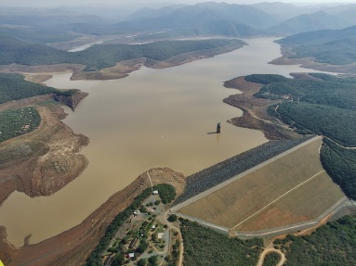
Goedertrouw , Kwazulu-Natal Province
GRAVITY DAMS
A Vanderkloof dam is made from concrete or masonry, or sometimes both. It is called a gravity dam because gravity holds it down to the ground stopping the water in the reservoir pushing it over.
A cross-section (or slice) through a gravity dam will usually look roughly triangular.
Gravity dams are suited to sites with either wide or narrow valleys, but they do need to be built on sound rock.
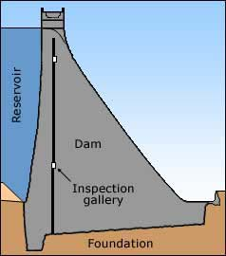
Cross-section of a gravity dam

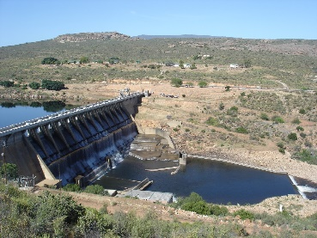
Clanwilliam Dam, Western Cape Province
TAILINGS DAMS
Tailings dams (or slimes dams) store the waste product (usually fine crushed sand, or sometimes power station ash or coal waste), from mining or industrial processes. Although the dam's primary function is to store waste, they also contain and store water from the mining/ industrial process and stormwater.
Some dams can reach heights above ground level of over 100 metres, can cover areas of land up to 1600 hectares, and can receive up to 100,000 tons of waste per day over a period of 20 to 30 years. As such the dams are classified by ICOLD as large dams.
Good examples are the many gold and platinum mine tailings dams (slimes dams) that are always visually prominent in South Africa.
Because of their size, potential hazard classification and environmental sensitivity, the design of tailings dams is well regulated in South Africa, has become an advanced sector of dam engineering and is always undertaken by specialised engineers and environmental scientists.
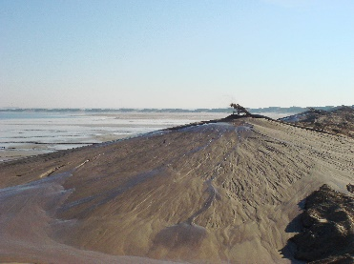

Tailings Dam
USES OF DAMS
For centuries, the world's water resources have been developed to benefit mankind. The construction of dams to create reservoirs has served many purposes.
These are some common uses for reservoirs:
WATER SUPPLY
Reservoir water can be used to supply water to our homes and factories. Reservoirs are designed to store the rain that falls during the wetter parts of the year, so that there is a continuous supply of water for the drier periods. They are also used to regulate the flow of water in rivers. Water can be released from the reservoir during drier seasons to support wildlife and the environment downstream, and to provide a resource for human uses.
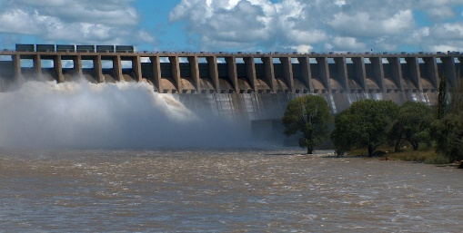
Vaal Dam, Gauteng Province
HYDROELECTRIC POWER
Reservoirs can be used to store water to feed hydroelectric power stations. Hydroelectric power is generated by using the energy from falling water to drive water turbines that in turn drive electric generators. The reservoir water is stored at a higher level than the turbines, which are housed in a power station. Sometimes, the power station is directly in front of a dam, and pipes through the dam feed water directly to the turbines. In other cases, the power station is some distance downhill from the reservoir, and the water is fed to it through long pipes or tunnels called penstocks.
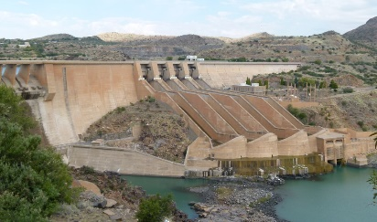
Van derKloof Dam, Free State Province
FLOOD CONTROL
Water from snow and rainfall will find its way into streams and rivers and eventually into the sea. After severe storms, or heavy snow or rain over a number of days, the water level in rivers can rise dramatically. Sometimes, the water flows over riverbanks or walls causing flooding of farmland, property, and in the worst cases, loss of life.
A reservoir can be used to control the amount of water flowing in a river after heavy rain. The water level in the reservoir is kept low during the rainier periods of the year. When heavy rain occurs, it is stopped by the dam and held back in the reservoir, but this is only possible for small to medium size floods. Large floods will quickly fill the reservoir; the rest of the incoming floodwater will then be passed downstream into the river. The facility to pass the water safely over or through the dam is called the spillway.
Sometimes, floodgates are used on top of spillways, and they can be fully or partly opened to control the amount of water let out into the river downstream.
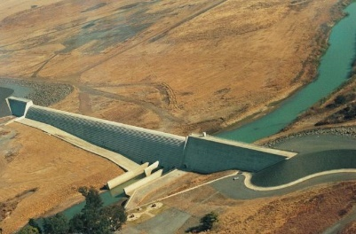
Quedisizi , Kwazulu-Natal Province
IRRIGATION
Plants will grow naturally on fertile soil that is watered by rain. However, in regions of the world where the climate is very dry for some seasons, the soil becomes so dry that it restricts the growth of vegetation. This problem can be overcome by irrigation, a man-made system for watering the land.
Irrigation water can be stored in reservoirs during the rainy season, then in the drier seasons it can be released from the reservoir and distributed over the land through a system of canals. Usually, the water flows under the influence of gravity to the areas requiring it, or the water can be pumped out of the canals onto the land.
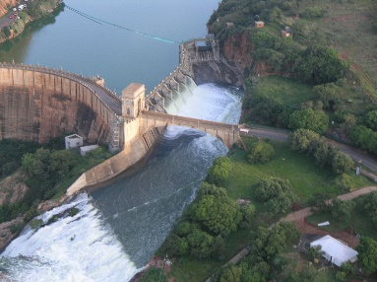
Hartbeespoort Dam, North West Province
NAVIGATION
The construction of a dam across a river forms a reservoir that raises the water level upstream, stores the water, and slows down its rate of flow. This improves the navigation conditions upstream of the dam for ships and boats. Dangerous areas of rocks and sandbanks, previously in shallow water, become well covered, and rapids in the river disappear. Also, water from the reservoir can be released into the river downstream during the drier seasons of the year to make sure that it is deep enough for navigation all the year round. None of South Africa 's are navigable.
IMPACT OF DAMS
Reservoirs are created to provide a benefit to people. However, the flooding, or inundation, of land and the management of the reservoir water can have an unfavourable effect on people, the wildlife and the environment, not only in and around the valley, but also downstream of the dam. The disadvantages of creating a new reservoir should be considered during the planning stages. Suitable methods should be decided upon to eliminate or reduce the disadvantages, so that the reservoir provides an overall benefit to people. These are some of the issues that are considered:
PEOPLE
People and their livelihoods are affected when the areas where they live and work are inundated by a reservoir. For some large reservoirs, tens of thousands of people have had to leave their homes and set up elsewhere. In the past, many of these people have not been given adequate compensation for their losses, and some have not even been given new places to live. Also, existing communities have been broken up and moved to different areas.
Some people made their living from farming the land or fishing from the river. Many of them suffered when they were relocated, as they were not given new land to work and were too far from a river to fish. They needed different skills to get another job and training was not always provided.
These days, authorities are becoming more aware of these issues. Resettlement plans have been developed to minimise the disruption and suffering caused to people in the reservoir area. Good plans make sure that fair compensation and employment opportunities are provided for all people, and that the law protects their rights. In some cases, efforts have been made to resettle people in their communities.
PLANTS AND ANIMALS
Dams are often constructed across rivers to store water that would naturally find its way to the lower reaches of the river and into the sea. The presence of the dam upsets the natural balance of the river, affecting the animal and plant life in and around it. These are some of the reasons. Upstream of the dam, the river is flooded and becomes a reservoir. The nature of the river flow downstream is changed. The dam can hold back sediment that normally finds its way downstream.
When the river valley is inundated with water, animals are forced to leave the area and plants and trees are killed. Sometimes, rare species can be affected.
For some large reservoir projects, nature reserves have been created. Plants and trees have been replanted in them and some of the affected animals have been moved there. However, the reserves can only be really successful when careful thought has been given to the way that the plants and animals depend on each other and their environment.
A dam across a river can form a barrier to fish that migrate, such as salmon. Fish passes can be included in the design of a dam to allow adult fish to swim upstream to spawn, and back downstream later with their young. Fish passes usually take the form of a fish ladder or a fish lock. These fish passes have to be designed very carefully to make sure that the conditions are right for the fish to use them.
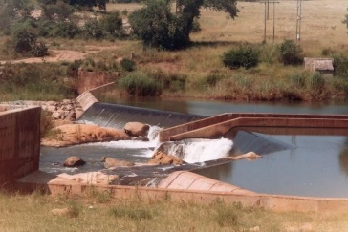
Fish ladder at Hoxani Weir, Limpopo Province
SEDIMENTATION
Rivers carry sediment. When a river enters a reservoir, the speed of the flowing water slows down and sediment can be deposited on the reservoir bed. Over a number of years, the sediment in the reservoir can build up, and reduce the space available for storing water. Some of the sediment held back in the reservoir would normally be carried downstream. If too much sediment is stored, the natural balance of the river downstream can be changed, affecting people, wildlife and plants as far away as the river estuary.
Farming land, used for growing crops, can be deprived of silt and its nutrients that are normally deposited when the river floods. Nutrients are important for fertilising the soil.
When designing a dam, the quantity of sediment that will flow into the reservoir has to be considered. The reservoir is designed to reduce the amount of sediment deposited, and to maximise the sediment flow downstream.
The flow of water carrying the sediment can be controlled by carefully positioning spillways and outlet pipes and tunnels. Sometimes sediment is allowed to build up in the reservoir. Then periodically, it is removed. This can be done by letting water out of the reservoir through outlets at the bottom of the dam, so that the sediment gets flushed out. Sometimes dredging is used for small reservoirs, but this is an expensive operation.
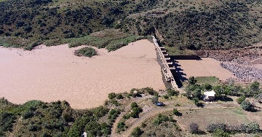
Sedimentation in Welbedacht Dam, Free State Province
WATER QUALITY
The quality of water can deteriorate when it is stored in a reservoir.
River water contains dissolved oxygen. Sufficient dissolved oxygen is needed to maintain aquatic animal and plant life, and to prevent some types of chemical reactions that form unwanted pollution in the water.
There are many factors that can reduce oxygen levels in a reservoir, for example, organic material in the water can use up oxygen as it decomposes (or rots). The depth of the water, its temperature and its flow can also affect the oxygen levels.
The type of land that is inundated by a reservoir may affect the water quality. Pesticides from farmland and toxic materials from industrial land can pollute the water. Also, the streams and rivers flowing into the reservoir may be carrying pollutants.
The designers of a reservoir have to consider whether any of these factors will have a significant effect on the quality of the water and whether they have to include special measures to offset any problems that could occur.
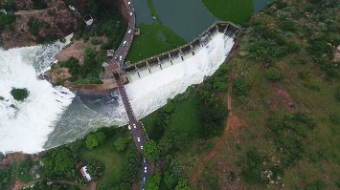
Water Hyacinth at Hartbeespoort Dam, North West Province
HISTORICAL SITES
Throughout history, people have settled and built their communities in river valleys. This means that many of the world's archaeological sites and historical buildings and monuments can be found in these areas. Often they include sacred buildings such as churches and temples and their burial sites, which can be of great value to the local inhabitants. Such heritage can be lost forever when a valley is inundated with water to create a reservoir.
In the past, there have been dam projects where no efforts have been made to explore or save any of the local heritages. More recently, special measures have been taken on some projects. They have included:
- Relocation of burial sites.
- Redesign of dams, to minimise the losses.
- The dismantling, relocation and re-erection of ancient monuments.
- Intensive archaeological investigations at sites believed to have been inhabited by ancient civilisations, before dam construction proceeds.

