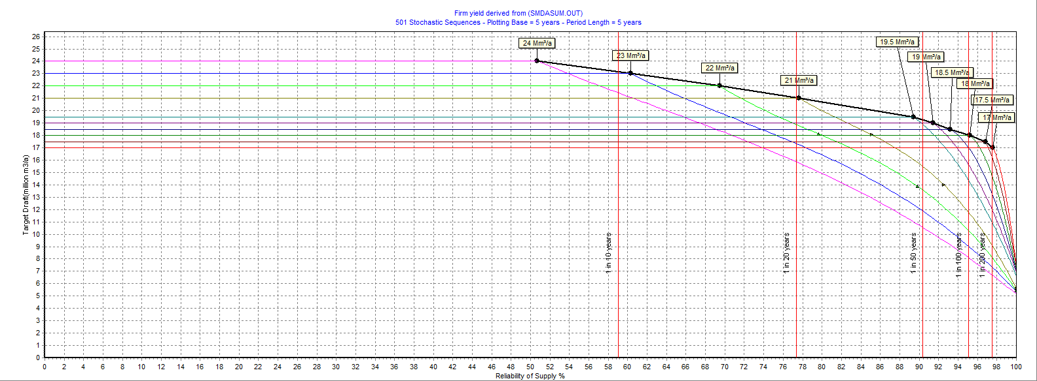

**Figure C-1: 100% starting storage short term curve: Fika Patso Dam**

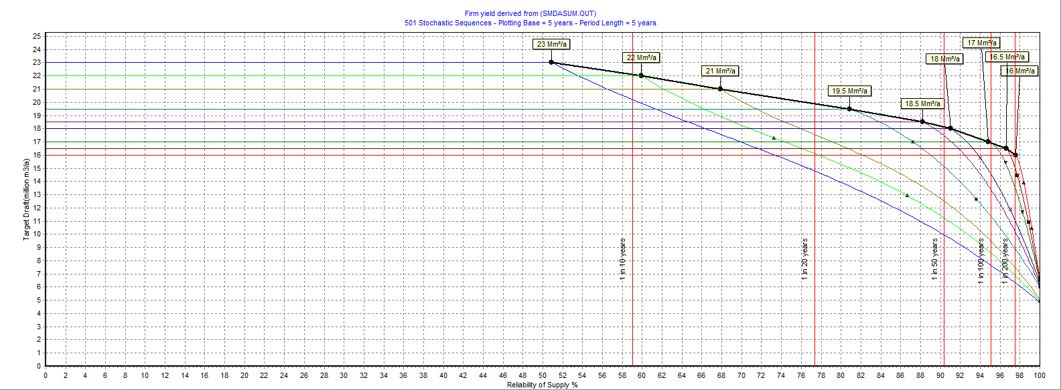

**Figure C-2: 80% starting storage short term curve: Fika Patso Dam**

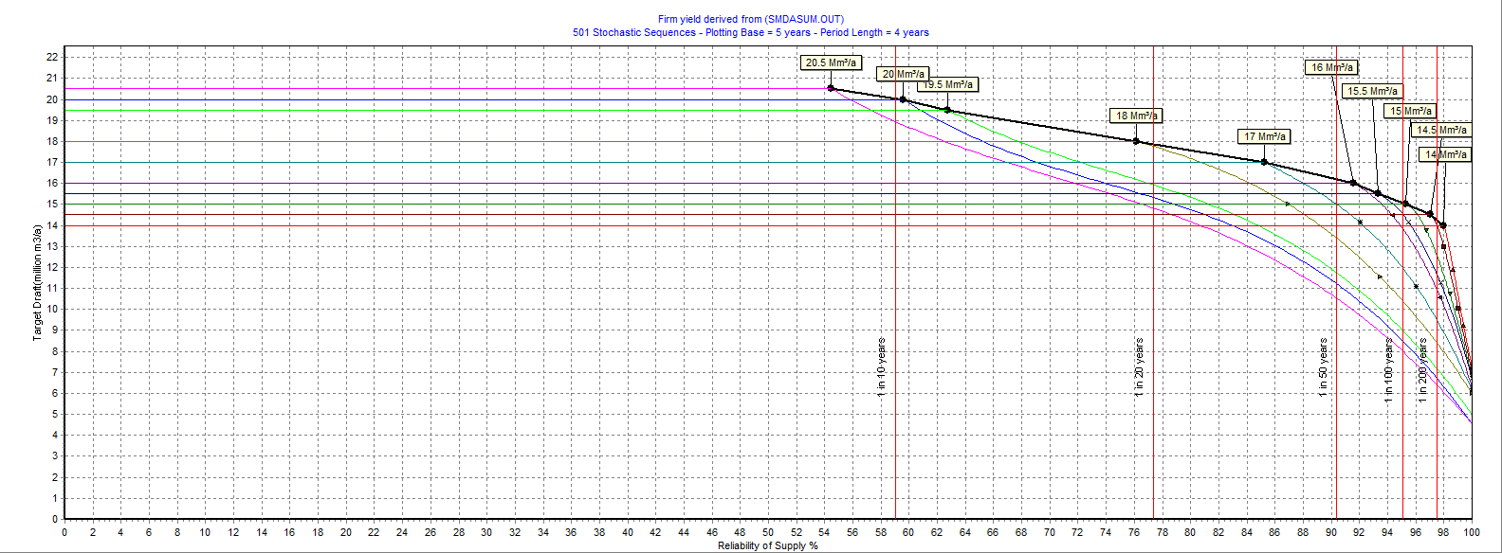

**Figure C-3: 60% starting storage short term curve: Fika Patso Dam**

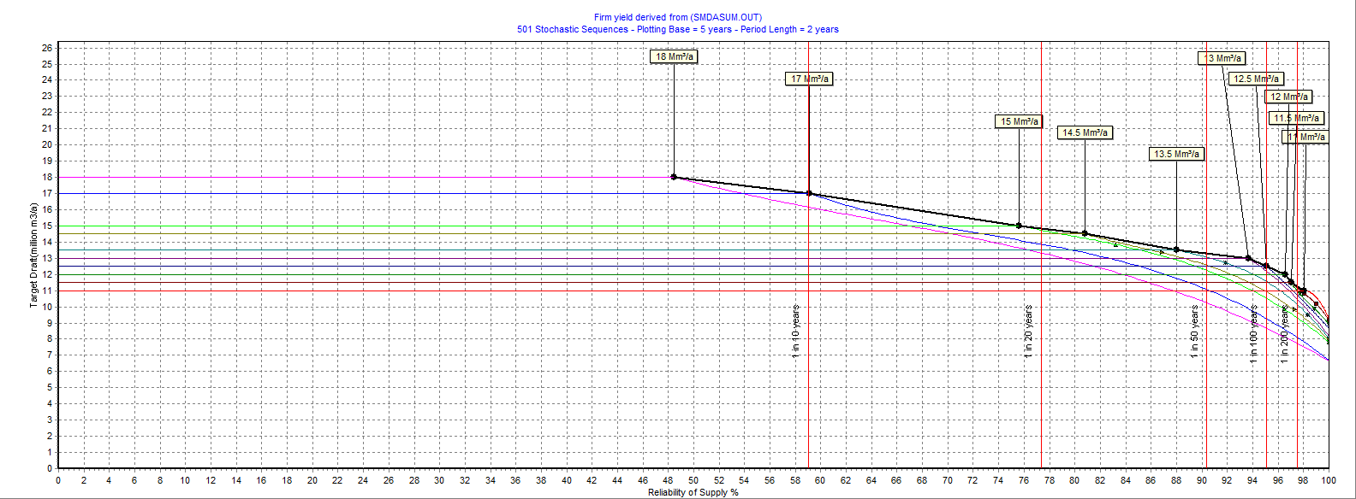

**Figure C-4: 40% starting storage short term curve: Fika Patso Dam**

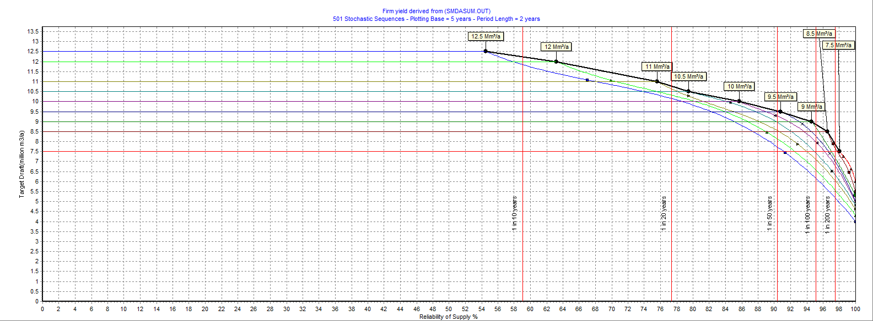

**Figure C-5: 20% starting storage short term curve: Fika Patso Dam**

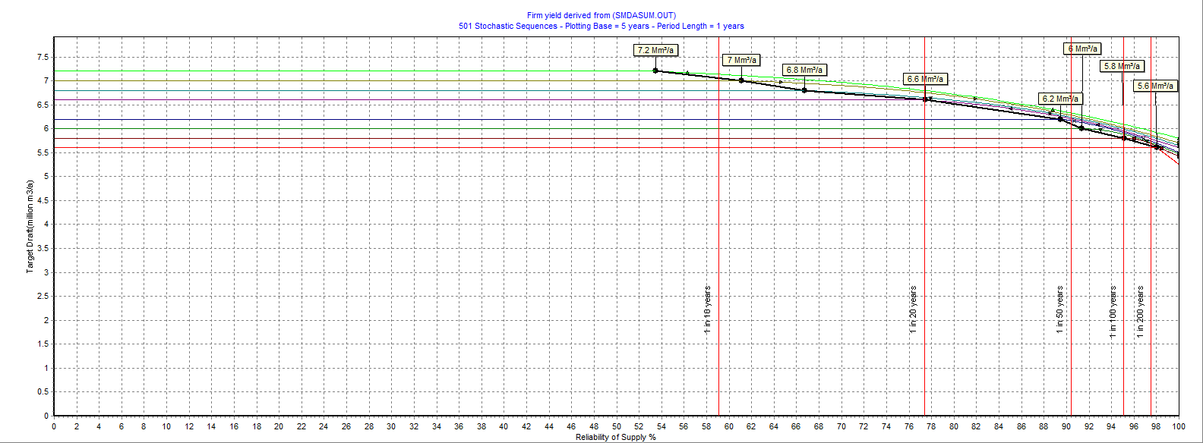

**Figure C-6: 10% starting storage short term curve: Fika Patso Dam**