**<http://www.nature.com/articles/nature06045>**

**Projected increase in continental runoff due to plant responses to increasing carbon dioxide**

* [Richard A. Betts](http://www.nature.com/articles/nature06045#auth-1)[1](http://www.nature.com/articles/nature06045#a1)
* , [Olivier Boucher](http://www.nature.com/articles/nature06045#auth-2)[1](http://www.nature.com/articles/nature06045#a1)
* , [Matthew Collins](http://www.nature.com/articles/nature06045#auth-3)[1](http://www.nature.com/articles/nature06045#a1)
* , [Peter M. Cox](http://www.nature.com/articles/nature06045#auth-4)[1](http://www.nature.com/articles/nature06045#a1), [2](http://www.nature.com/articles/nature06045#a2)
* , [Peter D. Falloon](http://www.nature.com/articles/nature06045#auth-5)[1](http://www.nature.com/articles/nature06045#a1)
* , [Nicola Gedney](http://www.nature.com/articles/nature06045#auth-6)[3](http://www.nature.com/articles/nature06045#a3)
* , [Deborah L. Hemming](http://www.nature.com/articles/nature06045#auth-7)[1](http://www.nature.com/articles/nature06045#a1)
* , [Chris Huntingford](http://www.nature.com/articles/nature06045#auth-8)[4](http://www.nature.com/articles/nature06045#a4)
* , [Chris D. Jones](http://www.nature.com/articles/nature06045#auth-9)[1](http://www.nature.com/articles/nature06045#a1)
* , [David M. H. Sexton](http://www.nature.com/articles/nature06045#auth-10)[1](http://www.nature.com/articles/nature06045#a1)
* [[…]](javascript:;)
* & [Mark J. Webb](http://www.nature.com/articles/nature06045#auth-11)[1](http://www.nature.com/articles/nature06045#a1)
* [- Show fewer authors](javascript:;)

*Nature* **volume 448**, pages 1037–1041 (30 August 2007) | [Download Citation](http://www.nature.com/articles/nature06045.ris)

**Subjects**

**Abstract**

In addition to influencing climatic conditions directly through radiative forcing, increasing carbon dioxide concentration influences the climate system through its effects on plant physiology[1](http://www.nature.com/articles/nature06045#ref1). Plant stomata generally open less widely under increased carbon dioxide concentration[2](http://www.nature.com/articles/nature06045#ref2), which reduces transpiration[1](http://www.nature.com/articles/nature06045#ref1),[3](http://www.nature.com/articles/nature06045#ref3),[4](http://www.nature.com/articles/nature06045#ref4),[5](http://www.nature.com/articles/nature06045#ref5),[6](http://www.nature.com/articles/nature06045#ref6) and thus leaves more water at the land surface[7](http://www.nature.com/articles/nature06045#ref7). This driver of change in the climate system, which we term ‘physiological forcing’, has been detected in observational records of increasing average continental runoff over the twentieth century[8](http://www.nature.com/articles/nature06045#ref8). Here we use an ensemble of experiments with a global climate model that includes a vegetation component to assess the contribution of physiological forcing to future changes in continental runoff, in the context of uncertainties in future precipitation. We find that the physiological effect of doubled carbon dioxide concentrations on plant transpiration increases simulated global mean runoff by 6 per cent relative to pre-industrial levels; an increase that is comparable to that simulated in response to radiatively forced climate change (11 ± 6 per cent). Assessments of the effect of increasing carbon dioxide concentrations on the hydrological cycle that only consider radiative forcing[9](http://www.nature.com/articles/nature06045#ref9),[10](http://www.nature.com/articles/nature06045#ref10),[11](http://www.nature.com/articles/nature06045#ref11) will therefore tend to underestimate future increases in runoff and overestimate decreases. This suggests that freshwater resources may be less limited than previously assumed under scenarios of future global warming, although there is still an increased risk of drought. Moreover, our results highlight that the practice of assessing the climate-forcing potential of all greenhouse gases in terms of their radiative forcing potential relative to carbon dioxide does not accurately reflect the relative effects of different greenhouse gases on freshwater resources.

<ftp://ftp.ncdc.noaa.gov/pub/data/sds/cdr/abstracts/2010/kato.pdf>

Need to download:

<http://rnd.zednet.co.za/WRP_Marketing/Papers/2018/19th_SANCIAHS/Papers&ExtendedAbastracts/Pitman_Droughts%20in%20Kruger%20Park.pdf>

**DROUGHTS IN THE KRUGER NATIONAL PARK – ARE THEY GETTING WORSE**[**?**](http://rnd.zednet.co.za/WRP_Marketing/Papers/2018/19th_SANCIAHS/Papers&ExtendedAbastracts/)

<http://adsabs.harvard.edu/abs/2004AGUSM.A12A..05P>

# Trends in Solar Radiation Over South Africa and Namibia During the Period 1957-1997.

[Power, H. C.](http://adsabs.harvard.edu/cgi-bin/author_form?author=Power,+H&fullauthor=Power,%20H.%20C.&charset=ISO-8859-1&db_key=PHY); [Mills, D. M.](http://adsabs.harvard.edu/cgi-bin/author_form?author=Mills,+D&fullauthor=Mills,%20D.%20M.&charset=ISO-8859-1&db_key=PHY)

American Geophysical Union, Spring Meeting 2004, abstract id. A12A-05

Spatial and temporal variability in global, diffuse, and horizontal direct irradiance and sunshine duration has been evaluated at ten stations in South Africa and two stations in Namibia where the time series range between 21 and 41 years. Global and direct irradiance and sunshine duration decrease from northwest to southeast; diffuse irradiance increases toward the east. Annually-averaged global irradiance (Ga) increased significantly by 0.46% per decade at Pretoria and decreased between 1.26% and 1.72% per decade at Bloemfontein, Cape Town, Durban, and Upington. Annually-averaged diffuse irradiance (Da) decreased 5.20% per decade at Grootfontein and increased 2.51% per decade at Port Elizabeth. Annual direct irradiance (Ba) decreased 2.10% per decade at Cape Town and 2.83% per decade at Alexander Bay. A simultaneous decrease in annually-averaged daily sunshine duration (Sa) may have contributed to the decrease in Ba at Alexander Bay. Increases in aerosols may have contributed to the observed decrease in Ga at Cape Town and Durban, while the decrease in Da at Grootfontein may be due to a decrease in aerosols. On average, variability in Sa explains 53.8%, 30.4%, and 48.8% of the variance in Ga, Da, and Ba, respectively. The radiative response to changes in sunshine duration is greater for direct irradiance than for global and diffuse. In the two years following the 1963 Mount Agung eruption in Indonesia, responses in global were small and inconsistent. At eight stations, diffuse irradiance increased 22.80% on average and direct irradiance decreased 8.93%. After the 1982 El Chichon eruption in Mexico, global irradiance increased at two stations and decreased at seven stations. Eight stations witnessed an increase in diffuse averaging 7.20% and an average decrease in direct of 4.96%. Following the 1991 Mount Pinatubo eruption in the Philippines, diffuse irradiance increased an average of 19.20% at three stations and direct decreased by 7.57%.

<http://www.scielo.org.za/scielo.php?script=sci_arttext&pid=S1021-447X2017000200005>

**Is the summer season losing potential for solar energy applications in South Africa?**

**Jyotsna SinghI,** [**\***](http://www.scielo.org.za/scielo.php?script=sci_arttext&pid=S1021-447X2017000200005#back)**; Andries KrugerI, II**

ISouth African Weather Service, 442 Rigel Avenue South, Erasmusrand, Pretoria 0181, South Africa   
IIDepartment of Geography, Geoinformatics and Meteorology, University of Pretoria, Private Bag X20, Hatfield 0028, Pretoria, South Africa

**ABSTRACT**

Seasonal trends using in situ sunshine duration (SD) and satellite, incoming shortwave solar radiation (SIS) data for South Africa over a period up to six decades were investigated. Trend analysis was applied to SD data of 22 sunshine-recording stations from the South African Weather Service that cover the length and breadth of South Africa. Satellite application facility on climate monitoring provided the high-resolution derived SIS for the period 1983-2013. A number of stations show a statistically significant decreasing trend in SD in all four seasons on a seasonal scale. Declines (number of stations showing significant trend) in SD at 17(7), 8(3), 7(3) and 3(0) stations, were observed for summer, autumn, winter and spring, respectively. The SIS has also shown a decreasing trend over South Africa in most of the regions during the summer season followed by autumn. The results indicated a general tendency of decrease in incoming solar radiation mostly during summer which could be of some concern for solar energy applications.

**Keywords**: in situ data, sunshine duration, shortwave solar radiation, satellite data, climate trends, solar energy

**1. Introduction**

Solar radiation data analyses across the world revealed that there was a decline in solar radiation from the 1950s to the 1990s (Singh et al., 2016; Wild, 2009). In South Africa also, studies by Singh, 2016 (1980s to 2000s) and Power and Mills, 2004 (1957 to 1997) indicated a decline in solar radiation. Air pollutants like atmospheric aerosols were considered to be one of the main reasons for this decline (Streets et al., 2006). Air pollution is one form of environmental pollution that is arguably the greatest problem the world is currently facing. The use of fossil fuels makes a paramount contribution to environmental pollution, including in South Africa, and many countries are now focusing on cleaner energy resources, in an endeavour to solve the issues of environmental pollution. South Africa showed a 37% increase in renewable energy consumption from 1990 to 2010, but the consumption of renewables was higher in some other African countries in 2010 (Nakumuryango and Inglesi-Lotz, 2016).

Research and development in the field of renewable energy will help to find ways of increasing renewable energy consumption. Dresselhaus and Thomas (2001) explained the alternative energy technologies that can be used to meet the world's energy demand. Solar energy is a freely available energy resource, and indirectly the source for all the other types of energy (e.g. wind, hydro and biomass energy) on earth. Most solar energy-related studies require three solar radiation parameters: global horizontal irradiance (GHI), direct normal irradiance (DNI) and diffuse horizontal irradiance (DHI) (Gauché et al., 2017; Martin-Pomares et al., 2017; Perez-Astudillo and Bachour, 2014). Different types of radiometric instruments - such as pyra-nometers for GHI, pyrheliometers for DNI and shaded ring pyranometers for DHI - are needed to measure different types of irradiances. These instruments are expensive, making it not feasible to install all of them at many locations to develop a dense radiometric network. The network for measuring the duration of sunshine is, however, dense compared with GHI, DNI and DHI. There are long established sunshine duration (SD) measurement activities across the world (Sanchez-Romero et al, 2015). The data availability for SD is also better than for GHI, DNI and DHI in South Africa because simpler and less expensive instruments are used for measuring it.

The SD (also known as the sunshine hour or bright sunshine hour) is a measure of the duration of sunshine for that day. The device (sunshine recorder) for measuring sunshine hours is simple (more details in Section 2), but useful information can be generated from the data and can be employed in many areas of research. This data has been used in several studies, including for air quality (Sanchez-Romero et al, 2016; Li et al., 2016); environmental pollution (Kaiser and Qian, 2002; Statheropoulos et al., 1998); energy (Yaiche et al., 2014); and solar radiation prediction modelling studies (Mulaudzi et al., 2015; Adeyemi et al., 2015; Singh et al, 2011). The sunshine hour of any day is affected by varying atmospheric and sky conditions, so SD can, therefore, indirectly indicate atmospheric turbidity, visibility and sky conditions.

There is a relatively dense network of *in situ* SD observation points over South Africa. Satellite data is, however, always a better option when it comes to spatial coverage (Rees, 2013; Bojanowski et al., 2014; Singh, 2016). Various issues related to satellite data, like low temporal resolution compared to the *in situ* data must nonetheless be taken into account. Where both *in situ* and satellite data are available, it is advisable to use both to extract the most possible information. The satellite application facility (SAF) on climate monitoring (CM), CM-SAF produced the surface solar radiation dataset -Heliostat (SARAH); which provides a useful high-resolution data set of incoming surface shortwave (SIS) for solar radiation studies. The use of this data set has become popular in the scientific community (Ruiz-Arias et al., 2016, Trentmann et al., 2016; Badescu and Dumitrescu, 2013). The present study aims to assess long-term trends in SD and change detection using SIS over South Africa on a seasonal scale. The datasets and periods used in the analyses are explained in detail.

***2. Study region and datasets***

The present study has been conducted over the country using *in situ* SD observation data (22 stations) from the South African Weather Service (SAWS) and SARAH SIS satellite data set from CM-SAF. The SAWS has a dense network of SD stations, most of which have measurements from 1950 onwards. The selected 22 stations cover all nine provinces of South Africa, as shown in [Figure 1](http://www.scielo.org.za/img/revistas/jesa/v28n2/05f01.jpg). The long-term SD dataset is required for trend analysis studies. The Campbell-Stokes sunshine recorder, invented in the late nineteenth century (Sanchez-Romero et al., 2015), was the only instrument that SAWS used to measure the sunshine.

This instrument allows SD to be determined by calculating the burn mark made by the sun on a specially coated card. It also indicates times or periods of cloudiness and solar irradiance along with SD (Wood and Harrison, 2011; Stanhill, 2003).

The time series produced from the measured data can be regarded as homogeneous if the instrument was continuously well-exposed during the station's history. Many stations that could otherwise have been used in the study had large gaps in their time series, while most stations have data only since around 1978. The 22 selected stations are given in [Table 1](http://www.scielo.org.za/img/revistas/jesa/v28n2/05t1.jpg), together with the analysis periods, from various start dates up to the end of 2014. Relevant climatic regions of the stations are also given, with many in arid or semiarid environments (Kruger, 2004).

The SIS or global radiation was derived from the long-term EUMETSAT CMSAF a European Union-based initiative to produce high-quality satellite-derived data and services for climate monitoring (Müller et al., 2015). The SARAH dataset comprises derived global solar surface radiation with a resolution of 0.05° x 0.05° for the period 1983-2013 (Müller et al., 2015).

**3. Methodology**

This investigation focuses on SD and SIS trends in different seasons. The SD data used goes back to 1951 and was minutely analysed for quality assurance.

***3.1 Data quality***

Only those years were used for the trend analysis where percentage SD data availability was more than 90%. The SD data was checked carefully and all the impossible SD values were removed, e.g., the days where more hours are reported than the maximum possible SD. False zeros were also removed, thus ensuring quality SD data before trend analyses.

***3.2 Trend analysis***

Trend analysis was performed on the quality checked SD data on a seasonal scale - summer: December, January and February (DJF); autumn: March, April, and May (MAM); winter: June, July, and August (JJA); and spring: September, October, and November (SON). The significance of the linear trend was tested using the t-test at the 5% level of significance and the change detection method was used on SIS datasets. The differences in attributes, processes, and phenomena over different time periods in the change detection method were examined.

The SIS dataset (1983-2013) was subsequently divided into two groups of almost equal periods, (i) 1983-1997 and (ii) 1998-2013. The detection of the change between the two data groups was achieved by subtracting the mean of (i) from (ii).

**4. Results and discussion**

There was, in most cases, a broad agreement between the seasonal SD and SIS data. [Figure 2](http://www.scielo.org.za/img/revistas/jesa/v28n2/05f02.jpg) illustrates, per season, the differences in the average global solar radiation/SIS received between the periods 1983-1997 and 1998-2013 from the CM-SAF SARAH data. [Table 2](http://www.scielo.org.za/img/revistas/jesa/v28n2/05t2.jpg) presents the results of linear trends of the daily sunshine hours received per season for the periods from the start year (as indicated in [Table 1](http://www.scielo.org.za/img/revistas/jesa/v28n2/05t1.jpg)) to 2014.

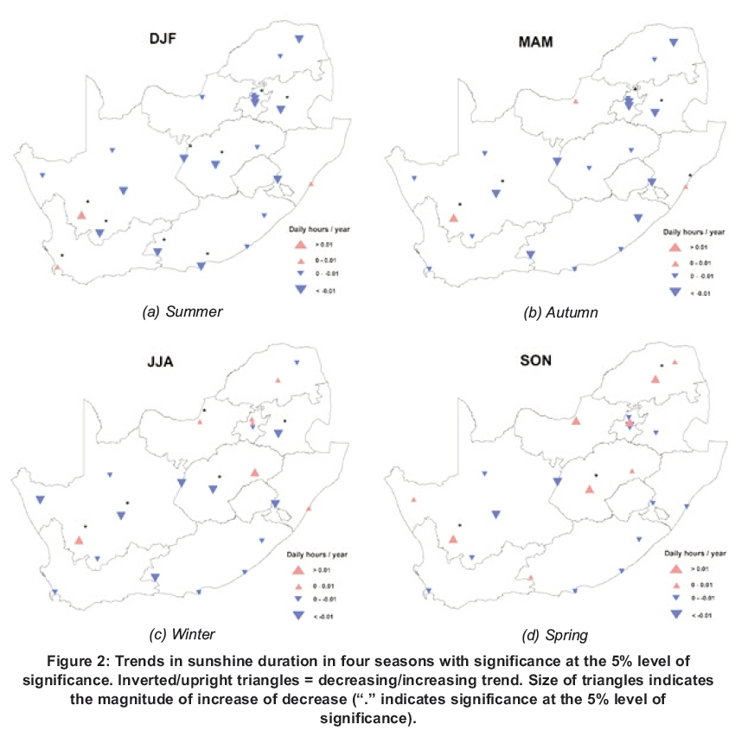

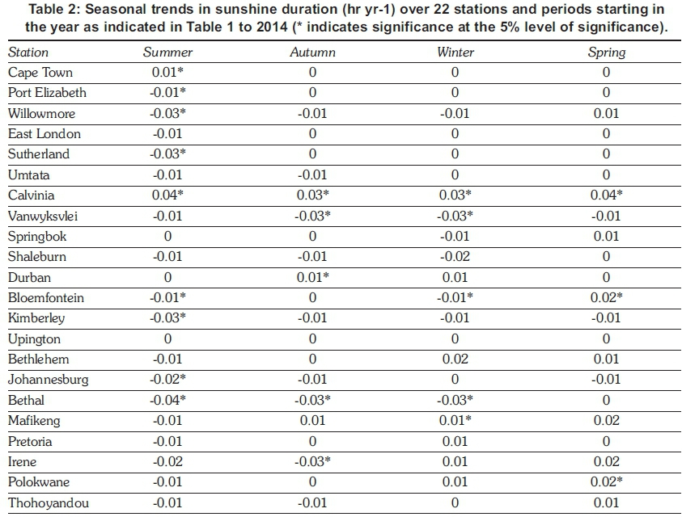

***4.1 Trends in SD***

Significant trends at 5% level of significance (p<0.05) are marked by an asterisk in [Table 2](http://www.scielo.org.za/img/revistas/jesa/v28n2/05t2.jpg). Kimberley and Vanwyksvlei in the Northern Cape Province were the only two out of the 22 stations that showed declining trends in all seasons.

The decline in SD at Kimberley in all the seasons was possibly because of the mining in this area, as mining activities release air pollutants that interact with the incoming solar radiation. No trend was observed at Upington over all the seasons. It was noted that Calvinia, on the other hand, was the only station where a significant increase in SD occurred in all seasons. Calvinia is a sparsely populated regional town in Northern Cape Province with little industrial activity. The Eastern Cape stations also showed a decline or no trend in all the seasons, except Willowmore, where there was an increasing trend (0.01 hr yr-1) in SD in spring. Both stations (Bloemfontein and Bethlehem) in the Free State Province showed a decline in SD during summer. Bloemfontein showed a decreasing trend in SD in summer (-0.01* hr yr-1) and winter (-0.01* hr yr-1), but an increasing trend in SD was observed during spring (0.02* hr yr-1). Bethlehem showed a declining trend in SD only in summer (-0.01* hr yr-1), and in other seasons either no or and increasing trend were observed in SD. This could be explained by the possibility of less aerosol concentration over the Free State during winter and spring season, probably because of the cleaning of the atmosphere by baroclinic westerly disturbances passing over the region. This disturbance is associated with high wind speed and advection of cleaner air from the west (Ross et al., 2003).

Two stations of KwaZulu-Natal indicated opposite behaviour. In Shaleburn, there was a negative trend in SD in all the seasons, except spring with no trend. In Durban, on the other hand, increasing trends were observed in autumn (0.01* hr yr-1) and winter (0.01 hr yr-1). No trend was observed during summer and spring in Durban. The two stations of Limpopo were also characterised by declining trends in summer: Polokwane (-0.01 hr yr-1) and Thohoyandou (-0.01 hr yr-1). North West province (Mafikeng), however, displayed a declining trend only in summer (-0.01 hr yr-1), and in other seasons showed an increasing trend: autumn (0.01 hr yr-1), winter (0.01* hr yr-1), and spring (0.02 hr yr-1). The SD in the Western Cape (Cape Town) did not show any trend in most of the seasons, except an increasing trend in summer (0.01* hr yr-1).

Mpumalanga (Bethal) showed a declining SD trend in all the seasons except spring, when there was no trend. A maximum decline in SD (-0.04* hr yr-1) over this station during summer was also observed. There are many thermal power stations in Mpumalanga (<http://www.eskom.co.za/sites/her-itage/Documents/Mpumalanga90th.pdf>). Eskom Komati power station near Bethal consumes 10 000 tonnes of coal per day (Singer, 2010). Coal-fired power plants produce many pollutants like sulphur dioxide, nitrogen oxides, ash, and particulate matter. An increase in atmospheric load because of the particulate matter might account for a decrease in the incoming solar radiation.

Gauteng, also in summer, displayed a decreasing SD trend at all three stations: Irene (-0.02 hr yr-1), Pretoria (-0.01 hr yr-1) and Johannesburg (0.02* hr yr-1). Irene, however, was characterised by maximum decreasing trend during autumn (-0.03* hr yr-1). In this province, Johannesburg was the only station with a declining SD trend in all the seasons except winter (no trend). Johannesburg, Bloemfontein and Pretoria, as the largest cities in the interior, all showed a declining trend in SD during summer. Johannesburg is densely populated and the economic capital of South Africa, with road traffic, biomass burning and industrial activities contributing to the particulate and gaseous pollutants. The city is also near the industrialised region of Mpumalanga (100 km west) and Vaal Triangle (50 km south) and these areas also influence its air quality (Aurela et al., 2016).

During summer most of the stations showed a decreasing trend except Cape Town and Calvinia. Upington, Springbok and Durban, however, displayed no trend in SD in summer. In summer, out of the total number of stations (22), 17 stations showed declining trends with 7 of them statistically significant. In autumn, 8 stations showed declines with 3 significant, in winter 7 and 3, and spring 3 with 0 significant. The decrease in SD in summer was likely caused by cloudier conditions. The inverted triangles in [Figure 2](http://www.scielo.org.za/img/revistas/jesa/v28n2/05f02.jpg) indicate a decline in SD, while upright triangles show the increasing trend. The size of the triangles signifies the magnitude of decrease or increase. From [Figure 2](http://www.scielo.org.za/img/revistas/jesa/v28n2/05f02.jpg), there are more inverted triangles than upright ones during summer ([Figure 2a](http://www.scielo.org.za/img/revistas/jesa/v28n2/05f02.jpg)), followed by autumn ([Figure 2b](http://www.scielo.org.za/img/revistas/jesa/v28n2/05f02.jpg)).

The SD trends in [Figure 2](http://www.scielo.org.za/img/revistas/jesa/v28n2/05f02.jpg) accord with the decreasing trend in worldwide solar radiation (Wild, 2009). Several studies have explained the decrease in solar radiation in past decades by an increase in aerosol concentrations and cloud cover (Singh et al., 2012; Wild 2009; Liepert and Kukla 1997).

Summer in South Africa is the main rainfall season except for the western and southern Cape regions. Clouds can absorb and reflect the incoming solar radiation and in this way play an important role in the decline of solar radiation. Kruger (2007) observed a decline in total cloud cover over South Africa for the period 1960-2005, with the decline at a minimum during autumn and summer. The current analyses also showed that a decrease in SD was at a maximum in summer, followed by autumn. Southern and south-western parts of the country also experienced an increase in cloud cover (Kruger, 2007), which could explain the significant decrease in SD in Willowmore (-0.03* hr yr-1), Sutherland (-0.03* hr yr-1), and Port Elizabeth (0.01* hr yr-1). Studies have confirmed that a decline in solar radiation during cloudy conditions was greater than with clear skies (Wang et al., 2014; Liepert and Kukla 1997). Aerosols are mainly responsible for the decline in solar radiation during clear sky conditions.

***4.2 Change detection in SIS***

This investigation endeavoured to identify the differences in SIS over different time periods. The calculations explained in Section 3 showed that the positive change was associated with a decreasing trend, while a negative change with an increasing trend. The positive and negative changes are shown in blue and yellow/red, respectively, in [Figure 3](http://www.scielo.org.za/img/revistas/jesa/v28n2/05f03.jpg).

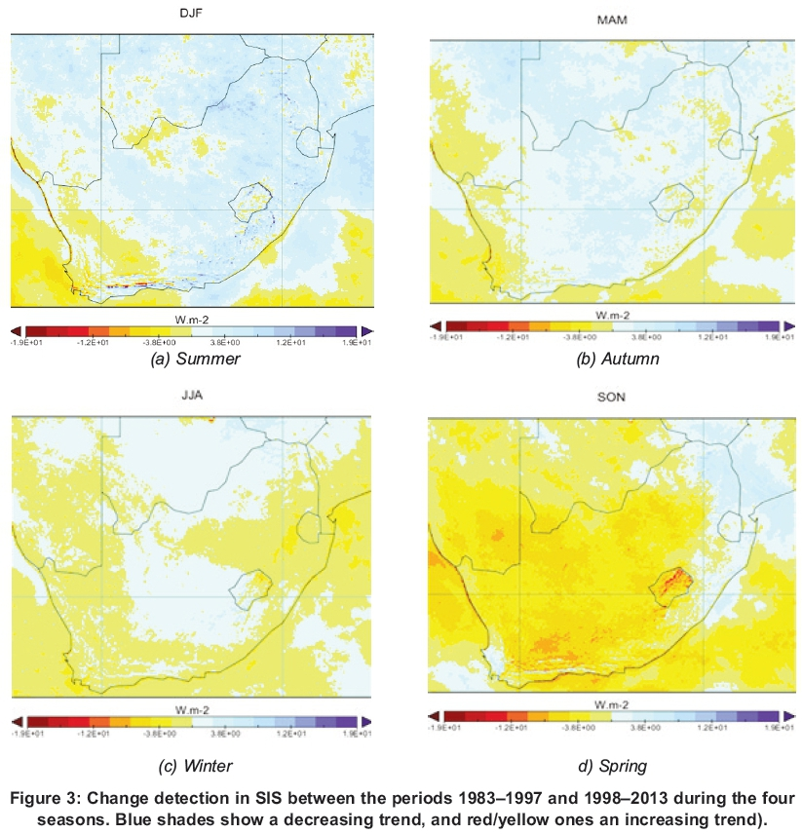

Cape Town showed a positive or no SD trend in all seasons. The SIS data also showed that, in almost all seasons, the change was negative, meaning that the amount of incoming solar radiation over this region followed a positive trend. Satellite data of SIS and SD trend results showed approximately the same behaviour, i.e. a decrease in SIS over most of the country, except for the south-western Cape and some areas in the west of the Northern Cape and the interior of the Western Cape. Autumn showed SIS trends similar to those of summer, but with the SARAH data showing, for most regions, little change over the 1983-2013 period. The decreasing trend was evident in the winter season from the SARAH data. The only stations with significantly positive trends were Calvinia in the southern Northern Cape and Mafikeng in North-West. Most of the country for spring showed a positive tendency of received radiation, in contrast with summer and autumn. Some areas in the western interior that showed large differences between the radiations received during 1997-2014 and 1983-1996, however, probably indicated strong positive trends.

**5. Conclusions**

This study set out to analyse long-term seasonal trends in sunshine hours using *in situ* SD and satellite CM-SAF, SARAH SIS data, with linear trend

analysis. It was shown that a decline in SD occurred mostly in summer. The results from the satellite-derived radiation SIS matched with the SD trend in summer. The results could provide helpful information for current and future developments in solar energy-based projects. Further research, particularly into the effect of aerosols and cloud cover on incoming solar radiation could prove useful.

**Acknowledgement**

The authors acknowledge the European Organisation for the Exploitation of Meteorological Satellites (EUMET-SAT) Satellite Application Facility on Climate Monitoring (CMSAF) for incoming surface shortwave radiation data, and the reviewer and editor of this journal for their valuable comments.

**References**

A new dawn has arrived 1923-2013 Mpumalanga Province (<http://www.eskom.co.za/sites/heritage/Documents/Mpumalanga90th.pdf>) (accessed 11 December 2016).         [ [Links](javascript:void(0);) ]

Aurela, M., Beukes, J.P, Van Zyl, PG., Vakkari, V, Teinilä, K., Saarikoski, S. and Laakso, L. 2016. The composition of ambient and fresh biomass burning aerosols at a savannah site, South Africa. *South African Journal of Science* 112(5/6): 1-8.         [ [Links](javascript:void(0);) ]

Adeyemi, A.A., Huan, Z. and Enweremadu, C.C. 2015. Evaluation of global solar radiation using multiple weather parameters as predictors for South Africa provinces. *Thermal Science* 19(2): S495-S509.         [ [Links](javascript:void(0);) ]

Badescu, V and Dumitrescu, A. 2013. The CMSAF hourly solar irradiance database (product CM54): Accuracy and bias corrections with illustrations fo Romania (south-eastern Europe). *Journal of Atmospheric and Solar-Terrestrial Physics* 93: 100-109.         [ [Links](javascript:void(0);) ]

Bojanowski, J.S., Vrieling, A. and Skidmore, A.K. 2014. A comparison of data sources for creating a long-term time series of daily gridded solar radiation for Europe. *Solar Energy* 99:152-171.         [ [Links](javascript:void(0);) ]

Dresselhaus, M.S. and Thomas, I.L. 2001. Alternative energy technologies. *Nature* 414(6861): 332-337.         [ [Links](javascript:void(0);) ]

Gauché, P, Rudman, J., Mabaso, M., Landman, W.A., von Backstrõm, T.W. and Brent, A.C. 2017. System value and progress of CSP *Solar Energy.* Doi.org/10.1016/j.solener.2017.03.072.         [ [Links](javascript:void(0);) ]

Google Earth Image: Source: [http://www.earth.google.com](http://www.earth.google.com/). Imagery date- December 14, 2015. December 10, 2016. (Retrieved on 10 December, 2016).         [ [Links](javascript:void(0);) ]

Kaiser, D.P and Qian, Y 2002. Decreasing trends in sunshine duration over China for 1954-1998: Indication of increased haze pollution? *Geophysical Research Letters* 29(21).         [ [Links](javascript:void(0);) ]

Kruger, A.C. 2004. Climate of South Africa. *Climate regions. WS45.* South African Weather Service, Pretoria.         [ [Links](javascript:void(0);) ]

Kruger, A.C. 2007. Trends in cloud cover from 1960 to 2005 over South Africa. *Water SA,* 33(5): 603-608.         [ [Links](javascript:void(0);) ]

Li, J., Liu, R., Liu, S.C., Shiu, C.J., Wang, J. and Zhang, Y. 2016. Trends in aerosol optical depth in northern China retrieved from sunshine duration data. *Geophysical Research Letters* 43(1): 431-439.         [ [Links](javascript:void(0);) ]

Liepert, B.G. and Kukla, G.J. 1997. Decline in global solar radiation with increased horizontal visibility in Germany between 1964 and 1990. *Journal of Climate,* 10(9): 2391-2401.         [ [Links](javascript:void(0);) ]

Martín-Pomares, L., Martinez, D., Polo, J., Perez- Astudillo, D., Bachour, D. and Sanfilippo, A. 2017. Analysis of the long-term solar potential for electricity generation in Qatar. *Renewable and Sustainable Energy Reviews* 73:1231-1246.         [ [Links](javascript:void(0);) ]

Müller, R., Pfeifroth, U., Trãger-Chatterjee, C., Trentmann, J. and Cremer, R. 2015. Digging the METEOSAT treasure-3 decades of solar surface radiation. *Remote Sensing* 7(6):8067-8101.         [ [Links](javascript:void(0);) ]

Müller, Richard; Pfeifroth, Uwe; Trãger-Chatterjee, Christine; Cremer, Roswitha; Trentmann, Jõrg; Hollmann, Rainer. 2015. Surface Solar Radiation Data Set - Heliosat (SARAH) - Edition 1. Satellite Application Facility on Climate Monitoring. <http://dx.doi.org/10.5676/EUM_SAF_CM/SARAH/V001>.         [ [Links](javascript:void(0);) ]

Mulaudzi, T.S., Maluta, N.E. and Sankaran, V 2015. Evaluation of the global solar irradiance in the Vhembe district of Limpopo Province, South Africa, using different theoretical models. *Turkish Journal of Physics* 39(3): 264-271.         [ [Links](javascript:void(0);) ]

Nakumuryango, A. and Inglesi-Lotz, R. 2016. South Africa's performance on renewable energy and its relative position against the OECD countries and the rest of Africa. *Renewable and Sustainable Energy Reviews* 56: 999-1007.         [ [Links](javascript:void(0);) ]

Perez-Astudillo, D. and Bachour, D. 2014. DNI, GHI and DHI ground measurements in Doha, Qatar. *Energy Procedia* 49: 2398-2404.         [ [Links](javascript:void(0);) ]

Power, H. C., and Mills, D. M. 2004. Trends in solar radiation over South Africa and Namibia during the period 1957-1997. Presented at American Geophysical Union Spring Meeting 2004.         [ [Links](javascript:void(0);) ]

Rees, W.G., 2013. *Physical principles of remote sensing.* Cambridge University Press.         [ [Links](javascript:void(0);) ]

Ross, K.E., Piketh, S.J., Bruintjes, R.T., Burger, R.P, Swap, R.J. and Annegarn, H.J. 2003. Spatial and seasonal variations in CCN distribution and the aerosol-CCN relationship over southern Africa. *Journal of Geophysical Research: Atmospheres* 108(D13).         [ [Links](javascript:void(0);) ]

Ruiz-Arias, J.A., Arbizu-Barrena, C., Santos-Alamillos, FJ., Tovar-Pescador, J. and Pozo-Vázquez, D. 2016. Assessing the surface solar radiation budget in the WRF model: A spatiotemporal analysis of the bias and its causes. *Monthly Weather Review* 144(2): 703-711.         [ [Links](javascript:void(0);) ]

Sanchez-Romero, A., Gonzalez, J.A., Calbó, J. and Sánchez-Lorenzo, A. 2015. Using digital image processing to characterize the Campbell-Stokes sunshine recorder and to derive high-temporal resolution direct solar irradiance. *Atmospheric Measurement Techniques* 8(1): 183-194.         [ [Links](javascript:void(0);) ]

Sanchez-Romero, A., Sanchez-Lorenzo, A., González, J.A. and Calbó, J. 2016. Reconstruction of long- term aerosol optical depth series with sunshine duration records. *Geophysical Research Letters* 43: 1296-1305. <https://doi.org/10.1002/2015GL067543>.         [ [Links](javascript:void(0);) ]

Stanhill, G. 2003. Through a glass brightly: some new light on the Campbell-Stokes sunshine recorder. *Weather* 58(1): 3-11.         [ [Links](javascript:void(0);) ]

Statheropoulos, M., Vassiliadis, N. and Pappa, A. 1998. Principal component and canonical correlation analysis for examining air pollution and meteorological data. *Atmospheric Environment* 32(6): 1087-1095.         [ [Links](javascript:void(0);) ]

Singer, M., 2010. Changing conceptions of South African coal-based pollution, with special reference to the Witbank coalfield, 1906-1978. University of the Witwatersrand, Johannesburg (Doctoral dissertation). <http://hdl.handle.net/10539/8366>.         [ [Links](javascript:void(0);) ]

Singh, J., Kumar, M. and Bhattacharya, B.K. 2011. Estimation of diffuse insolation for Nagpur, India. *Geophysical Research Abstracts* 13, EGU2011-906-1.         [ [Links](javascript:void(0);) ]

Singh, J. 2016. Ranking South African provinces on the basis of MERRA 2D surface incident shortwave flux. *Journal of Energy in Southern Africa* 27(3): 50-57.         [ [Links](javascript:void(0);) ]

Singh, J., Bhattacharya, B.K. and Kumar, M. 2012. Solar radiation and evaporation trend over India. *Journal of Earth Science and Engineering* 2(3): 160-165.         [ [Links](javascript:void(0);) ]

Singh, J. and Kumar, M. 2016. Solar radiation over four cities of India: Trend analysis using Mann-Kendall statistical test. *International Journal of Renewable Energy Research (IJRER)* 6(4): 1385-1395.         [ [Links](javascript:void(0);) ]

Singh, J., Kumar, M. and Bhattacharya, B.K. 2012. Global radiation, transmissivity and bright sunshine hour trend over Nagpur in pre-monsoon and mon soon seasons. *Atmospheric and Climate Sciences.* 2(2): 206-209.         [ [Links](javascript:void(0);) ]

Streets, D. G., Wu, Y., and Chin, M. 2006.Two-decadal aerosol trends as a likely explanation of the global dimming/brightening transition. *Geophysical Research Letters* 33, L15806. Doi: 10.1029/2006gl026471.         [ [Links](javascript:void(0);) ]

Trentmann, J., Müller, R.W., Posselt, R. and Stõckli, R. 2013, April. Satellite-based surface solar radiation data provided by CM SAF-Solar energy applications. In *EGU General Assembly Conference Abstracts* 15, EGU2013-10494.         [ [Links](javascript:void(0);) ]

Wang, L., Gong, W., Lin, A. and Hu, B. 2014. Analysis of photosynthetically active radiation under various sky conditions in Wuhan, Central China. *International Journal of Biometeorology* 58(8): 1711-1720.         [ [Links](javascript:void(0);) ]

Wild, M. 2009. Global dimming and brightening: A review. *Journal of Geophysical Research: Atmospheres* 114(D10), D00d16. Doi: 10.1029/2008jd011470.         [ [Links](javascript:void(0);) ]

Wood, C.R. and Harrison, R.G. 2011. Scorch marks from the sky. *Weather* 66(2): 39-41.         [ [Links](javascript:void(0);) ]

Yaiche, M.R., Bouhanik, A., Bekkouche, S.M.A., Malek, A. and Benouaz, T. 2014. Revised solar maps of Algeria based on sunshine duration. *Energy Conversion and Management* 82: 114-123.         [ [Links](javascript:void(0);) ]

<https://journals.co.za/docserver/fulltext/waters/33/5/waters_v33_n5_a3.pdf?expires=1542099969&id=id&accname=guest&checksum=73C55AD9CA33F2162C3E6D628003B4CD>

**Trends in cloud cover from 1960 to 2005 over South Africa**

**Abstract**

Seasonal trends in low and total cloud cover, as well as for associated climate variables diurnal temperature range (DTR) and number of rain days, are investigated for South Africa. It is also investigated whether the observed trends and variability in cloud cover could be related to the El Niño-Southern Oscillation (ENSO) phenomenon, which has a major influence on the variability of summer rainfall in South Africa. These trends have not been investigated recently and in such detail. In the light of the climate change debate, updated studies of historical climate change are important, especially for regions and climate variables of which such studies are not published often. Seasonal trends of daily means were examined from quality-controlled data time series of 28 climate stations over South Africa, for the period 1960 to 2005. Regional trends could be determined by averaging series of stations showing similar trends, within areas delineated in such a way that the trend of the averaged series would be statistically significant. In this way the intra-seasonal spatial variability of same trend regions, as well as the spatial relationships between trends of the different climate variables under discussion, could be established. The main results, taking all seasons into account, is a general decrease in mean daily low cloud cover, and to a lesser extent total cloud cover, over most of South Africa, but an increase in the south and south-west of the country. However, the sizes of same trend

regions show considerable variability between seasons. While trends in DTR and rain days are the opposite and the same,

respectively, of trends in cloud cover in most cases, it is shown that this is not always the case. A region covering the northern,

central and western interior of South Africa, with late-summer (JFM) cloud cover negatively correlated with equatorial

Pacific sea-surface temperatures (SSTs), shows only a non-significant decrease in total and low cloud cover for JFM, which

corresponds to a non-significant increase in equatorial Pacific SSTs during the same period.

**Keywords**: cloud cover, climate change, trends, diurnal temperature range, rainfall

https://link.springer.com/article/10.1007/s00382-018-4143-1

Numerical simulation of surface solar radiation over Southern Africa. Part 1: Evaluation of regional and global climate models

## Abstract

This study evaluates the performance of climate models in reproducing surface solar radiation (SSR) over Southern Africa (SA) by validating five Regional Climate Models (RCM, including CCLM4, HIRHAM5, RACMO22T, RCA4 and REMO2009) that participated in the Coordinated Regional Downscaling Experiment program over Africa (CORDEX-Africa) along with their ten driving General Circulation Models (GCMs) from the Coupled Model Intercomparison Project Phase 5 over SA. The model simulated SSR was thereby compared to reference data from ground-based measurements, satellite-derived products and reanalyses over the period 1990–2005.

Results show that

(1) the references obtained from satellite retrievals and reanalyses overall overestimate SSR by up to 10 W/m2 on average when compared to ground-based measurements from the Global Energy Balance Archive, which are located mainly over the eastern part of the southern African continent.

(2) Compared to one of the satellite products (Surface Solar Radiation Data Set—Heliosat Edition 2; SARAH-2): GCMs overestimate SSR over SA in terms of their multi-model mean by about 1 W/m2 (compensation of opposite biases over sub-regions) and 7.5 W/m2 in austral summer and winter respectively; RCMs driven by GCMs show in their multimodel mean underestimations of SSR in both seasons with Mean Bias Errors (MBEs) of about − 30 W/m2 in austral summer and about − 14 W/m2 in winter compared to SARAH-2. This multi-model mean low bias is dominated by the simulations of the CCLM4, with negative biases up to − 76 W/m2 in summer and − 32 W/m2 in winter.

(3) The discrepancies in the simulated SSR over SA are larger in the RCMs than in the GCMs.

(4) In terms of trend during the “brightening” period 1990–2005, both GCMs and RCMs (driven by European Centre for Medium-Range Weather Forecasts Reanalysis ERA-Interim, short as ERAINT and GCMs) simulate an SSR trend of less than 1 W/m2 per decade. However, variations of SSR trend exist among different references data.

(5) For individual RCM models, their SSR bias fields seem rather insensitive with respect to the different lateral forcings provided by ERAINT and various GCMs, in line with previous findings over Europe.

(6) Biases in SSR are overall qualitatively consistent with those in total cloud cover. The information obtained in present study is of crucial importance for understanding future climate projections of SSR and for relevant impact studies.

[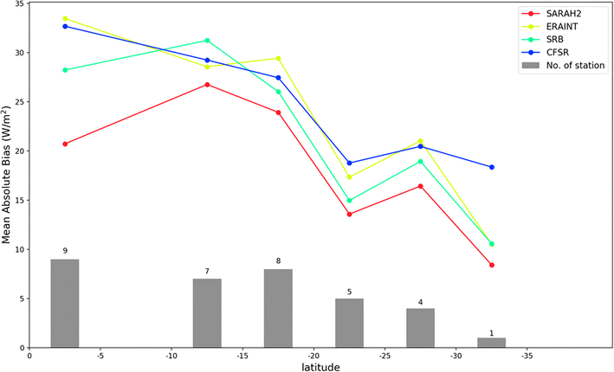](https://media.springernature.com/original/springer-static/image/art:10.1007/s00382-018-4143-1/MediaObjects/382_2018_4143_Fig12_HTML.gif)

**Fig. 12**

Latitudinal variation of the monthly SSR Mean Absolute Bias (MAB) from SARAH-2 (red), ERAINT (light green), SRB (green) and CFSR (blue) at the GEBA stations (Fig. [1](https://link.springer.com/article/10.1007/s00382-018-4143-1#Fig1)) during 1990–2005. Each MAB is an averaged value from all the stations located in a 5° latitude interval. The number of stations is indicated by the gray bar in each interval

[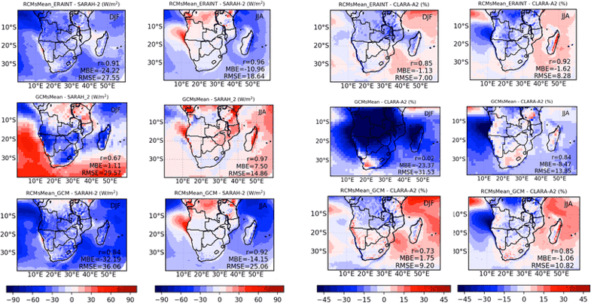](https://media.springernature.com/original/springer-static/image/art:10.1007/s00382-018-4143-1/MediaObjects/382_2018_4143_Fig13_HTML.gif)

**Fig. 13**

Multi-model seasonal mean SSR (CLT) differences with respect to SARAH-2 (CLARA-A2) in DJF and JJA seasons over the period 1990–2005. In order to avoid overrepresentation of those RCMs having many simulations (4 in CCLM4 and 10 in RCA4, 3 in HIRHAM4 and 2 in RACM22T and REMO2009), each model bias is firstly determined as average over the simulations conducted by this model, and then only the 5 remaining bias fields were averaged to obtain the multimodel mean. However, the resulting multimodel mean SSR field shows only negligible differences compared an unweighted average over all 20 RCMs simulations, so the “overrepresentation” is not crucial in this study

Establishment of the South African baseline surface radiation network station at De Aar

<https://doi.pangaea.de/10.1594/PANGAEA.887031> data portal: must log in.

<http://www.saeon.ac.za/Observations-on-Environmental-Change-in-SA-e-version-Section-2.pdf>

Measurement initiative: South African Environmental Observation Network (SAEON)

https://www.sciencedirect.com/science/article/pii/S0022169404004056

Which potential evapotranspiration input for a lumped rainfall–runoff model?: Part 2—Towards a simple and efficient potential evapotranspiration model for rainfall–runoff modelling

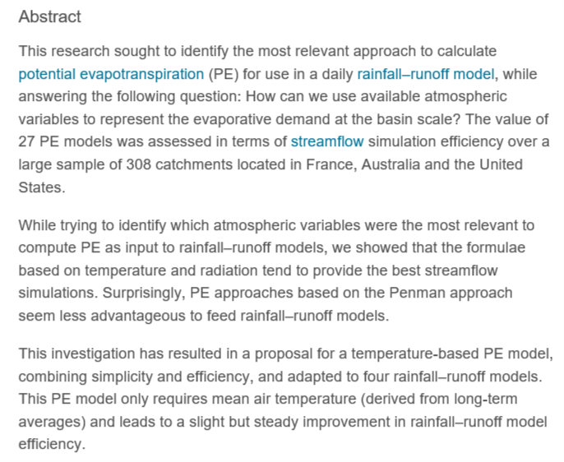

[**https://www.nature.com/articles/nature11983**](https://www.nature.com/articles/nature11983)

Terrestrial water fluxes dominated by transpiration

Renewable fresh water over continents has input from precipitation and losses to the atmosphere through evaporation and transpiration. Global-scale estimates of transpiration from climate models are poorly constrained owing to large uncertainties in stomatal conductance and the lack of catchment-scale measurements required for model calibration, resulting in a range of predictions spanning 20 to 65 per cent of total terrestrial evapotranspiration (14,000 to 41,000 km3 per year) (refs [1](https://www.nature.com/articles/nature11983#ref1), [2](https://www.nature.com/articles/nature11983#ref2), [3](https://www.nature.com/articles/nature11983#ref3), [4](https://www.nature.com/articles/nature11983#ref4), [5](https://www.nature.com/articles/nature11983#ref5)). Here we use the distinct isotope effects of transpiration and evaporation to show that transpiration is by far the largest water flux from Earth’s continents, representing 80 to 90 per cent of terrestrial evapotranspiration. On the basis of our analysis of a global data set of large lakes and rivers, we conclude that transpiration recycles 62,000 ± 8,000 km3 of water per year to the atmosphere, using half of all solar energy absorbed by land surfaces in the process. We also calculate CO2 uptake by terrestrial vegetation by connecting transpiration losses to carbon assimilation using water-use efficiency ratios of plants, and show the global gross primary productivity to be 129 ± 32 gigatonnes of carbon per year, which agrees, within the uncertainty, with previous estimates[6](https://www.nature.com/articles/nature11983#ref6). The dominance of transpiration water fluxes in continental evapotranspiration suggests that, from the point of view of water resource forecasting, climate model development should prioritize improvements in simulations of biological fluxes rather than physical (evaporation) fluxes.

<https://www.ncbi.nlm.nih.gov/m/pubmed/20935626/?i=4&from=/23552893/related>

Recent decline in the global land evapotranspiration trend due to limited moisture supply.

**Abstract**

More than half of the solar energy absorbed by land surfaces is currently used to evaporate water. Climate change is expected to intensify the hydrological cycle and to alter evapotranspiration, with implications for ecosystem services and feedback to regional and global climate. Evapotranspiration changes may already be under way, but direct observational constraints are lacking at the global scale. Until such evidence is available, changes in the water cycle on land−a key diagnostic criterion of the effects of climate change and variability−remain uncertain. Here we provide a data-driven estimate of global land evapotranspiration from 1982 to 2008, compiled using a global monitoring network, meteorological and remote-sensing observations, and a machine-learning algorithm. In addition, we have assessed evapotranspiration variations over the same time period using an ensemble of process-based land-surface models. Our results suggest that global annual evapotranspiration increased on average by 7.1 ± 1.0 millimetres per year per decade from 1982 to 1997. After that, coincident with the last major El Niño event in 1998, the global evapotranspiration increase seems to have ceased until 2008. This change was driven primarily by moisture limitation in the Southern Hemisphere, particularly Africa and Australia. In these regions, microwave satellite observations indicate that soil moisture decreased from 1998 to 2008. Hence, increasing soil-moisture limitations on evapotranspiration largely explain the recent decline of the global land-evapotranspiration trend. Whether the changing behaviour of evapotranspiration is representative of natural climate variability or reflects a more permanent reorganization of the land water cycle is a key question for earth system science.

<https://www.sciencedirect.com/science/article/pii/S0022169411007487>

Global review and synthesis of trends in observed terrestrial near-surface wind speeds: Implications for evaporation

## Summary

In a globally warming climate, observed rates of atmospheric evaporative demand have declined over recent decades. Several recent studies have shown that declining rates of evaporative demand are primarily governed by trends in the aerodynamic component (primarily being the combination of the effects of wind speed (u) and atmospheric humidity) and secondarily by changes in the radiative component. A number of these studies also show that declining rates of observed near-surface u (termed ‘stilling’) is the primary factor contributing to declining rates of evaporative demand. One objective of this paper was to review and synthesise the literature to assess whether stilling is a globally widespread phenomenon. We analysed 148 studies reporting terrestrial u trends from across the globe (with uneven and incomplete spatial distribution and differing periods of measurement) and found that the average trend was −0.014 m s−1 a−1 for studies with more than 30 sites observing data for more than 30 years, which confirmed that stilling was widespread. Assuming a linear trend this constitutes a −0.7 m s−1 change in u over 50 years. A second objective was to confirm the declining rates of evaporative demand by reviewing papers reporting trends in measured pan evaporation (Epan) and estimated crop reference evapotranspiration (ETo); average trends were −3.19 mm a−2 (n = 55) and −1.31 mm a−2 (n = 26), respectively. A third objective was to assess the contribution to evaporative demand trends that the four primary meteorological variables (being u; atmospheric humidity; radiation; and air temperature) made. The results from 36 studies highlighted the importance of u trends. We also quantified the sensitivity of rates of evaporative demand to changes in u and how the relative contributions of the aerodynamic and radiative components change seasonally over the globe. Our review: (i) shows that terrestrial stilling is widespread across the globe; (ii) confirms declining rates of evaporative demand; and (iii) highlights the contribution u has made to these declining evaporative rates. Hence we advocate that assessing evaporative demand trends requires consideration of all four primary meteorological variables (being u, atmospheric humidity, radiation and air temperature). This is particularly relevant for long-term water resource assessment because changes in u exert greater influence on energy-limited water-yielding catchments than water-limited ones.

### Graphical abstract

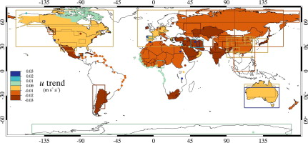

1. [Download full-size image](https://ars.els-cdn.com/content/image/1-s2.0-S0022169411007487-fx1.jpg)

### Highlights

► Globally 148 regional studies reviewed; average wind speed trend = ∼−0.014 m s−1 a−1. ► Globally 55 pan evaporation studies were reviewed; average trend = −3.19 mm a−2. ► Twenty-six crop reference [evapotranspiration](https://www.sciencedirect.com/topics/agricultural-and-biological-sciences/evapotranspiration) studies reviewed; average trend = −1.31 mm a−2. ► Globally 36 studies confirmed wind speed importance when assessing evaporation trends. ► Influence of wind speeds trends on actual evaporation depends on [limiting factor](https://www.sciencedirect.com/topics/earth-and-planetary-sciences/limiting-factor).

<https://books.google.co.za/books?id=ZhKTjpYCn-0C&pg=PA158&lpg=PA158&dq=climate+radiation+reversal+since+1990&source=bl&ots=YpO_f2I2TK&sig=znNQteN2oFc2AgCptAiT6TGRRq4&hl=en&sa=X&ved=2ahUKEwjM15eHy9DeAhVpJMAKHWYLCJoQ6AEwBXoECAQQAQ#v=onepage&q=climate%20radiation%20reversal%20since%201990&f=false>

